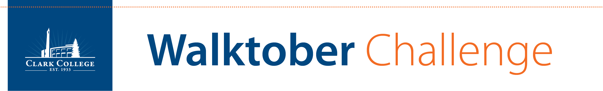

Track your steps and WIN!

**WHAT:** Clark College, Lower Columbia College, and Washington State University Vancouver walk it out in an epic trek towards a healthier lifestyle. The school with the most steps wins a trophy (and bragging rights)!

**WHEN:** October 1-31, 2018.

**WHO:** You! Track all physical activity for the month of October.

**PRIZES**: Presented to the top three (3) Clark employees with the highest steps! We will also announce the department with the most steps!

**LEARN MORE:** <http://www.clark.edu/cc/walktober>

