Clark College Penguin Digest February 6th, 2023
Do not forget to review the attachments to the email when applicable.

What’s New This Week in The Digest

AARP Tax Assistance
Our volunteers are just there to answer questions. Free e-file is available depending upon income level. Note: our in-person service does not have an income limit. Please review the flyer attached to this email for more information, including dates and locations. More info here.

Health Services on Campus- New Pricing
Did you know you can access health services right here on campus with Dr. Buschur? She can help you if you are not feeling well, need vaccines or prescriptions for medications, or lab testing. She can diagnose and treat all kinds of illnesses.
To keep costs as low as possible we only charge what we pay for materials. These costs have increased so we have needed to charge slightly more, however we never want a lack of funds to prevent students from accessing the care they need. Come talk to us if you have any questions, if there is a service you need but you don't see it on our list, or to arrange alternate payment. We also have free mental health counseling, and over-the-counter medications at the Counseling and Health Center. Get in touch by calling or texting 360-992-2614, or by email. Price sheet attached to email.

Wakanda Forever Double Showing, February 21
Come enjoy free pizza and watch Wakanda Forever on Tuesday, Feb. 21 starting at 11am & 2pm in Gaiser Student Center. We are offering two showings in-case you have class during one of them. Closed captioning provided. Questions email Malcolm
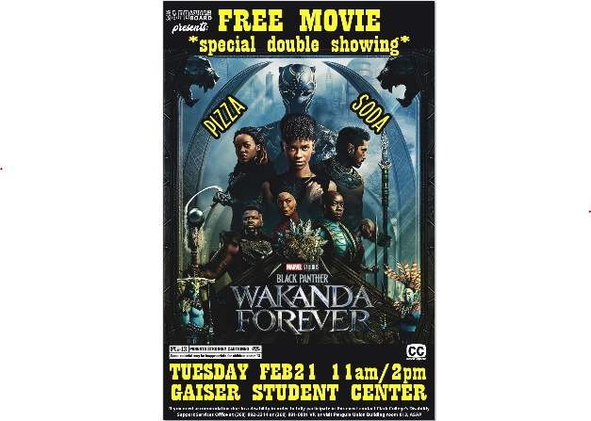

Thompson Fitness Center Promotion
You started the New Year right! Keep up the effort and love your heart during February, the American Heart month. Make your ticker happy by coming to the Thompson Fitness Center 10 times during the month of February to be entered into a drawing for a chance to win.

Loving Your Resources Department Scavenger Hunt, Feb 13-15
Come learn about what free resources the departments can offer you as you walk the campus and collect candy. Start in the Office of Student Life - PUB 160 and fill up your passport to receive 2 Regal Movie Tickets. One prize per student. Monday, Feb. 13 - 15 from 9am - 4pm. Questions email Sami.
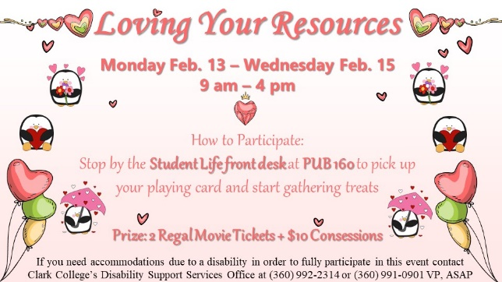

MyPlan Canvas Course
Do you want more time with your community, career, class planning or cash? Check out MyPlan and select an activity. Sign up for your MyPlan Canvas invitation now! If interested in checking out our new canvas page complete this short form. We would love your feedback on it as well.

Marshall Award Nomination Due February 17th
Do you know a senior in high school, resident of Clark County, committed to serving a greater good and demonstrates leadership potential, serves as a role model, motivating others to become involved? If so, nominate them for a $3,500 scholarship.

Join a Clark College Committee
The College needs to hear from students. Apply to serve as a student representative on a variety of college committees and share your perspective. Apply and earn $15.74 per hour. Questions? Contact ASCC Vice President, David Goebel.

Join a Student Club Today
Looking to connect with students with similar interests? Check out the student clubs page here. Questions email Student Life.

Outstanding Faculty Award Nominations
Do you know an instructor, librarian or counselor who supports students, makes an impact, respects difference and/or teaches passionately? Nominate them for a cash award and college-wide recognition! Learn more about this award, view past recipients, and how to nominate your favorite instructor (which is any Clark College full- or part-time faculty, counselor, librarian, or department head). Nominations open March 6 and on March 17, so you have time to think about who you would like to see win this award! A Canvas banner will run this Winter quarter to remind you and let you know when nominations open!

Event Recommendations Needed
Student input is needed to help plan spring quarter events for students. Each student who fills out the survey receives 2 movie tickets. Brought to you by your Service and Activities Fees. Questions email Malcolm
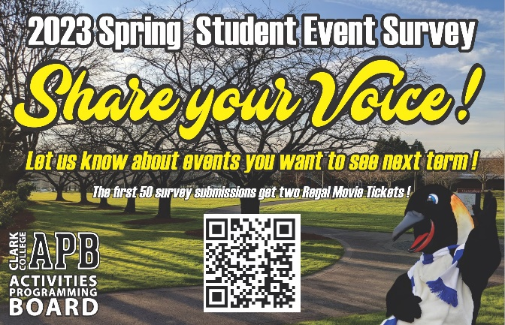

Scholarship Opportunities

2023-2024 Scholarships Available, Apply Now Through April 14
Over $1 million is available to Clark students in any major for the upcoming academic year. Students with a minimum 2.5 GPA who are attending next year can submit a completed Clark College Foundation Scholarship Application by April 14 to be considered. Be sure to start early as letters of recommendation are required.
Transfer scholarships are also available for students who will be graduating this year and transferring to other colleges next year. Check eligibility requirements before applying. The deadline is May 1. Other scholarship opportunities are also available, so be sure to check the website to see if there are others you would like to apply for. Apply here!

Clark college foundation Deadline: April 14, 2023
Over $1 million is available to Clark students in any major for the upcoming academic year. Students with a minimum 2.5 GPA who are attending next year can submit a completed Clark College Foundation Scholarship Application by April 14 to be considered. Be sure to start early as letters of recommendation are required. Transfer scholarships are also available for students who will be graduating and transferring to other colleges. Other scholarship opportunities are also available, so be sure to check the website to see if there are others you would like to apply for. Apply here!

Washington state Opportunity Baccalaureate Deadline: February 28, 2023
The Baccalaureate Scholarship provides up to $22,500 in financial aid support and access to career-launching support services for students pursuing high-demand STEM and health care majors. This scholarship can be used to cover tuition, fees and other indirect costs of attendance such as housing, transportation, food and more. Funding can be used for any eligible STEM or health care degree at any eligible public or private college or university in Washington state. Apply Here!

Washington Women in Need Deadline April 13, 2023
WWIN is accepting applications now through April 13 for new Star Scholars! Our Scholars are women who represent WWIN’s values and are ready to transform their lives through higher education and careers. Each Scholar receives up to $5,000 per year toward their total Cost of Attendance, and their scholarship may be renewed each year up to $20,000 total over the course of their undergraduate education. They also have the support of our Resiliency Fund to help with financial setbacks along the way and our Career Coaching program. Apply Here!

Fellowship Opportunity for Recent High School Graduates
Calling all recent high school graduates! Want to earn $1,000? iUrban Teen and Vancouver Public Schools have a 60-hour fellowship opportunity where you will get the chance to have an impact on a young person at YOUR elementary school of choice within the Vancouver School District. Please visit our website to learn more about this opportunity and apply!

Events

Free Virtual Cooking Classes, 2/8, 2/15 & 2/22
Do you like to cook? Cook virtually with Food Network Star Jyll Everman and your APB on Feb. 8, Feb. 15 and Feb. 22. Email Angie, ASAP, for recipes, equipment, list of ingredients etc... Also, if you need the ingredients let her know now so we can buy them for you. Zoom is good for all 3 classes.
- Feb. 8 - BBQ Chicken Rice Bowl & Chicken Pasta Salad (deadline to order ingredients is Feb. 1)
- Feb. 15 - Microwave Avocado Toast, Parmesan Risotto & Caramel Macchiato Mugcake (deadline to order ingredients is Feb. 8)
- Feb. 22 - Chipotle Sweet Potato Taco and Spicy Corn Muffins (deadline to order ingredients is Feb. 15)
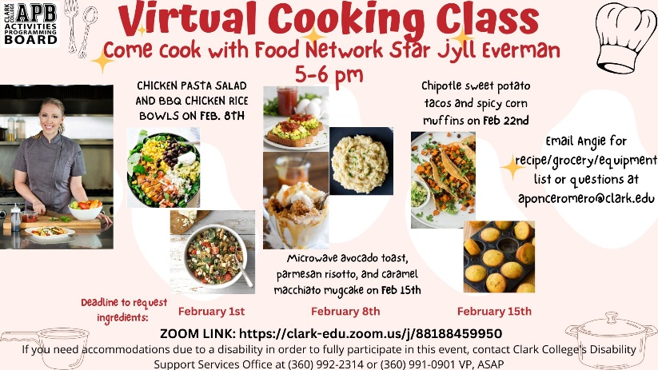

Chill Out Mondays, 2/6-2/27
Come connect and relax with other students and your APB on Mondays from 11am - 2pm in PUB 161. All Make & Take items are free for students, staff, and faculty. In addition to the activity, we will also be offering board games, coloring pages etc. Questions email Sami.
2/6 - Embroidery Heart
2/13 - Air Plants & Hot Cocoa Bar
2/27 - Art Journaling & Hot Cocoa Bar
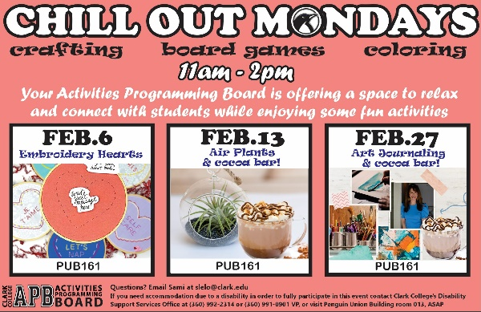

Free Virtual Trivia Fridays, 2/3 & 2/10
Join us virtually as we play various trivia and bingo games each Friday starting on Feb. 3 & Feb. 10 from 11:00am - 12:00pm. Friends and family can play although only currently registered students can win. One Amazon Gift Card per student. Questions email Sami.
Feb. 3 - Cartoon Bingo
Feb. 10 - The Most Magical Bingo on Earth (Disney Theme)
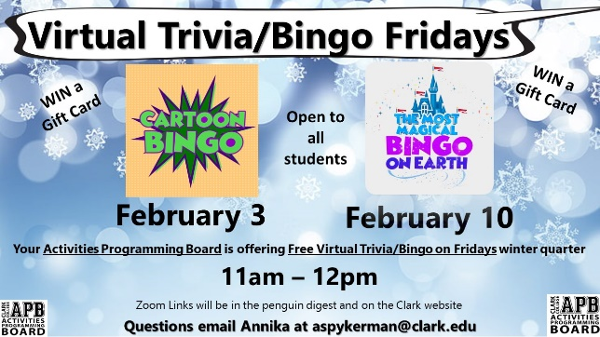

Student Employment

Student Employment Open Positions
Apply to Student Employment! Complete the Student Employment Quiz by going to your MyClark@Clark > Paying for College > Student Employment. You will see jobs you qualify for, whether that is Work Study (WS) or Institutional Hire (IH) positions or both.
IH0368B – Lab Assistant Aide II $15.94/hr.
Assist students with locating and using laboratory equipment. Maintain a clean and safe laboratory environment. Maintain laboratory equipment. Responsible for securing equipment in locked cabinets, checking out equipment to students, inspecting equipment for damage/loss. Assist in laboratory equipment setup for classroom & instructional use.
IH840B – ESL Classroom Tutor $15.94/hr.
Required availability: Tuesday's & Thursday's 6:30pm- 9pm
Assist instructor in beginning ESL classes. Follow instructor’s directions. Help students individually and in small groups in the classroom.
WSS489B – Grounds & Nursery Services Specialist 1 $16.25/hr.
Perform maintenance of grounds, landscapes, and fields. Perform routine duties including weeding, pruning, raking, and shoveling or materials. Collect and remove accumulated litter on campus, in parking areas and along campus perimeter. Assists in moving materials and supplies. Perform other related duties as required and/or assigned.
WSS846B - MESA Community Builder $16.25/hr.
Be an enthusiastic STEM (Science, Technology, Engineering, and/or Math) student with a passion for MESA's mission to empower historically underrepresented students in STEM. Enjoy interacting with diverse students and planning and promoting social events.
If you have any questions regarding student employment, you can email Career Services or visit the Student Employment Page.

ASCC Student Government is Hiring, $15.94/hour
The ASCC Student Government is looking for student leaders for the 2022-2023 school year! Qualifications at time of application:
• Be enrolled in eight (8) credits or more at Clark College.
• Possess and maintain a 2.50 cumulative grade point average at Clark College: and
• Have completed a minimum of twelve (12) college level credits at Clark College at time of application.
Compensation – Institutional Hire (not work-study eligible):
• Positions are paid $15.94 per hour
• Must be able to work 15 hours per week during regular business hours. Regular business hours are Monday-Friday 9:00 am-5:00 pm.
Review job descriptions and submit the application online. Questions email Student Life

Student Resources

How Does Your Class Schedule Look for Spring Term?
Now is a great time to meet with your academic advisor to review and make modifications to your plan for spring term classes AND your long-term plan for summer and fall. Schedule an appointment (virtual or in person) soon to co-create your plan with your advisor. Schedule your appointment here.

Get Involved and Volunteer
Student Life is looking for students to volunteer and help at on-campus events and the Penguin Pantry. Fill out the interest form here. Questions email Sami

Student Success Workshops
Check out the Student Success Workshop schedule. You can register for as many as you want. There is a workshop for everyone. They are all free and anyone can attend.

Advising Services Workshops
Advising Services is holding a series of helpful workshops to make sure students are on the right track and getting the right information! These workshops include transfer planning and degree pathway sessions that cover healthcare, general transfer, business, education, and engineering. For more information and to register, check out the Student Success Workshop schedule or the advising website.

Working Family Tax Credit Information
Beginning in February 2023 through December 31, 2023, individuals with and without children and people that file their taxes with a Social Security Number (SSN) or an Individual Taxpayer Identification Number (ITIN) will be able to claim this money. This is a video on how to get an ITIN number. ITIN Webinar from the IRS: ITIN Process Webinar (irsvideos.gov). You can check here to see if you are eligible for the WFTC.

Tutoring In Person or Online – Visit Today!
Visit Clark College Tutoring Services Monday through Thursday 9am to 5pm or Friday 9am to 2pm! Tutoring Services is available for in-person support in Hawkins Hall, room 102! The Virtual Center also continues to provide Zoom tutoring, you can connect with any of our Zoom tutors OR our in-person tutors via the Virtual Center. View tutor availability for both in-person and Zoom tutoring on the Tutoring Services web page by clicking “Visit the Virtual Tutoring Center to view tutor schedules”. Students may access links to the Zoom sessions and helpful tutoring resources via Canvas in the Virtual Tutoring Center for most general subjects or select Accounting and Business for those specific subjects virtually as well. Please have your Student ID ready to sign-in with our helpful front desk staff and they will get you connected to the tutor you need! Online support is also available at etutoringOnline.org. Remember, tutoring is a FREE resource to you and an extremely beneficial study practice!

Check Your Textbook Costs for Free or Low-Cost Options First
Many of our instructors work hard to keep the costs low for you and find materials that are FREE and low cost to keep your costs down as much as possible! When searching for your classes you can view which classes use these materials BEFORE signing up for your class! There are three types of searches you can look for:
- OER stands for Open Educational Resources - this is an option where the instructor has chosen instructional materials that do not have any cost to you at all - FREE!
- LCT stands for Low-Cost Textbooks - this is an option where the instructor has chosen instructional materials that are $50 or less.
- FDDA stands for First Day Digital Access - this is an option where the instructor has chosen instructional materials that you do not purchase from the bookstore but that are already charged as part of your tuition when you register. The advantage is that you have access within your course's Canvas shell on the first day of classes. These are not always low cost but typically do fall in the low-cost range.
How to search for classes that use OER and/or LCT?
- Go to the Class Search page in ctcLink
- Fill out the information for the class you are looking for, then click on "more filters."
- Go to the "Course Attribute" dropdown.
- Click the box for both "Low-Cost Textbooks" and "OER: No textbook to purchase." or "FDDA: First Day Digital Access"
If the class you need to take has LCT, OER or FDDA options, those class sections will appear. If nothing appears, then those textbook options are not available for that class. You can view each individual section and class to see which option it has available. How cool is that!?

Career & Personality Assessment Opportunities!
Want support with discovering your career possibilities? The Strong Interest Inventory (SII) provides insight into your interests, career motivators, workstyle preferences, and helps you identify good-fit careers and educational programs. Sign-up to complete this assessment and attend an interpretation session, visit here.
Want to learn more about your unique personality type preferences and career possibilities? The Myers-Briggs Type Indicator (MBTI) is the most-widely-used assessment for understanding personality type preferences. The MBTI identifies and describes your strengths and unique preferences, and helps you answer these questions: "How does my personality inform my choice of work environment?" and "What careers are popular among people with my personality type?" Sign-up to complete this assessment and attend an interpretation session, visit here. To learn more, visit the Career Assessments page. Questions? Contact Career Services or call 360-992-2902.

Childcare Availability & Funding for PELL Eligible Students
Do you need quality childcare where families are welcomed as we partner to nurture our youngest penguins? Come join the wonder of learning in our nationally accredited childcare and lab school through hands on play and inquiry. Child and Family Studies has selected openings both FT and PT for two- to five-year-old children. CCAMPIS funding is available to assist our PELL eligible student families, applications are available.
For interest and to learn more, please email us.

Join the New Students Resources Canvas Page
ASCC has built a wonderful canvas page with links, resources, announcements and much more. It is free and easy to access. To join the community of other students please email Student Success and you will be added. Soon you will be able to connect with other students through discussion boards and find study groups to support each other through your classes.

Free Student ID & Free Bus Passes
Currently registered students can obtain a free Clark College Student ID and free C-Tran Bus Pass with proof of current registration and valid photo ID through the Clark College Bookstore. More information is here.
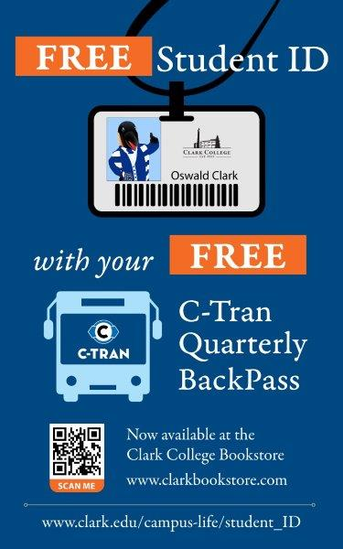

Free Monthly Penguin Pantry Food Distribution Boxes
The Clark College Penguin Pantry will be distributing monthly food boxes to students in February, and March. Sign up now on your MyClark@Clark to receive a free food box. For more info check here.

Free Legal Consultation, Wednesdays 1pm-3pm by Appointment
All current Clark College students are eligible for one free legal consultation. Schedule your consultation here. He can assist with many things such as parenting plans, landlord issues, legal notices and much more. Questions email Sami.
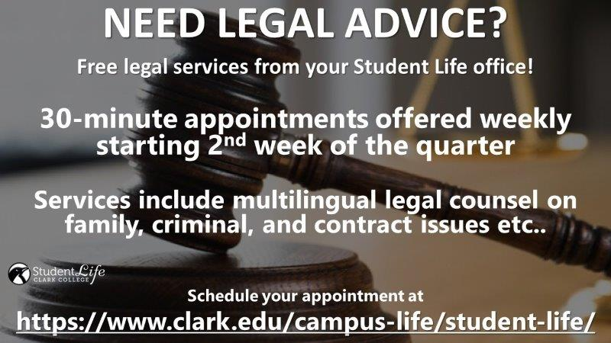

Counseling & Health Services
Did you know that as a Clark student you can access FREE, confidential mental health counseling, and low-cost medical services right here on campus? There are also support and skills groups available. For more information visit us on the web, call or text 360-992-2614, or email us here! See attached flyer in the email for other info.

Student Success Coaches Are Available for You
Each Area of Study (AoS) Coach provides free, consistent, one-on-one coaching that can help you develop skills, connect you to resources, and navigate higher education. Your Coach will be by your side throughout your journey at Clark to help support your individual goals for academic and personal success. Learn more about the Success Coaching program at our website and visit our online booking system to schedule a meeting with a Coach. We cannot wait to meet you!
Brief drop-in appointments are available every day of the week in Gaiser 214!
Mon 1pm-3pm, Tues 2pm-4pm, Wed 10am-12pm. Drop in via Zoom Fri 11am-1pm

Workforce Education Services (WES) Programs
Looking for additional funding for school related expenses? Workforce Education Services has several programs that you may be eligible for. If you live in Washington and are low income, receiving food benefits (SNAP/EBT), receiving cash assistance through DSHS (TANF), receiving unemployment, or received unemployment in the past four years, or became a displaced homemaker in the past four years, you may be eligible. Complete the application here!

Other Important Information

Disability Support Services Accommodations
Are you a student who is new to Clark and has a disability? Clark’s Disability Support Services supports students with a range of disabilities and health conditions, from depression to ADD/ADHD to Crohn’s disease and more. We approve students for things such as: additional time on exams, recording of lectures, shared peer notes from lectures, and alternate book format such as audiobooks. Check out our easy four Steps to Requesting Accommodations to get started. We ask for documentation on your disability/health condition and are more flexible this year on what we accept. Contact us for questions or visit our Documentation Guidelines. CONTACT US: Email, Visit our DSS website for Zoom Room info, or call us at: 360-992-2314.

Drug Free Schools & Communities Act (DFSCA)
The Drug-Free Schools and Communities Act (DFSCA) of 1989 - also known as the Drug-Free Schools and Campuses Act - requires institutions of higher education to establish policies that address unlawful possession, use, or distribution of alcohol and illicit drugs for faculty, staff, and students. Read more here.

Sam’s Law, Anti-Hazing
Sam’s Law is the name of new anti-hazing legislation recently adopted in Washington State. Read more here.

