**Azure Labs 101 for Techs**

* **Note:** Always use your admin account when working with Azure
* **Note:** Azure labs are not joined to the Labs domain. They are local VMs
* Contact Lucy for permission to the Azure lab before you proceed
* Contact Lucy if you need any software copied to the Azure File Storage
* [https://portal.azure.com:](https://portal.azure.com/) main site with all information about Azure services, storage accounts, Lab Services, SQL Databases, Service Apps, Monitor, etc
* [https://labs.azure.com;](https://labs.azure.com/) where you create the actual Azure Labs and install software

# Creating an Azure Lab

* Log in to [https://labs.azure.com](https://labs.azure.com/) with your admin account

•

Click on “New Lab” to create your new Lab

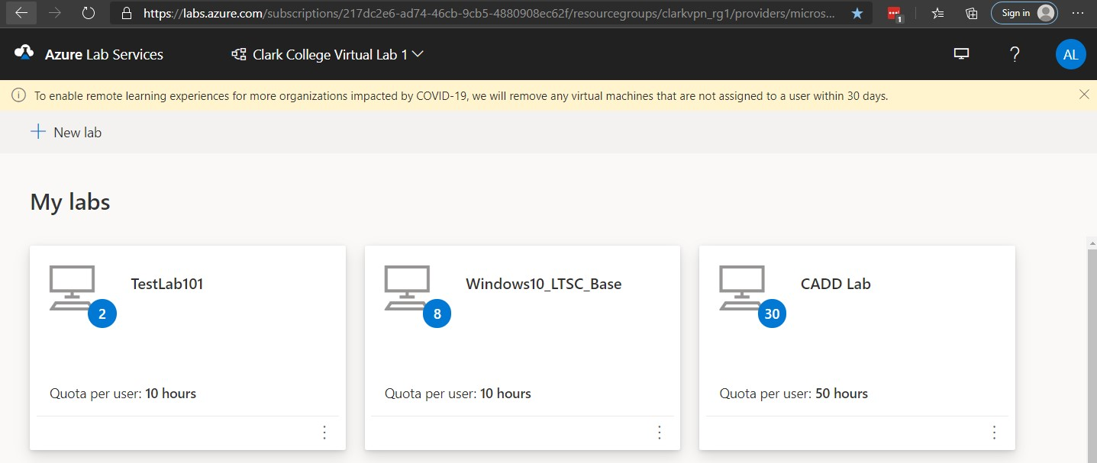

* 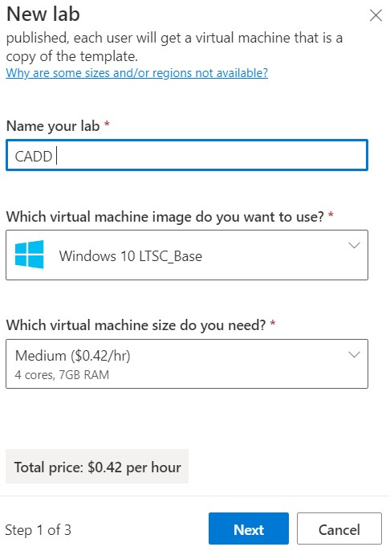Name your lab: the name the Faculty specified in the IT ticket

* Virtual machine image: use **Windows 10 LTSC Base** to create a new Azure lab then install more

specialized software as requested

* Virtual machine size: depends on what class the Azure lab is for will be to determine the hardware requirements (by default, we

select Medium ($0.42/hr 4 cores,

7GB RAM)

* Click Next

* 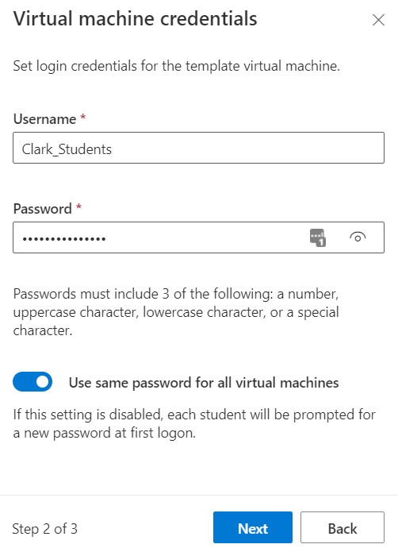Username: **Clark_Students**

* Password: **Clark_Students!**

* By default “Use same password for all virtual machines” is left on

* Click Next

* 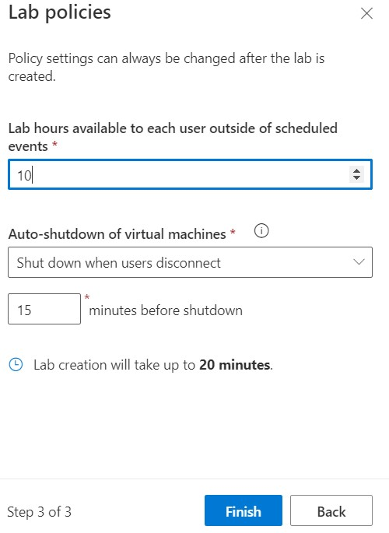Lab hours available to each user outside of scheduled events: By default, we set it at **10** hours unless the faculty specify in the ticket (this is also called **quota**). In the CADD

Lab example, we set it to 50 instead

* Auto-shutdown of virtual machines: **Make sure** you select “Shut down when users disconnect” and **15** minutes before shutdown. This will cost the College if VM is left on indefinitely

* Click Finish

* It will take 20 minutes to create the new template virtual machine

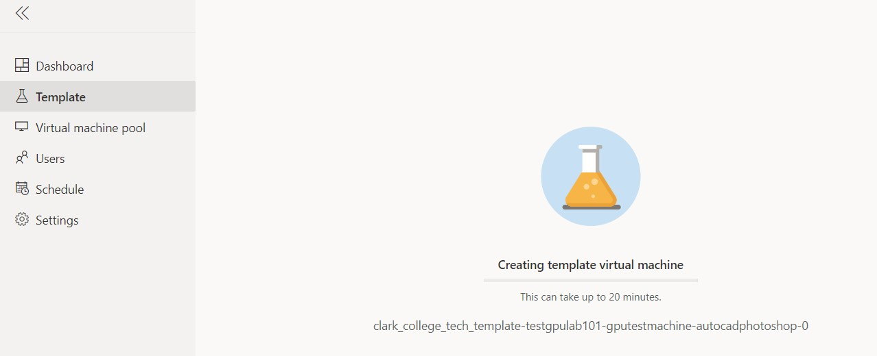

* Upon completion, you will see the CADD Lab template appearing as down below



* Click on CADD Lab then “Start template” to install additional software (takes about 4.11 minutes to turn on the template with these hardware specs).

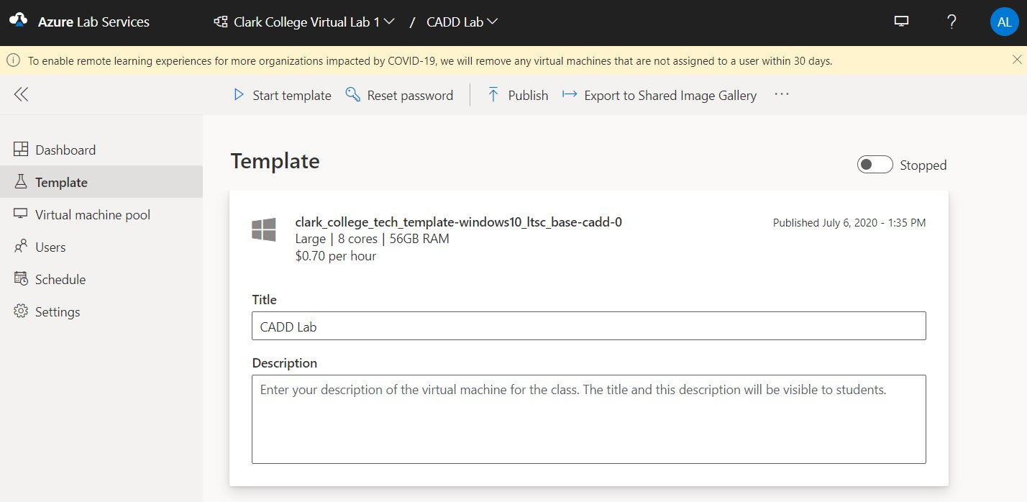

* The Template status changes to “Running” when the template is turned on. **(Note: Make sure you always turn the Template off when you are done working on it!)**

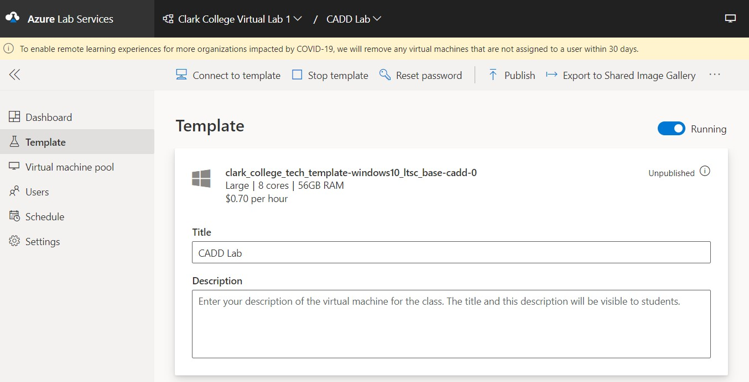

* Click on “Connect to template” will automatically download the CADD Lab.rdp



* Find your CADD Lab.rdp and log in with Clark_Students and Clark_Students!

* You are ready to customize your Azure lab now

* Keep in mind that the Azure Lab was previously configured to shut down in 15 minutes. If you choose to turn off that setting while working, make sure you set a reminder to turn it back on before you are done; otherwise, the College will be charged.

➢ Go to Settings (see screenshot down below)

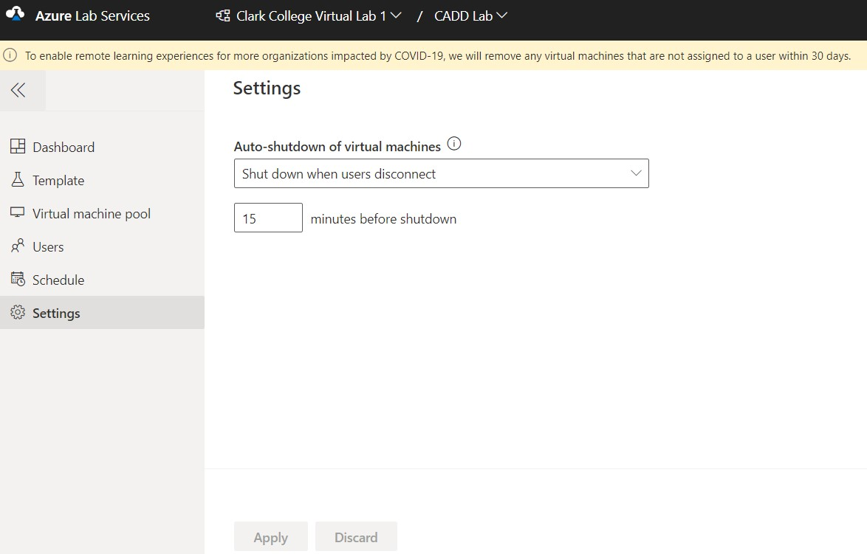

* **Note:** Microsoft is automatically installing Teams on all the Azure labs. Uninstall Teams first

* You are now ready to customize your Azure Lab template

* Contact Lucy if you need any software copied to the Azure File Storage

# Map a Network drive to Azure File Storage/Explorer [Software Storage]

From [https://portal.azure.com,](https://portal.azure.com/) click on Storage Accounts then click on the link called **clarkvpnrg1diag** (this is our Azure File Storage). This is a more direct way to access the software.

* Note: You do need to have the software copied to the File Storage first.

* Scroll down and find Files Shares and click on it

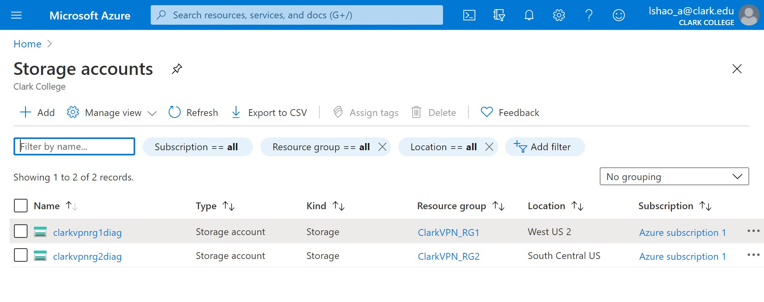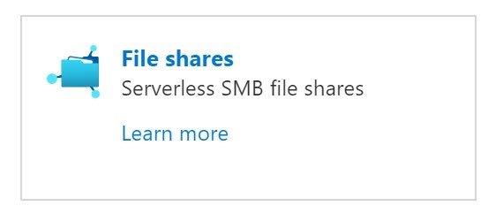

* “**clarkappinstall**” is the actual file share name we will use. Click on the … to the right and select Properties

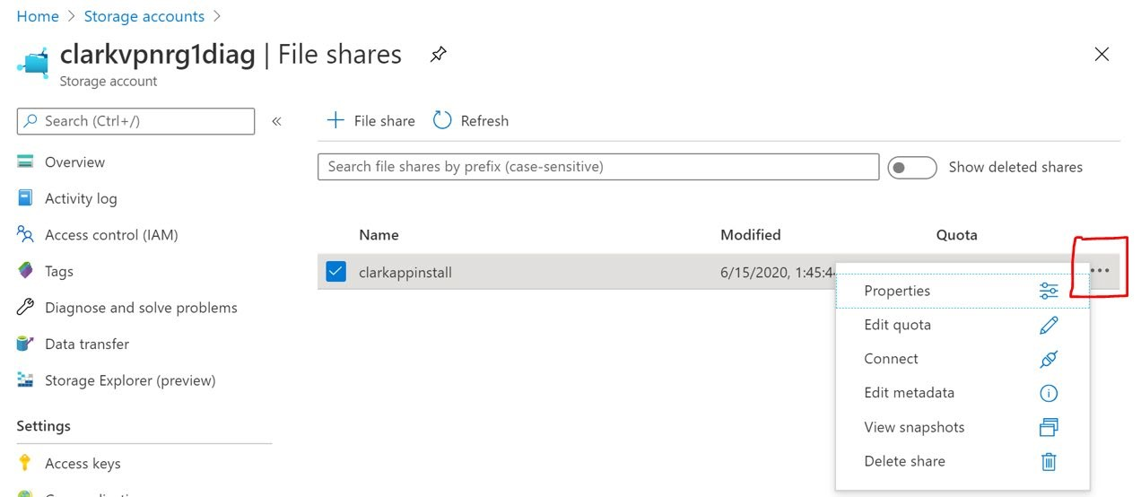

On the **clarkappinstall** Properties screen, copy the URL address (this will be our share name we use to map later)

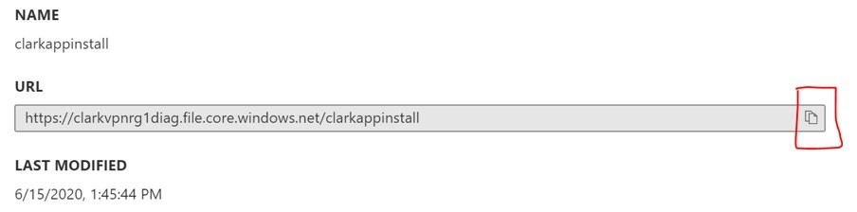

* From [https://labs.azure.com,](https://labs.azure.com/) go back to your Azure Lab.rdp connection and click on “Map network drive”

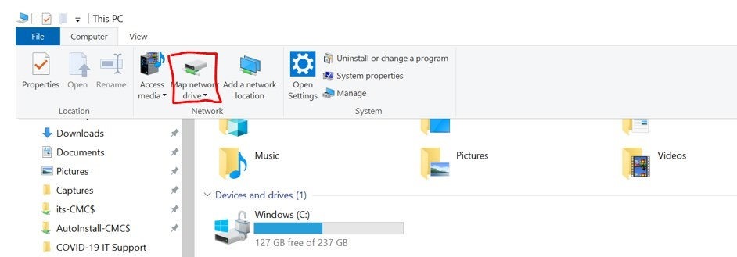

* Select a Drive letter and paste the URL you copied previously in as the share name and modify it

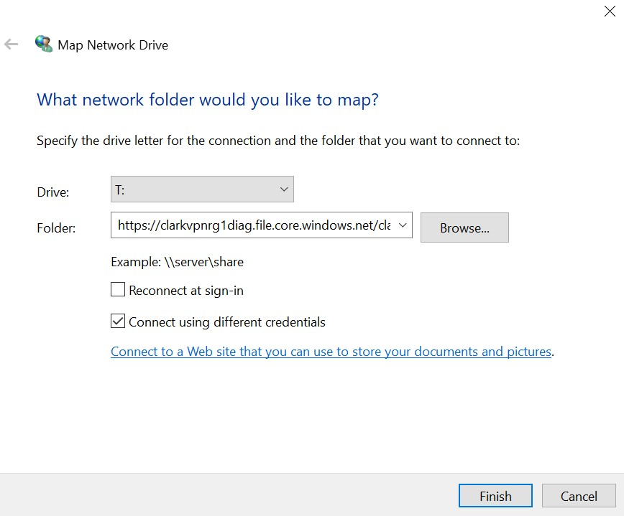

The original URL address previously copied is

https://clarkvpnrg1diag.file.core.windows.net/clarkappinstall

* + Now, modify it to **\\**clarkvpnrg1diag.file.core.windows.net**\**clarkappinstall
  + Select “Connect using different credentials” then Finish

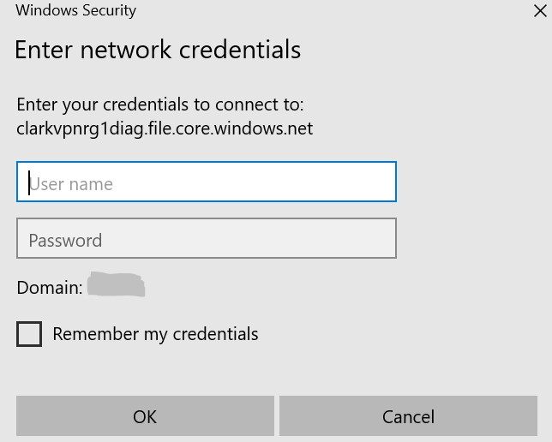

* To get the different credential account name and password key, go back to [https://portal.azure.com](https://portal.azure.com/) – clarkvpnrg1diag storage account. Under Settings, click on “Access Keys”

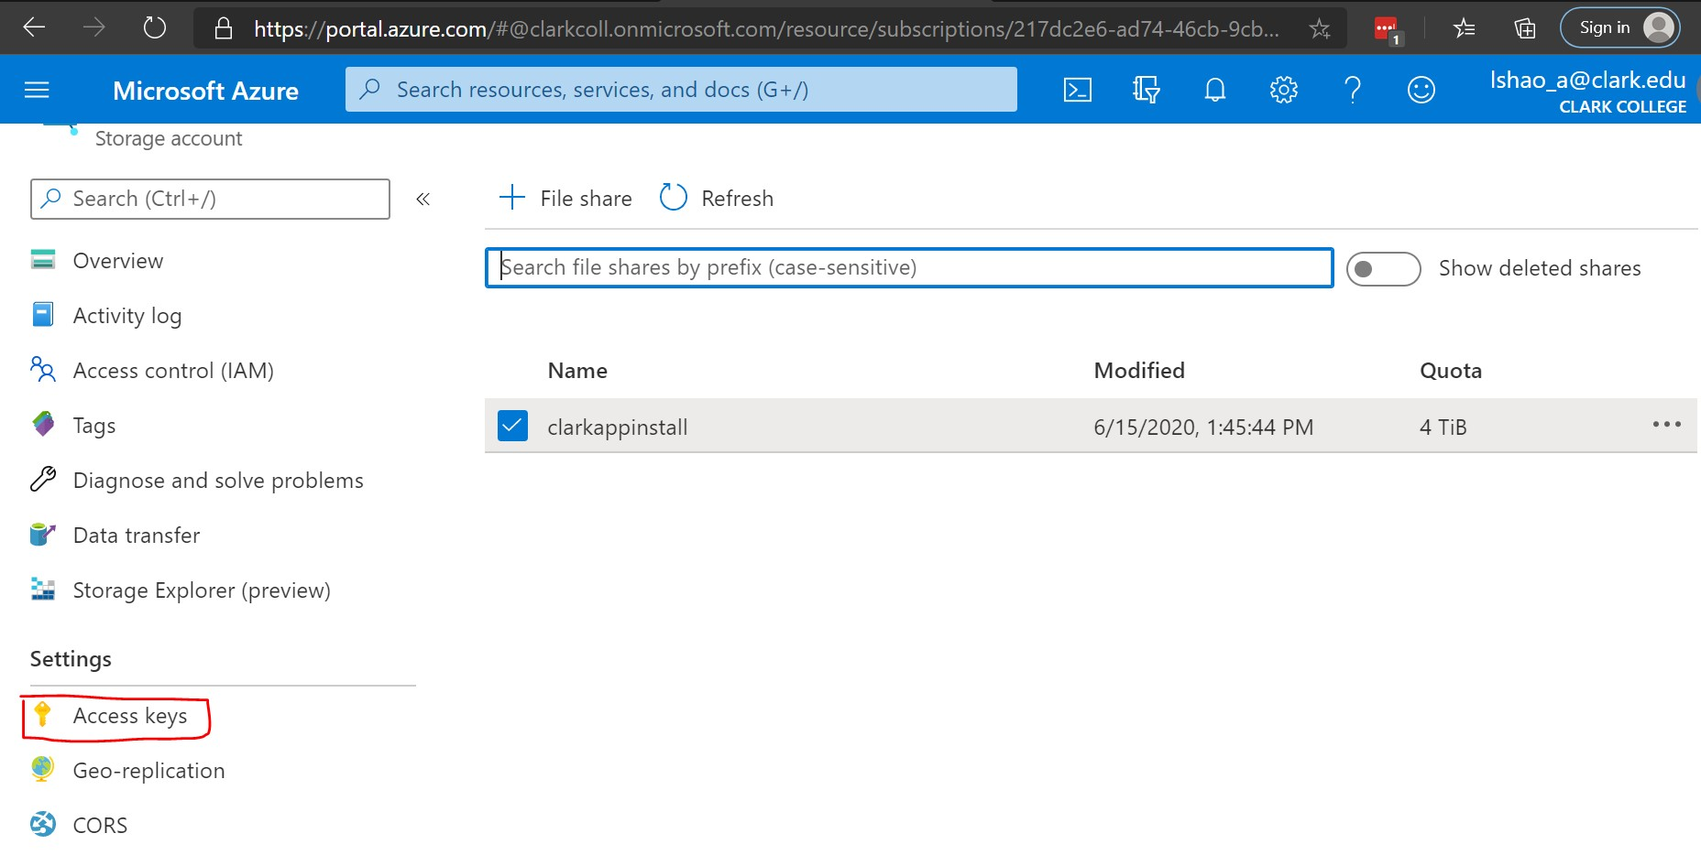

Username = Click and copy the Storage account name ( clarkvpnrg1diag )

Password = Click and copy the Key1

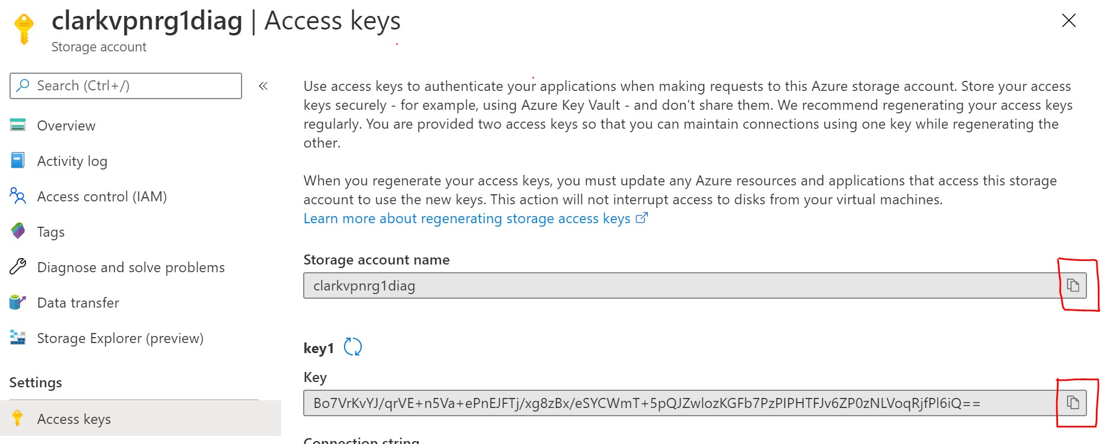

* Click OK to map the drive

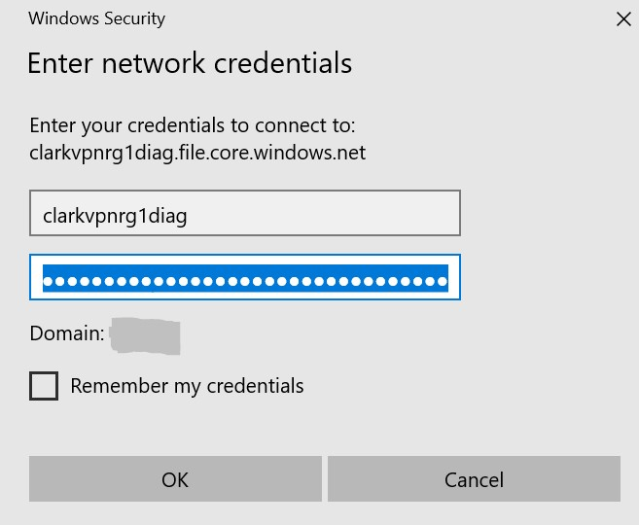

* Open up Windows Explorer and look for the newly mapped drive called **clarkappinstall**

**Ready to Publish Your Azure Lab:**

* Make sure you turn off the Azure lab template first
* Click on Publish



* 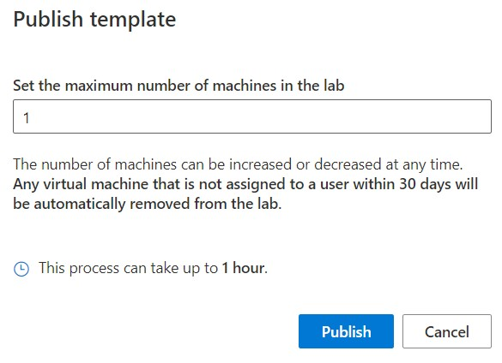Set the maximum number of machines in the lab: determined by the instructor who should have included it in the submitted IT ticket
* This number can be changed and republished later as well

* Click “Publish”

* The CADD Lab took an hour to publish

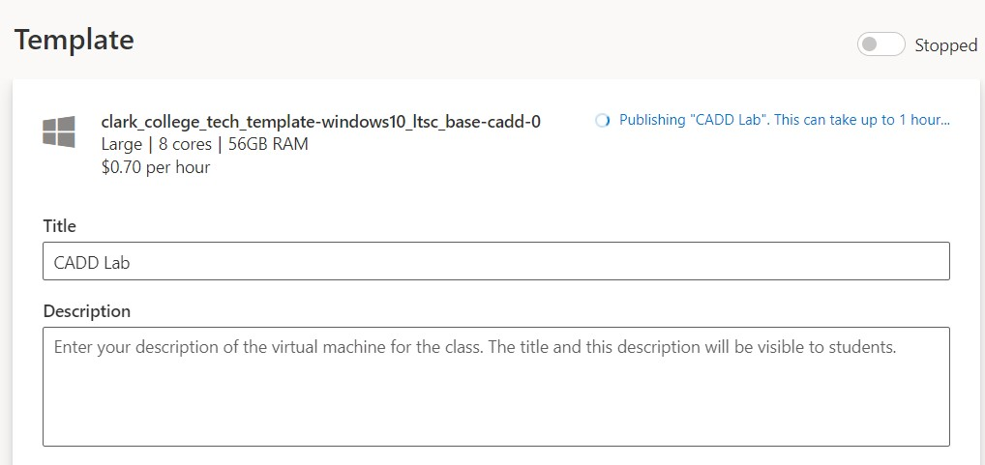

* Congratulations, you have completed your Azure Lab!

* **There are still some things left to do:** 
  + Contact Lucy to assign the Azure lab permission for the instructor if you have not done so yet

* + Give a copy of the “Azure Lab Instructions for Faculty” to your instructor and work with the individual on what he/she needs to do as a Faculty (i.e. add students and send invites to them)

* + Give a copy of the “Azure Lab Instructions for Students” to your instructor (Lucy will email a copy of the file to Ken as well for student support)

# Modifying an Existing Azure Lab after the Initial Publication

* 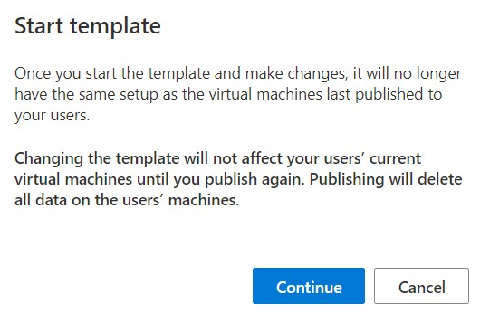You can modify your lab template after you have already published it

* When you start the CADD lab template, this message appears

* Click “Continue”

* Just remember to **Republish** your template afterwards!!

* Make sure you contact Lucy to assign role permission for your instructor before he/she can proceed with adding and inviting students to the Azure lab. After Lucy assigns the permission, the instructor will:

* + Receive an invitation email to the designated Azure lab
  + Go through Microsoft multi-factor authentication
  + Have access to [https://labs.azure.com](https://labs.azure.com/)
  + Be able to add and send invitations to students