**Azure Lab Instructions for Students**

* Your instructor will send you an invite to your Clark Student Gmail in order to access the Lab and its software. This is a Microsoft cloud based service called Azure Lab

* Log into your Clark Student Gmail

* You must open up the email and click on “Register for the lab” and follow the instructions before you have access to use the Lab software

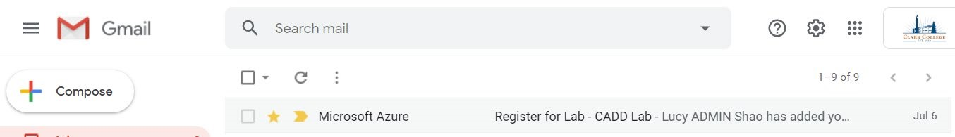

* After opening up the invite email, click on “Register for the lab”

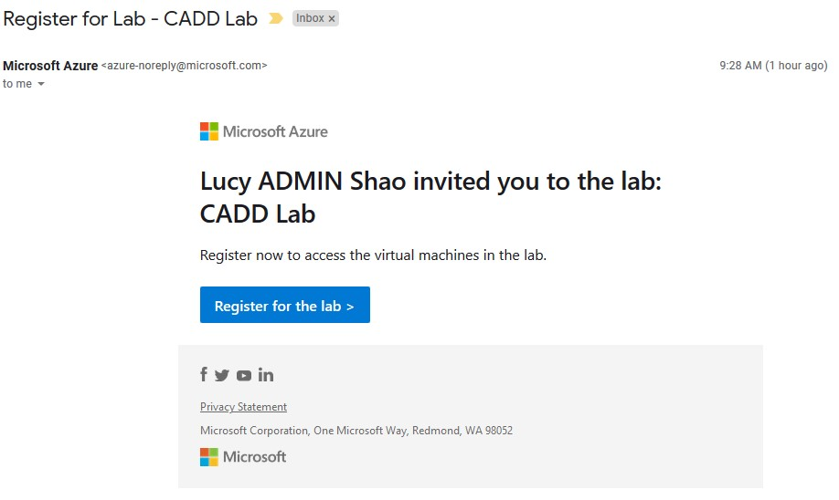

* 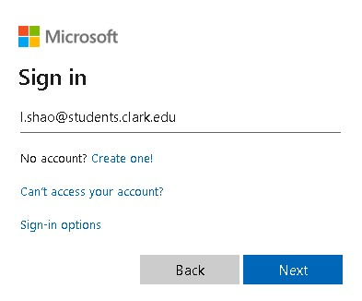Enter your **Clark Student Gmail** address under “Sign

In”

* Click on Next

* 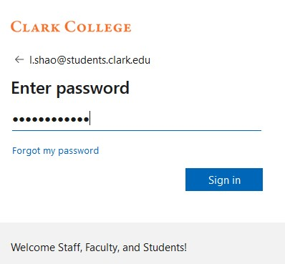Now enter the password for your **Computer/Wifi Password** (Note: **NOT** your

Student Gmail Password!!!)

* Click on Sign in

* Setup **Microsoft multi factor authentication** if it shows up. (Highly recommending you to setup at least two of the options). You will only need to do this once

* Click Finish

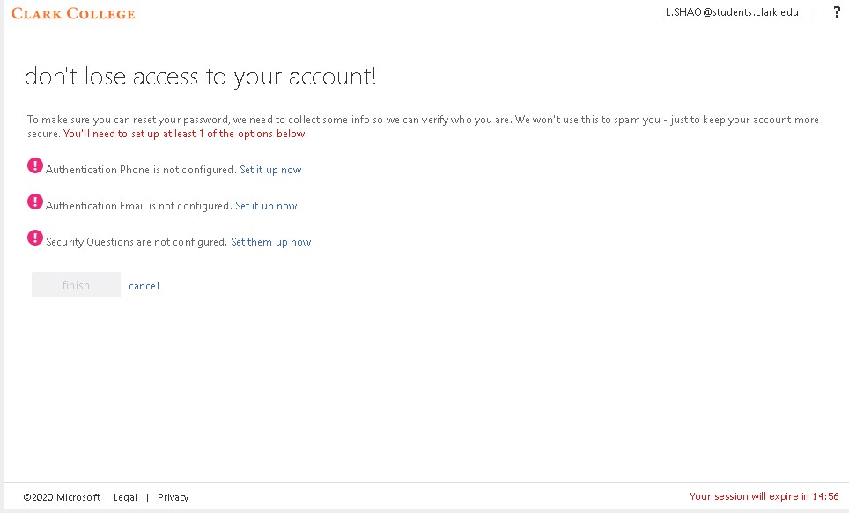

* 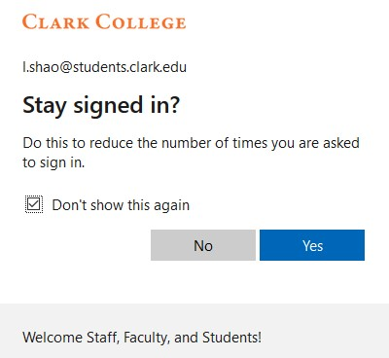Put a check mark next to

“Don’t show this again”

* Click Yes

# How to Access the Lab (ex: CADD Lab)

• If you have multiple classes, then you will receive individual invite to each Computer Lab. You need to register for each Lab before you have access to all your Labs as shown in the screenshot below

1. Click on “Stopped” to “Start” the CADD Lab virtual machine (VM). It takes ~ 4 minutes for the VM to Start Up.

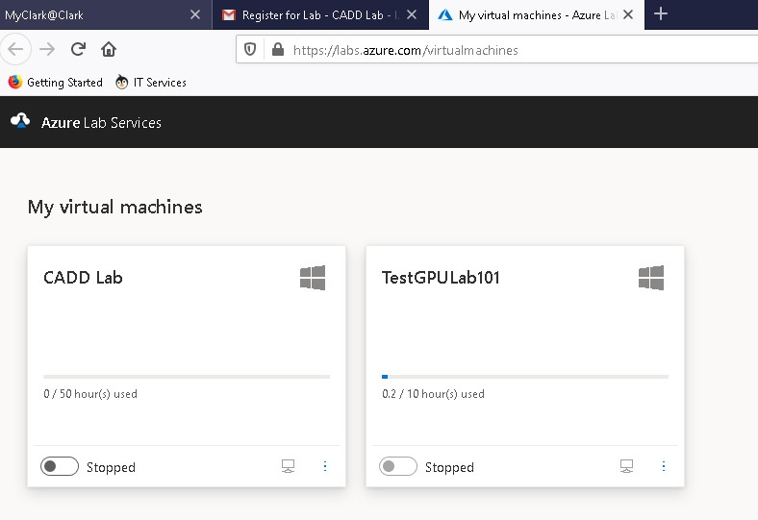

**1**

1. When the CADD Lab VM has finished starting up (it takes about 4 min 11 seconds), click on the “monitor” icon to download the **CADD lab.rdp**. You need this .rdp to connect to the computer as if you were connecting to a computer in the Computer lab.

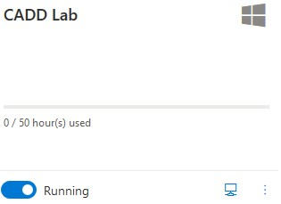

**2**

1. Find the downloaded Cadd lab.rdp (mine was downloaded to the Download folder)



1. Highly recommending you to save the CADD lab.rdp to a different location such as to your Desktop to continue using it throughout the quarter

1. Right click on CADD lab.rdp icon

1. 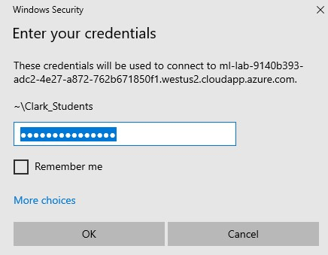Windows Security window pops up, by default the username is already entered in for you as **Clark_Students**

(not in bold)

1. Just enter the password **Clark_Students!** (not in bold)

1. Click OK

1. This is a screen you will see while the CADD Lab.rdp is starting up

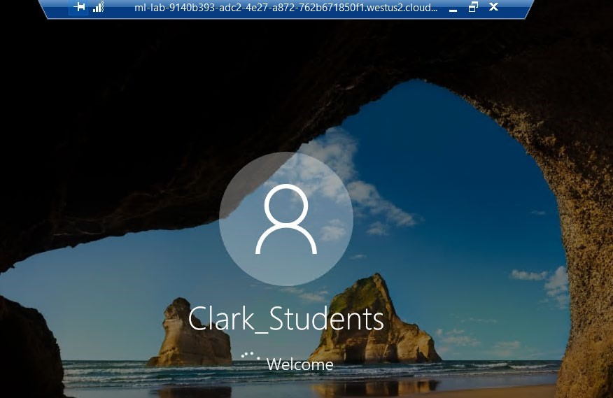

1. After the VM comes up, you will see the typical Desktop screen.

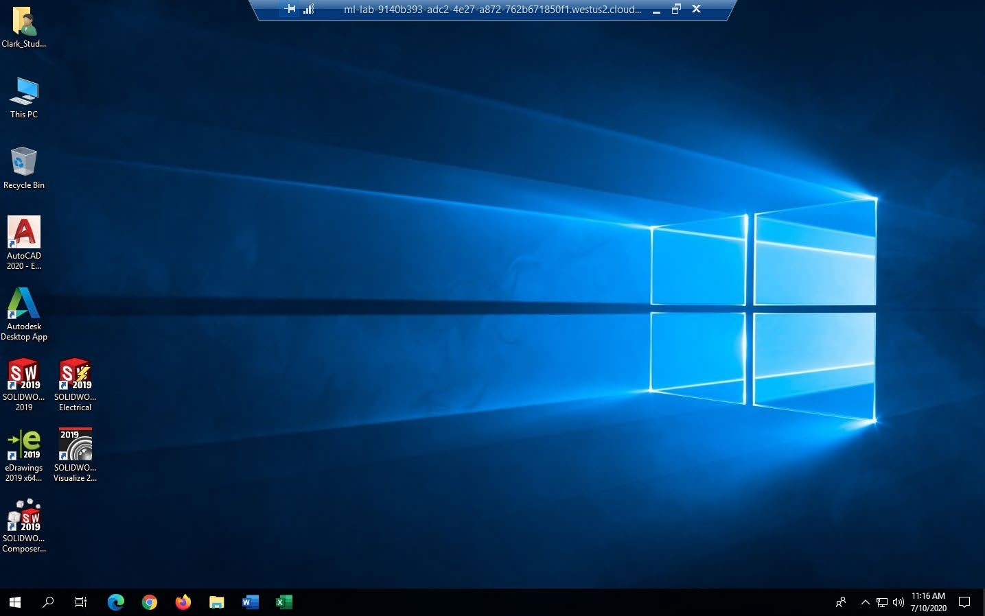

1. Always Sign Out of the VM when you are done working

1. Go back to Azure Lab Services website and click on “Running” to tur off the VM

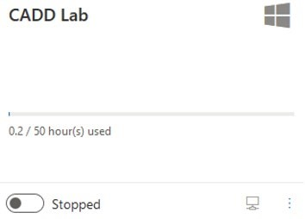

1. Keep in mind that several factors can affect the performance of the VM such as your internet speed, your computer hardware, and so forth. You may want to consider requesting for a loaner laptop if your computer is very outdated

1. To make the laptop loaner request, go to [http://www.clark.edu/its/documentation-andresources/students/techhub/index.php](http://www.clark.edu/its/documentation-and-resources/students/techhub/index.php)

1. Or go to [www.clark.edu,](http://www.clark.edu/) I am a Current Student, scroll all the way to the bottom of the page under eLearning & Communications, click on TechHub, click on “Laptop Request Form”

