**Clark College Azure Lab Instructions for Instructors**

**Required from Instructors:**

1. Submit an IT ticket for an Azure lab with the following information:
   * Azure lab name
   * For which quarter including start and end dates
   * Software request with appropriate licenses
   * Number of students
   * Specified quota hours outside class time for students to use the Azure lab

1. Your IT Tech will contact you when the Azure Lab is ready for use along with this instruction file

1. Access to Azure lab
   * Log on to **https:://labs.azure.com**
   * Set up Microsoft multi-factor authentication
   * Add and send invites to students before they can register for the Azure lab

# Add Students to the Azure Lab

* [https://labs.azure.com,](https://labs.azure.com/) instructor logins in with Clark login and may need to go through the Microsoft multi-factor authentication wizard

* Click on your specific Azure Lab (ex: CADD Lab). You may see one or more depending on how many you have requested from IT. Contact your Tech if you do not see the Lab for your class.

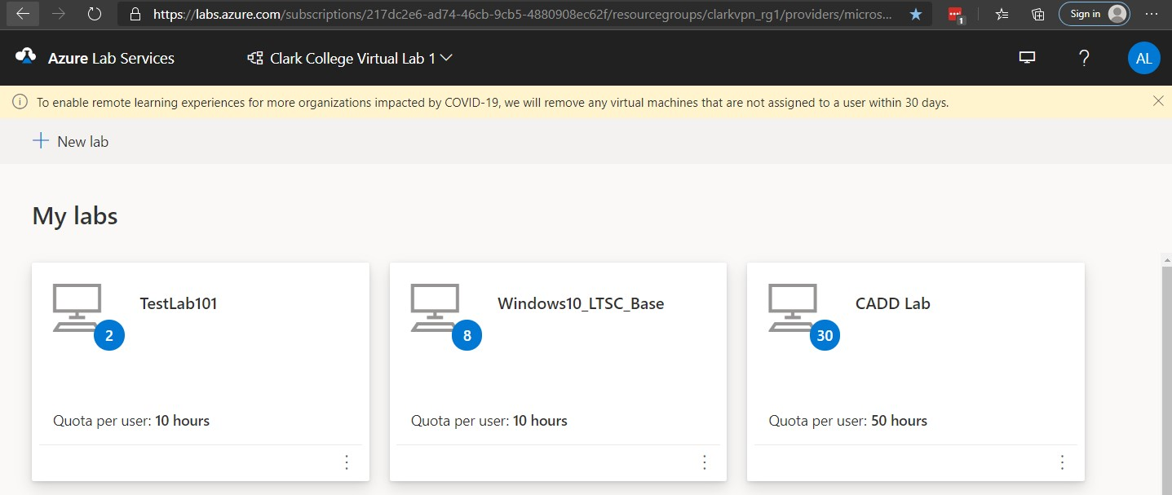

* Click on Users then click on “Add users”. From the drop down menu, select “Add by email address”

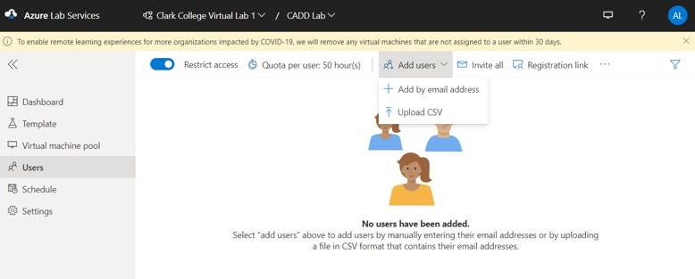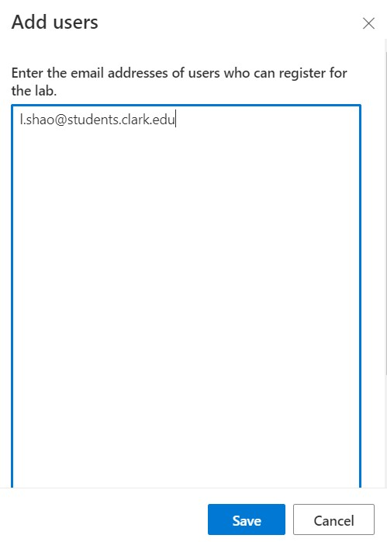

**1**

**2**

**3**

•

Enter your student’s email

address and click on Save

* The student’s email address will now appear in the Users window as “Not registered” and Invitation as

“Not sent”. We will work on that after you have finished adding all the students to your lab

•

**To delete a student**

, move your mouse cursor in front of the student’s email address and an icon with

3

dots appears

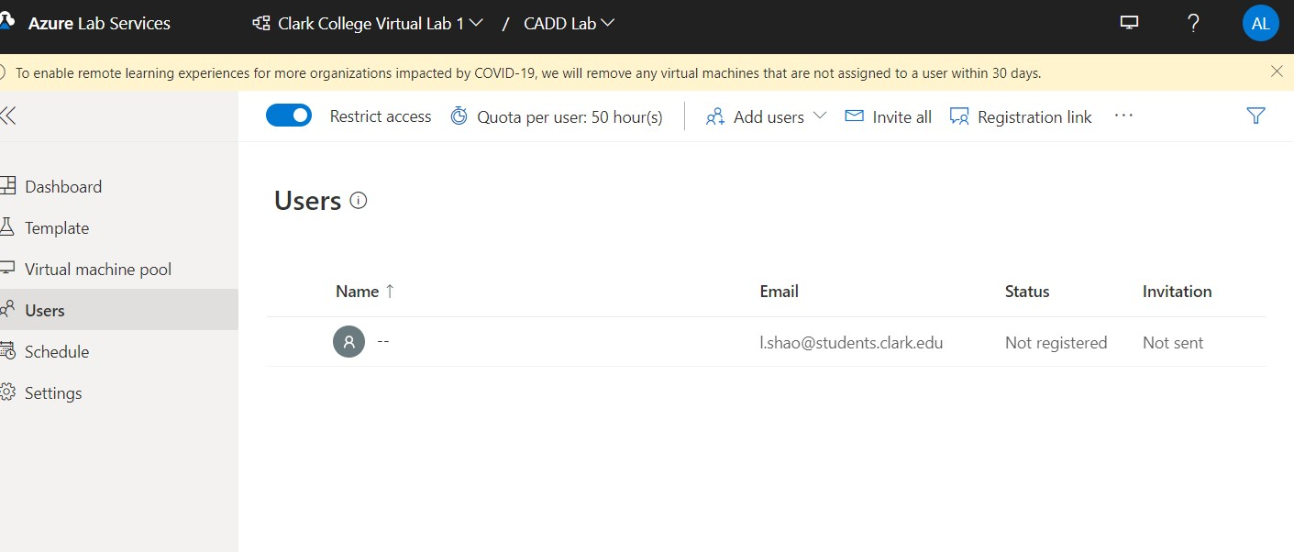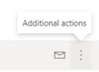

➢ Click on the 3 dots icon and it will give you a drop down menu with an option to “Delete” the student

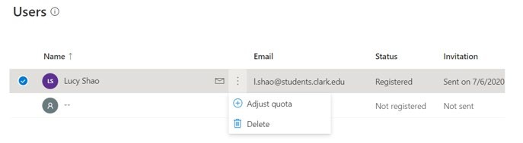

* Now repeat the process of adding students until all your students show up in the “**Users**’ list” (see the above screenshots). You also have the option of uploading a CSV file including the student email addresses

# Send Invites to Students



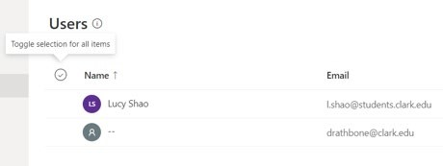

•

In order

to select the

whole list of

students, you must

move the cursor

over to about where

the red box is, then

the

check mark

circle will

automatically

appear for you to

click on

* Next, click on the envelope icon and the pop window appears. You have the option of adding a message or leave it blank

* Now, click on “Send”. This will sends out an invitation to the Lab by email to each student in your list

Azure Lab in the browser

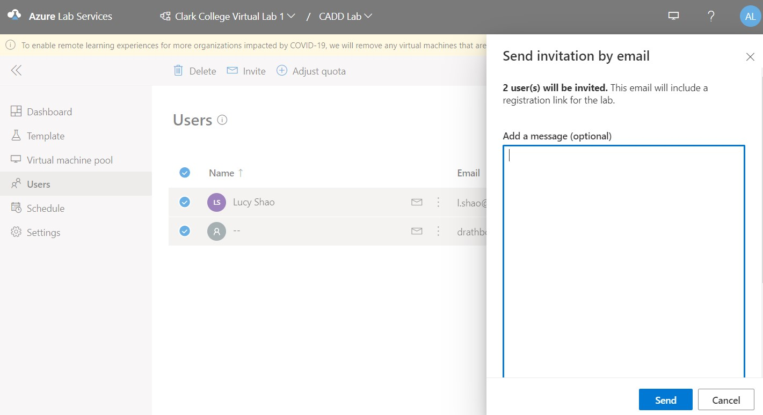

**1**

**2**

* The **“Invitation”** column shows when you sent the invite to your student(s). In the screenshot below, it shows that I have removed the 2nd student before I actually sent out the invitation

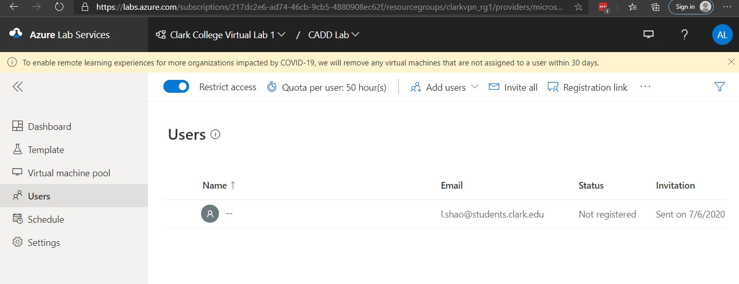

* The **“Status”** column will update automatically from “Not Registered” to “Registered” once the student completes the registration process. Students will also need to set up the Microsoft multifactor authentication

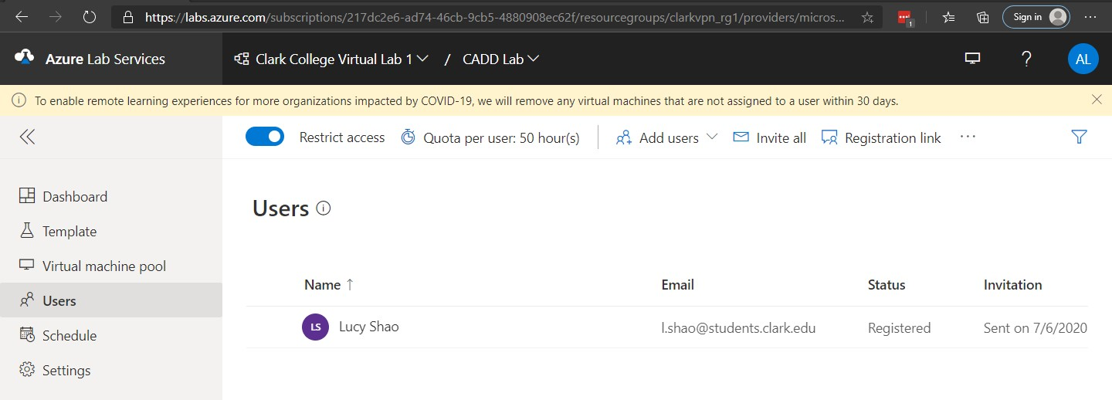

* Click on **Virtual machine pool** allows you to see who has turned on the VM (virtual machine) and who has turned it off. It takes about 4 minutes 11 second to turn on or off

* **Note:** Any spare VM not assigned to a user within 30 days will be automatically removed (this is a default setting from Microsoft to save resources)

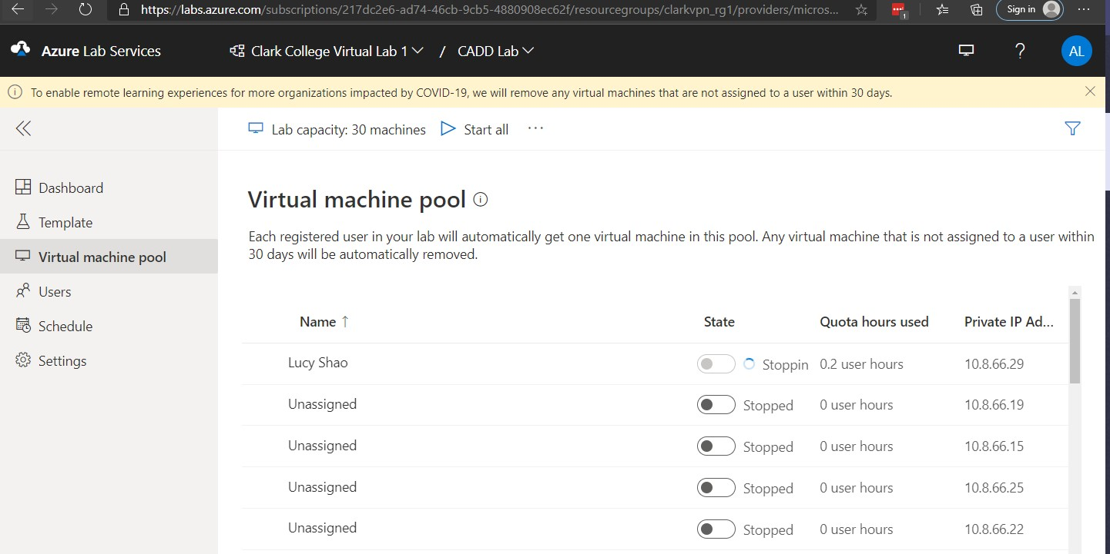

* **Settings** is where IT has pre-set the VMs to auto-shutdown in 15 minutes when users disconnect.

