STEP ONE:  Log into ctcLink.  https://ptprd.ctclink.us  Note: Use only the Google Chrome web browser for best results.  STEP TWO:  From the left-side menu on the home page select the HCM Self-Service module. | 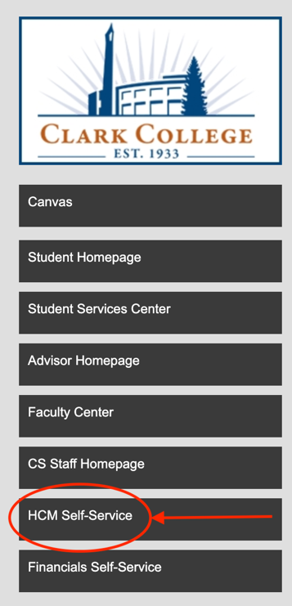
OVERVIEW: | How to report an absence from work. This tutorial applies to all employees.

STEP THREE:  From the Employee Self-Service dashboard select the Time module. | 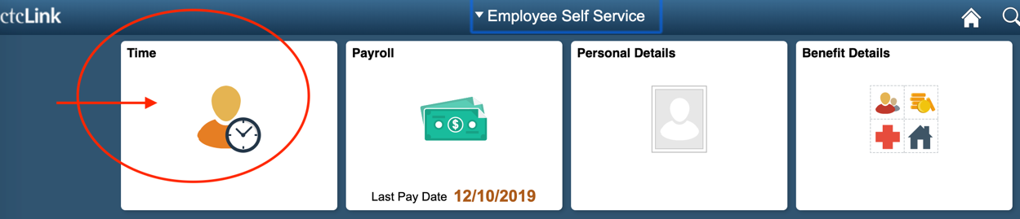

STEP FOUR:  From the Time dashboard select Request Absence. | 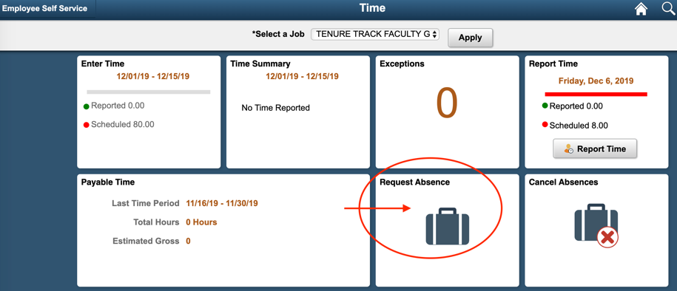

STEP FIVE:  - Select your job title effected by the absence.  - Select reason for absence  - Click the Submit button. | 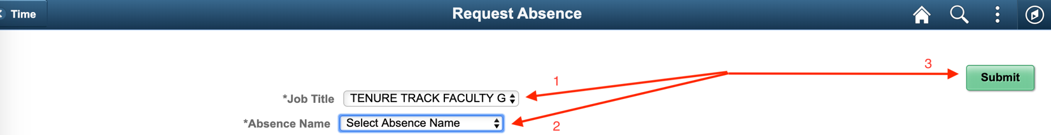
STEP SIX: Complete the form, then click the Submit button. | 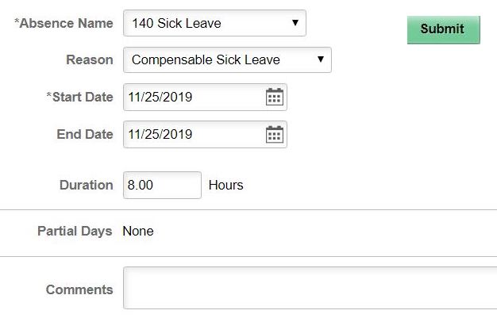
Then click the Yes button. | 

END OF TUTORIAL.

