Community College Presidents’
Scholarship in honor of Val Ogden

Washington State University Vancouver is pleased to announce the WSU Community College Presidents’ Scholarship in honor of Val Ogden Award will be available for the 2017 fall semester. The full-tuition award requires the nominee to register as a full-time student and will be renewable for one additional year as long as the renewal criteria are met.

The award is designed for community college transfer students who have leadership potential, are community-service oriented, and who have an excellent grade point average. With this award, community college students will work side-by-side with world-class faculty who care about student success. They will have many opportunities for leadership roles at WSU Vancouver, which in turn will prepare them for outstanding career opportunities after graduation.

Each community college presidents’ office in Southwest Washington, as well at Portland Community College Cascade Campus and Mt. Hood Community College, has received a packet of information about the award program. Each president is asked to select a student from his/her student body to receive the award, beginning fall semester 2017.

We anticipate that many qualified students will be eligible for this scholarship and that each community college president will be faced with a difficult decision. Our hope is that the presidents will select a well-rounded student who has demonstrated the best of the community college system. The scholarship will be awarded at the commencement ceremony on June 22, 2017 and your attendance is required.

WSU Vancouver welcomes the occasion to partner with presidents of Southwest Washington and Portland community colleges on the Presidents’ Award.

If you have questions about this scholarship or need addition information, please contact April Lappin, Washington State University Vancouver. Her phone number is 360-546-9103, and her email address is april.lappin@vancouver.wsu.edu.

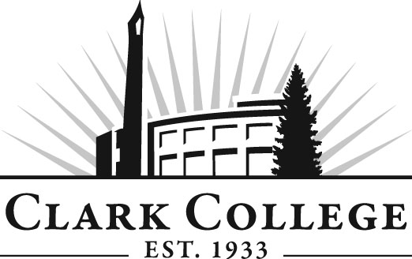 | Clark College  Office of the President, MS BRD 101  1933 Fort Vancouver Way  Vancouver, WA 98663  (360) 992-2101 | Application must be typed or printed legibly.  Page 1 of 3
2017-2018 Community College Presidents’ Scholarship
in honor of Val Ogden Application

Full-time Tuition Waiver for Two Years
DUE DATE: MONDAY, MAY 1, 2017 BY 3:00 P.M.

ELIGIBILITY CRITERIA:  - Planning to complete Clark College Transfer Degree  - Washington State University-Vancouver Transfer Student  (Must be accepted by WSUV 17/18 Academic Year)  - Strong Academic Record  - Unofficial transcripts from Clark College |  |  | - Leadership Capabilities  - Extracurricular and/or community involvement  - Finalists will be required to interview with the President  - The scholarship will be awarded at the commencement ceremony on June 22, 2017 and your attendance is required

REQUIRED INFORMATION:
Name: ____________________________________________________________________________________________________
Student ID Number (NOT your Social Security Number): ____________________________ Date of Birth: _____________________

Address: __________________________________________________________________________________________________

City: ____________________________________________ State: ___________________________ Zip: ____________________

Telephone: ____________________Alternate telephone: _____________________E-Mail: _____________________________

Academic Area of Interest (Major): ___________________________________________________________________________

High School: ___________________________________________________________ Graduation year: ____________________

Cumulative Grade-Point Average: ____________________________________________GPA will be verified with official student record

Will you be walking at the commencement ceremony on June 22, 2017? Yes No

Will you have completed a two-year transfer degree as of June 2017? Yes No

Have you been admitted to WSU Vancouver? Yes No

Please list your extracurricular and community activities during the last three years, including summers, in order of their interest to you. (Examples: student government, drama, athletics, debate, music, 4-H Club, church groups, Red Cross etc.) Include only those activities in which you have participated for at least one-half of the school year.
Activity | Position Held

 | Clark College  Office of the President, MS BRD 101  1933 Fort Vancouver Way  Vancouver, WA 98663  (360) 992-2101 | Community College Presidents’ Scholarship Application  Page 2 of 2

SUPPLEMENTAL QUESTIONS:

Please use a separate sheet of paper to answer questions 1 – 3. Type or write your answers clearly and legibly. Answers should be brief (150-200 words per question), but complete.

Question #1
Please describe your contribution to the Clark County community.

Question #2
Please describe your involvement in Clark College activities.

Question #3
Why is higher education important to you?

LETTERS OF RECOMMENDATION:

Please enclose two letters of recommendation: One letter from a teacher or instructor at Clark College and one letter from a personal reference. No more than two letters will be accepted.

TRANSCRIPTS:

Please enclose Clark College unofficial transcripts.

SUBMISSION GUIDELINES:

Deadline
The deadline for submission is MONDAY, MAY 1, 2017 by 3:00 P.M. Applications will not be accepted after this deadline. Applicants should note that it is their responsibility to ensure that all portions of their application are received in a timely fashion. The Office of the President is not responsible for applications lost or misdirected in the postal system.

Application Materials
Please deliver all application materials (Application, Supplemental Questions, Letters of Recommendation and transcripts) to:

Community College Presidents’ Scholarship Committee
Clark College
C/O Julie Taylor
1933 Fort Vancouver Way, MS BRD 101
Vancouver, WA 98663

I certify that the information provided by me for the Presidential Scholarship Application is true, correct and complete. I give permission for Clark officials to check my academic records for purposes of this scholarship competition.

Signature: _______________________________________________________ Date: ___________________________________
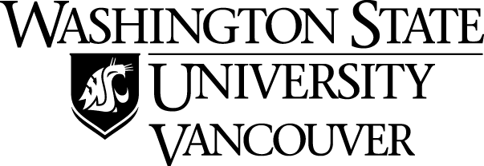

WASHINGTON STATE UNIVERSITY VANCOUVER -
COMMUNITY COLLEGE PRESIDENTS’ SCHOLARSHIP IN HONOR OF VAL OGDEN

NOMINATION FORM
(To be completed and signed by both the President and nominated student.)

Nominee:

Full Name – First Middle Initial Last

Address City, State Zip code

Phone E-mail GPA Quarter Credits Completed

Clark College Robert Knight
Community College President’s Name
1933 Fort Vancouver Way____ Vancouver, WA 98663-9286
Address City, State Zip code
360-992-2101 rknight@clark.edu
Phone Number President E-mail

By signature on this nomination form, we submit the above student as a Washington State University Vancouver Community College Presidents’ Scholarship in honor of Val Ogden nominee. In so doing, we acknowledge that the community college has notified the student of his/her nomination based on the award criteria.

Signature of Nominee Date

Return with President’s Nomination Letter & Form by 3:00 P.M. on
MONDAY, MAY 1, 2017. APPLICATIONS WILL NOT BE ACCEPTED AFTER THIS DEADLINE.

WASHINGTON STATE UNIVERSITY -
COMMUNITY COLLEGE PRESIDENTS’ SCHOLARSHIP IN HONOR OF VAL OGDEN

NEWS RELEASE AUTHORIZATION FORM

NOMINATED STUDENT: _________________________________________________________________

Full Name – First Middle Initial Last

__________________________________________________________________________________________
High School attended HS Graduation year

Mother’s full name Address City, State Zip code

Father’s full name Address City, State Zip code

I authorize Washington State University and Clark College to release any of the above listed information to the media.

(Signature of Nominated Student) (Date)

Return with President’s Nomination Letter & Form by 3:00 P.M. on
MONDAY, MAY 1, 2017. APPLICATIONS WILL NOT BE ACCEPTED AFTER THIS DEADLINE.

