**It PAYS to be Financially Educated**

The first 50 Clark Students to complete the following **3** tasks will receive a $25 gift card to the bookstore!

* Attend **ONE** of the following Financial Student Success Workshops offered this year.

- Better Banking   
- Conquer Credit   
- Destroy Debt  
- Financing Your Dreams

- Free Tax Prep

- Money Saving Strategies

- Smarter Money Management

* Create an account with SALT and complete the SALT Budgeting Workshop found at https://www.saltmoney.org under the My Money 101 tab.

Bring certificate of completion to the financial literacy coach during your third task.

*If you have difficulty accessing this course scroll to the bottom of the page or call

855.469.2724.

* Bring or create your own personal budget to be reviewed with the campus financial literacy coach in the Career Center, PUB 002.

(Students may use pen and paper, an excel spreadsheet, mint.com, or the budgeting software of their choice to complete this task)

Official Rules  
- Student must be registered for at least 3 credits to participate

- Contest will start January 1, 2017 and ends the final day of Fall Quarter 2017

- Budgeting worksheets completed during the College 101 curriculum will be eligible for submission

- Students who attend Financing Your Dreams as part College 101 curriculum will need to attend a different workshop as well in order to qualify.

- Bookstore cards will be dispersed to the first 50 students who complete all three tasks and meet the requirements listed above.

- Bookstore card recipients from 2016 promotion are ineligible.

**How to Access the Salt Budgeting Class**

Go to [www.saltmoney.org](http://www.saltmoney.org) and enter your login information.

If you do not already have an account click “Sign Up” at the top right corner of the page. Don’t worry, it’s free!

When entering your information be sure to select “Clark College” from the drop down menu under school. *Don’t skip this step or it won’t allow you to access the course

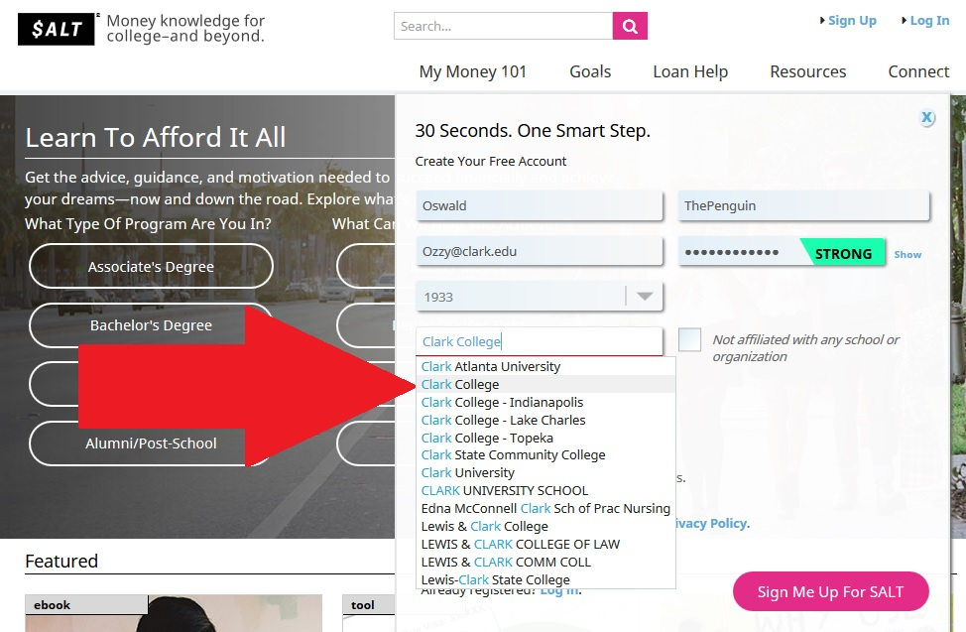

Once you are logged in **hover** over the “My Money 101” tab and click **“Go To My Money 101”**

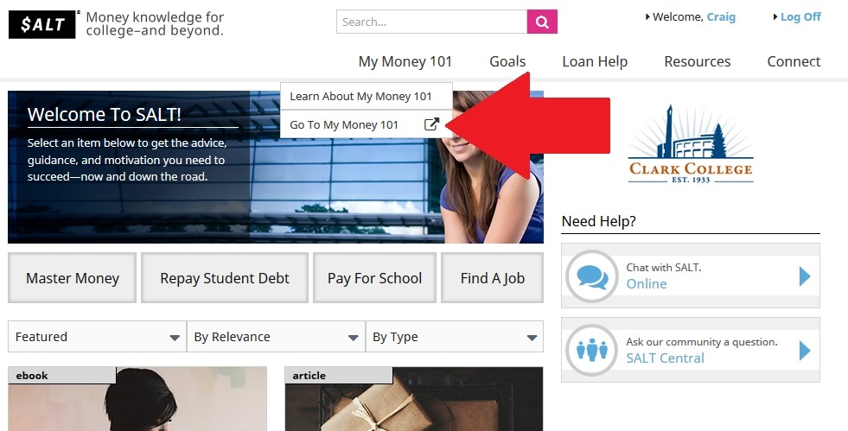

From the My Money 101 page, scroll down and click on the **“Budgeting”** link.

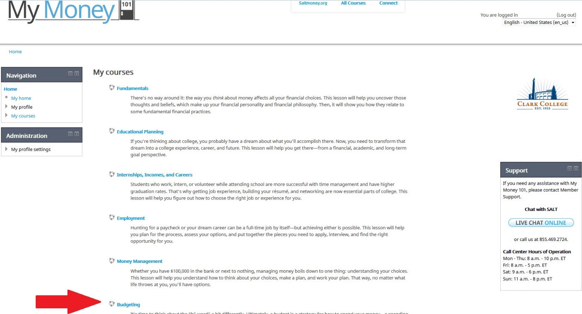

To start the course click **“Budgeting Lesson.”** Upon completion of the course click **“Budgeting Certificate”** and print your certificate or email it to [cebersole@clark.edu](mailto:cebersole@clark.edu)

