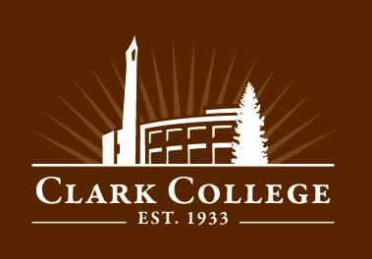

**Attend and Win!**

Attend 3 or more Career Days workshops or events for your chance to win great prizes!

**iPad Mini, Fitbit, and many more!**

**CAREER DAYS 2015**

**April 27–29**

**www.clark.edu/cc/careerdays 360-992-2902**

**All events are free to students and members of the community. No registration is required.**

**Monday, April 27**

**10:00 – 1:00 p.m. College Transfer Fair Gaiser Student Center**

If a bachelor’s degree is in your future, drop by the Spring Transfer Fair and visit with representatives from Northwest colleges and universities. Get all your questions about admissions, financial aid, and academic programs answered!

**NEW! 10:00 – 11:30 a.m. STEM Careers Speaker Panel GHL 213**

Learn from working professionals about Science, Technology, Engineering & Math degree related career paths

**11:45 – 12:45 p.m. LinkedIn & the Online Job Search Jessica Collins, First Tech Credit Union GHL 213**

Land a job using social media: a recruiter’s perspective

**1:15 – 2:45 p.m. Choosing a Career Carole Mackewich, Clark Counselor GHL 213**

Take a career assessment that will generate many possible good-fit occupations

**3:00 – 4:00 p.m. College Transfer Do’s and Don’ts Clark Alumni Panel GHL 213**

Hear from former students about their transfer experience and get tips on how to prepare for your transfer

**Tuesday, April 28**

**9:00 – 11:30 a.m. Drop-in Resume & LinkedIn Clinic Career Services, PUB 002**

Bring your resume for a personalized critique, or develop a new resume. Work on your LinkedIn profile

**12:00 – 1:00 p.m. Speed Dating for Jobs! Gary Coleman, Portland Community College GHL 213**

With most employers Googling you, applicant tracking systems eliminating 80% of you, resumes being read in only 6 seconds, and quick video interviews - you must learn the new ways to get work in 2015 and beyond

**NEW! 1:30 – 3:00 p.m. Succeeding at your Job! Employer Speaker Panel GHL 213**

Professionals share what traits employers are looking for in their employees

**Wednesday, April 29**

**11:00 – 3:00 p.m. CAREER DAYS JOB FAIR Gaiser Student Center**

Connect personally with local employers.  Recruiters from a variety of industries will be on hand with job openings, career information and tips on applying with their companies. Dress in your interview best!

**11:00 – 3:00 p.m. HEALTH CAREERS JOB FAIR PUB 161**

Recruiters from a variety of health organizations will be available to discuss job openings, career information and hiring tips

**11:00 – 1:00 p.m. LinkedIn Photo Booth Gaiser Student Center Stage**

Have your professional photo taken ***FREE*** for your profile!

**NEW! 3:00 – 4:30 p.m. Human Library: Borrow an Expert PUB 258 B & C**

Hosted by the Alumni Association in collaboration with the Clark College Libraries

Students can ‘check out’ community professionals/alumni for a 15-minute conversation

*If you need accommodations to fully participate in these events, contact Disability Support Services at (360) 992-2314 or* (360) 991-0901 *VP, or visit Penguin Union Bldg, room 013 by April 15, 2015.*