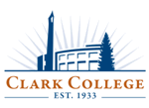**CLARK COLLEGE**

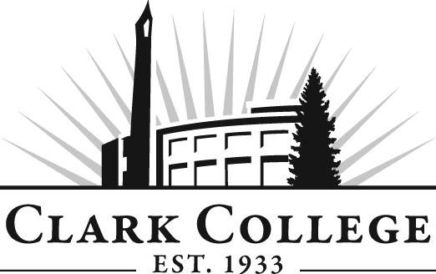

 **CAREER SERVICES**

Thank you for thinking of Clark College; we appreciate your job postings!

**Job/Internship Posting Guidelines**

* Jobs must pay a guaranteed hourly wage or salary that is at least $9.32 per hour (WA state minimum wage guidelines). If a job pays a base salary plus a commission, Career Services will evaluate the criteria for earning the commission before approving the job.
* Employers are required to have a current business license to post a job or internship with us.
* We do not accept the following jobs and internships:
  + Multi-level marketing opportunities
  + Commission-only jobs
  + Home based businesses
  + Opportunities that require any equipment or products to be purchased by the prospective employee in order to earn their wage. This is true prior to being hired, after the employment offer and after employment has commenced.
  + Opportunities that charge for any training that is required prior to employment (Required training must pay an hourly wage to the prospective employee).
* We require that you:   
   Provide a safe environment for your employees.  
   Are an Equal Opportunity Employer.  
   Comply with the Americans with Disabilities Act.
* Right of Refusal: We reserve the right to refuse service if an organization has any unresolved investigations, complaints filed with the Better Business Bureau, or for any reason as determined by Career Services.

For questions, contact the [Employer Relations Specialist](mailto:blisenbee@clark.edu) or call (360) 992-2964.

**Clark College**

**Career Services**

**PUB 002**