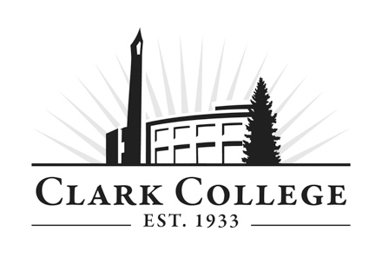

Privacy Guidelines for Parents

The Family Educational Rights and Privacy Act (FERPA) is a federal law that any educational institution administered by the U.S. Secretary of Education must follow. This act is about protecting student privacy by not releasing grades or other personal information to anyone but the student.

Under FERPA, instructors cannot communicate with anyone but the student about the student’s course work or grades. This is a federal law to which Clark College must legally adhere. It does not matter if the student is a minor and a Running Start student; all students taking college courses are considered adults and FERPA applies to all.

Parents cannot schedule conferences with the instructor, file a grade appeal on a student’s behalf, or communicate details about a grade appeal or complaint. The student is responsible for all communication regarding course work, grades, and appeals or complaints.

Here are some important guidelines to keep in mind about FERPA and instructor-parent communication:

- Instructors and other college staff cannot communicate with parents about a student’s educational records in person, via email, or by phone.
- Grade appeals and student complaints must be handled by the student and communicated by the student to the instructor, department chair, or dean.
- Parents should not come to the instructor’s classroom or office in hopes of discussing a student’s work

For more information on FERPA, visit the Clark College website at the following link: http://www.clark.edu/clark-and-community/about/policies-procedures/consumer_information/ferpa/index.php\

