# Flex Plan Guide

Log in to DAC Faculty Portal Page: <https://teton.accessiblelearning.com/Clark/Instructor>

**The Faculty Portal uses Single Sign On.** Your username is the same as your full Clark email address. Example: Someone with the email address OPenguin@clark.edu. Your password is the same as your Clark Email password.

1. Review ‘Access Policy’ and select the ‘Continue to View Student Accommodations’ button

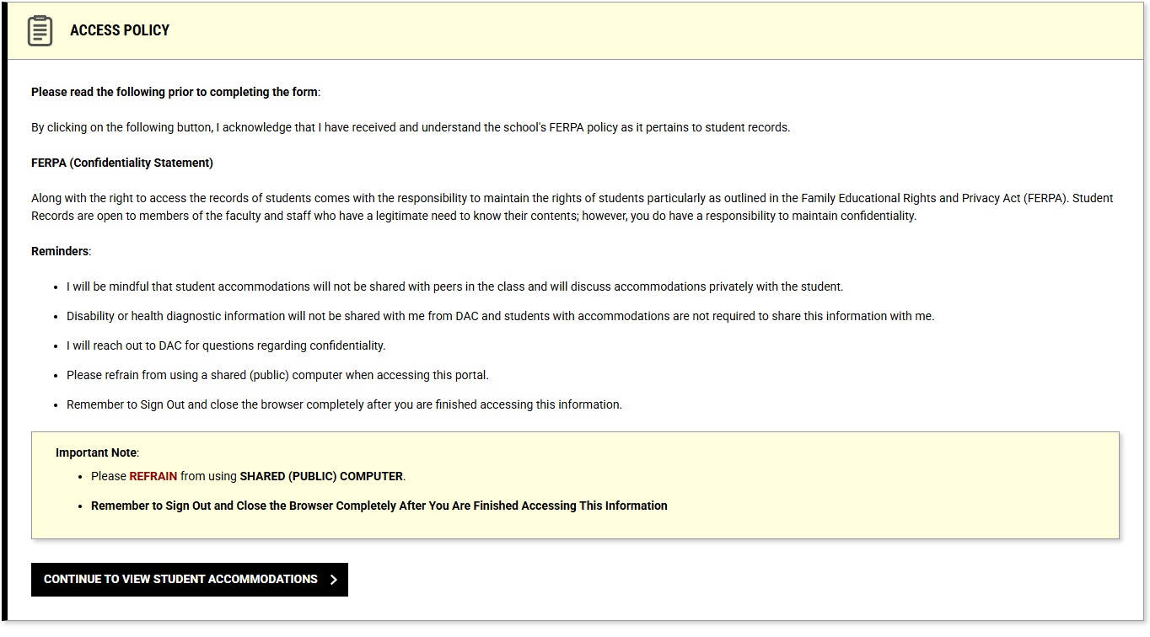

1. Select the ‘Flex Plan’ link under the ‘Home’ tab (to the left of the main portion of the screen) to navigate to your class’s Flex Plan page.

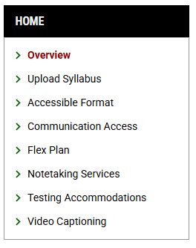

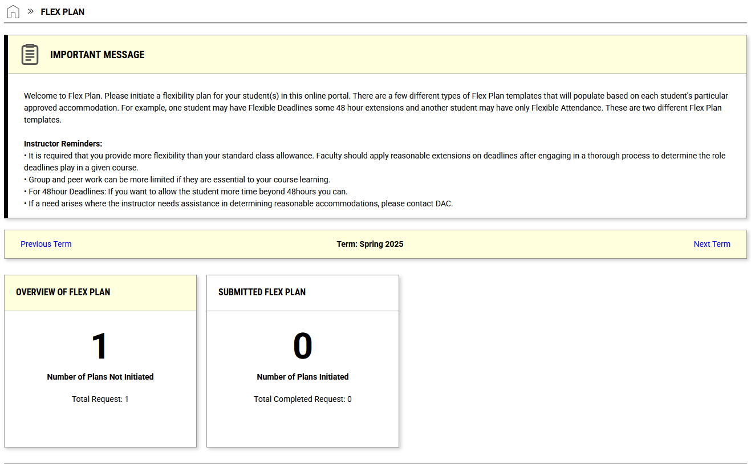

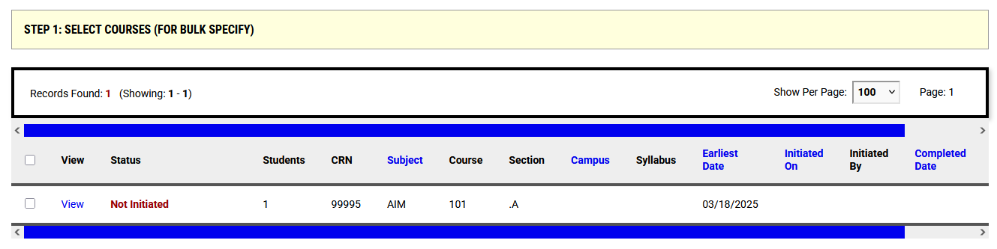

1. Select check box for specific course under ‘Step 1: Select Courses’
2. Then select ‘Specify Flex Plan for Multiple Courses’ button under ‘Step 2: Select Available Options’

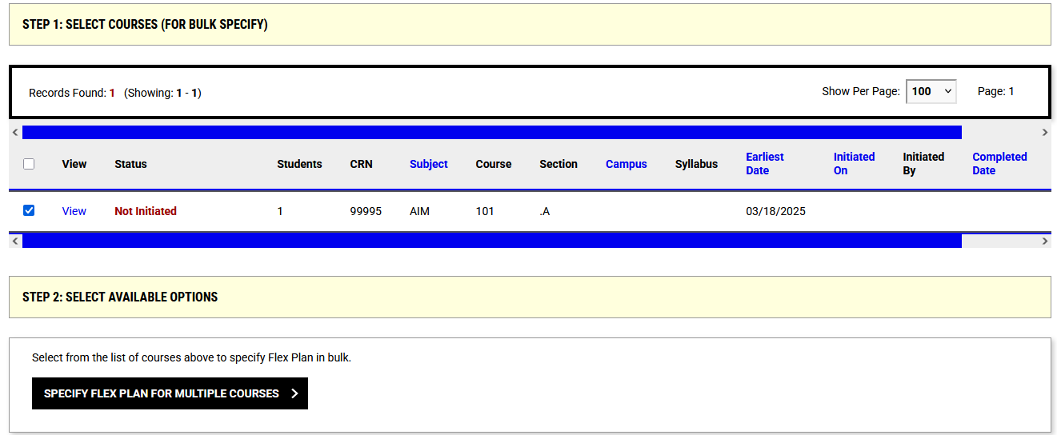

1. Fill in information on the ‘List of Questions’ to complete agreement. Then select ‘Submit Flex Plan’ button.

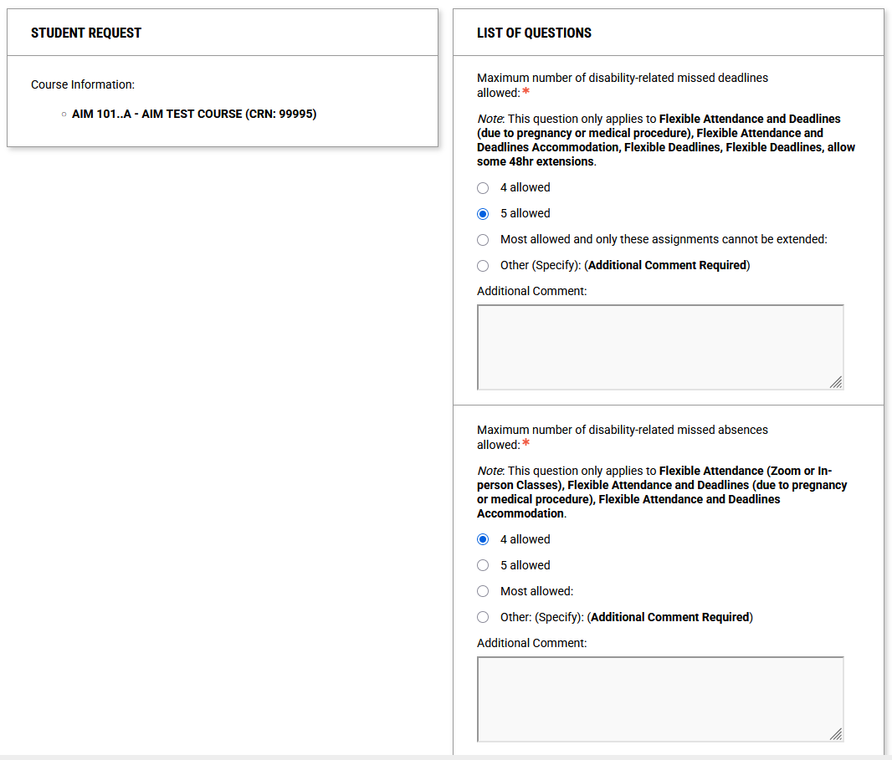

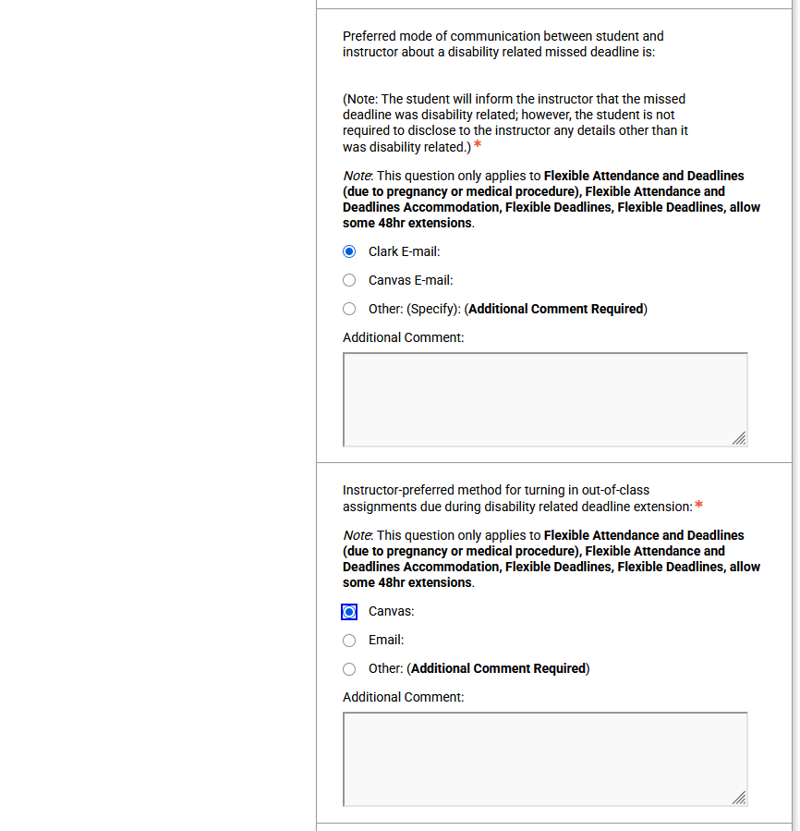

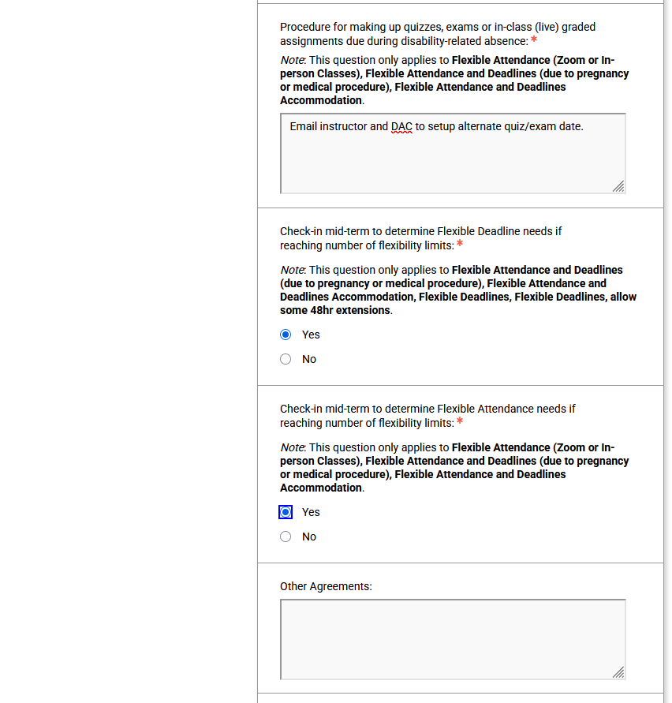

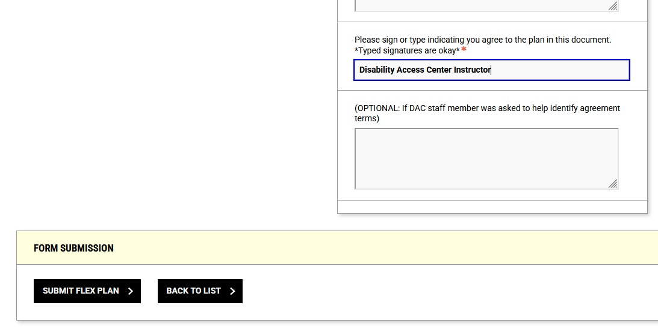

Success! Your flex plan has been completed.

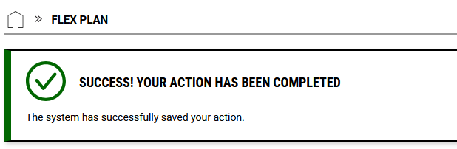

Now, you can review your flex plan at any time. The flex plan homepage will show that your agreement has been completed

