# **How to Request to Schedule Alternative Testing**

Students: It is your responsibility, NOT the professor’s, to schedule your tests with the DSS Office at least **five school days in advance** or as soon as you are notified. If advance notice is NOT provided, you may have to take the test in class without academic adjustments. Scheduling an exam with less than two business days may not be able to be arranged. Exceptions will only be made in the event that an instructor makes testing scheduling changes without advanced notice. Students now request online through myDSS.

1. Log into myDSS

Go to [www.clark.edu/dss](http://www.clark.edu/dss) and click on **myDSS Login**

Or visit: <https://teton.accessiblelearning.com/Clark/>

1. On the left sidebar, expand the “My Accommodations” tab and then select Alternative Testing.

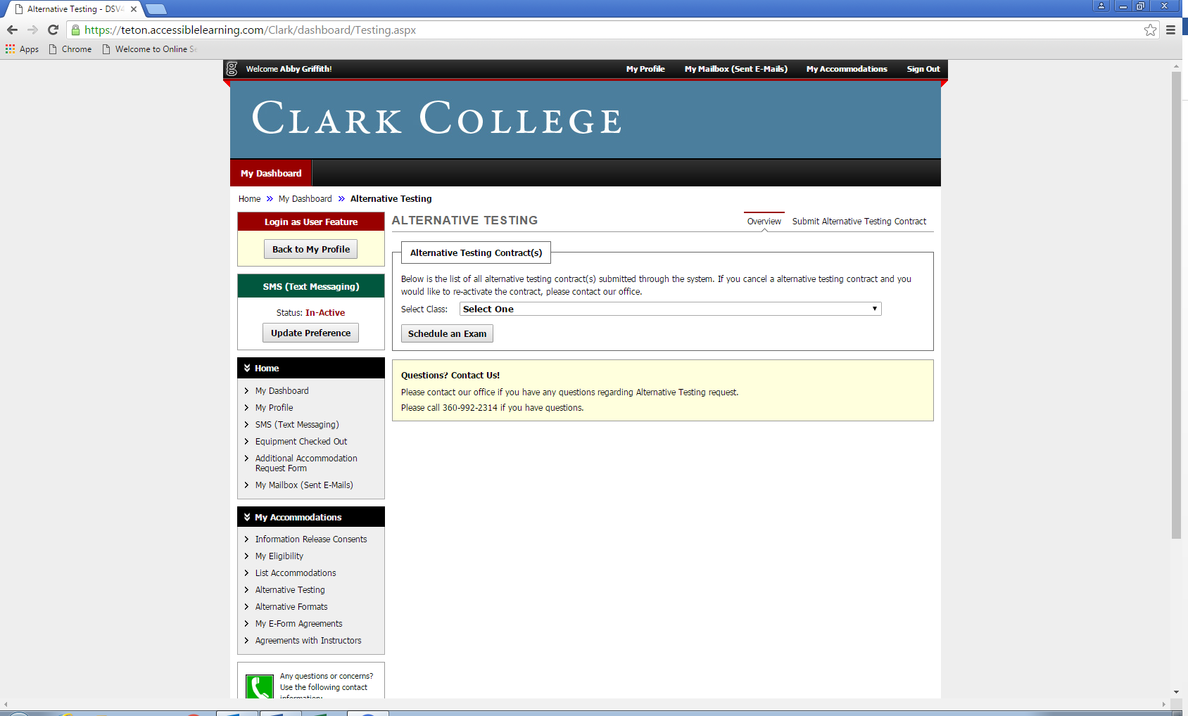

3. Select your class from the dropdown menu, and then click on the Schedule an Exam button.

If it says “No Alternative Testing Contract Specified” next to your class, your instructor has not filled out a contract. **You can still schedule an exam**, but your instructor must fill out the contract before you take the exam. Please still schedule your exam.



Fill out the Exam Detail.

Make sure to select only the accommodations you will need for the exam.

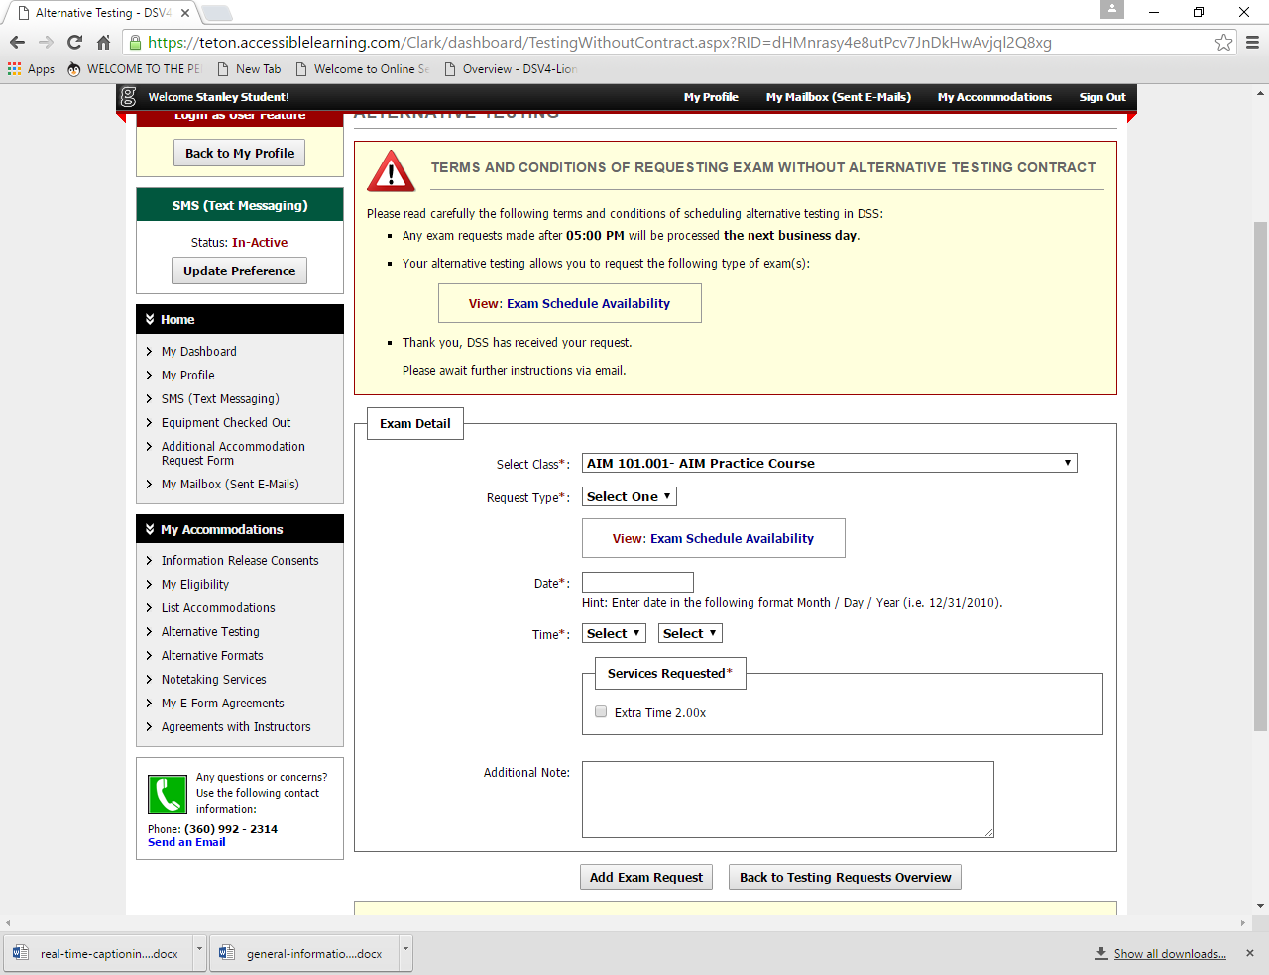

Once you have filled out all of the information, click “Add Exam Request”. You will be notified via email when your request is approved or if you need to reschedule.

If you need to cancel a scheduled exam, or if you need to reschedule, go to the Alternative Testing section. If you need to reschedule an exam, select “Modify Request” and update the information. If you need to cancel the exam, select “Cancel Request” and then “Confirm Cancellation” on the next page.

Reminder: Please be sure to review the complete Alternate Testing Policy listed on our website under “Responsibilities for Students”.