HOME PAGE

**Clark College Disability Support Services**

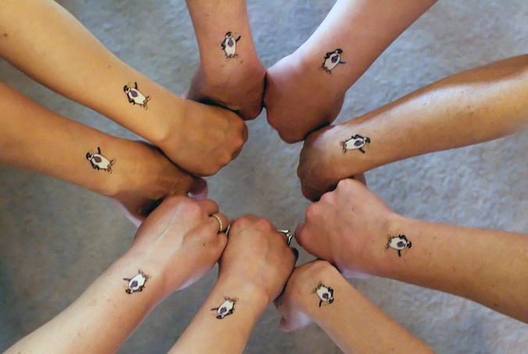

**Thank you for taking the time to complete this required Policies and Procedures process.  Please click "Modules" in the menu to the left of this window to begin.**

**Office Hours: [Remember to change for summer hours!]**

Monday - Thursday: 7:30 AM - 5:00 PM

Friday: 7:30 AM - 2:00 PM

**Location**:

Gaiser Hall Room 137

**Phone:**

(360) 992.2314 (office)

(360) 991.0901 (VP)

(360) 992.2879 (fax)

**Mailing Address:**

1933 Fort Vancouver Way

GHL 137

Vancouver, WA 98663-3598

**Website**: [DSS Home Page](http://www.clark.edu/student_services/disability_support.php)

**Twitter**: [@ClarkAccess](https://twitter.com/ClarkAccess) (Follow us for alerts about elevator outages, construction projects, and other issues affecting mobility and accessibility at Clark.)