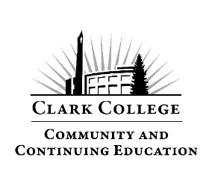

**Community Education Summer 2025**

**Instructor**: Terri Nystrom:

**Course Description:**

Whether it its your first time to line dancing or you are feeling a little rusty, learn hitches, grapevines, half-turns, scuffs, cha-cha steps, brushes and stomps are steps included in multiple dances. Dance steps are broken down and learned through repetition. No partner needed. Absolutely no experience necessary.

**Learning Outcomes:**

As a result of taking this course, students will:

* Learn a variety of dance steps found in various line dances.
* Become more confident on the dance floor through repetition.
* Ultimately able to dance without instruction.

**Summer Course Schedule:**

**Week 1: July 24 –** We will start off with a 10-step circle dance with heels, hooks and shuffles. “Copperhead Road” and “Power Jam” dances include a box step.

**Week 2: July 31** – We will review all 3 dances previously taught, then work on our 6/4 count. The Trail” danced to “Train of Tears”. Hopefully there will be no tears involved!

**Week 3: August 7** – After we cover all previous dances we will work on “Wild Wild West”, this dance has triple steps, grapevines and a ½ turn – and it’s quick!

**Week 4: August 14** – We will cover all dances and polish moves if needed.

**Selected Bibliography/Resources:**

**Class Evaluation**: Class evaluations are sent by email. Sometimes the email will be delivered to your “junk mail,” but we can assure you it’s from Clark College only. Your responses are completely anonymous. If you do not see your evaluation immediately after class, look in your junk mail and send it to your email address. If you do not receive an evaluation, please email [Continuingeducation@clark.edu](mailto:Continuingeducation@clark.edu) or call 360.992.2939.

**Inclement Weather:**

If the College cancels due to icy conditions, you can find this on the college website [www.clark.edu](http://www.clark.edu). If Community Education concludes that the weather is too hazardous, we may also decide to cancel this class. In that case you will receive both a phone call and email. Make certain that we have your correct contact information by viewing the class roster.

**Looking for classes? Visit our Community Education webpage:** www.clark.edu/cce/