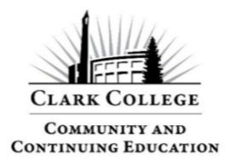
Community Education – Fall Quarter 2025
Course Title: Geology of Columbia River and Glacial Floods
Instructor: Prof. Kyle Dittmer
Email: kdittmer@clark.edu

Course Details
- Item # 45003
- Fee $49.00
- Room 338, Columbia Tech Center Campus, 18700 SE Mill Plain Blvd., Vancouver
- Wednesdays, October 1 & 8th, 1:30pm to 3:30pm

Course Description
Learn about the geologic forces that shaped the “land of fire and ice” – the scenic beauty of the Columbia River Gorge (CRG). The Pacific Northwest underwent a violent volcanic beginning only to be tamed by Ice Age glacial floods. After an overview of volcanic and glacial geology, the development of the Gorge will be explained and illustrated.

Learning Outcomes
By the end of this course, students will:
- Learn about the geology of Plate Tectonics and volcanoes (especially in the PNW)
- Learn about the geologic history of the Gorge and the Columbia River Basalt lava flows
- Learn about the science of Glaciers and how they can dramatically transform the landscape
- Learn how a glacial lake dam can form and break – helping to form CRG cliffs and waterfalls
- Learn about ways to visit the CRG to see the signs of volcanic action and glacial floods

Course Schedule
Week 1
Overview of Plate Tectonic Theory; Volcanic Geology (rocks and landforms); Geologic History of the Columbia River Gorge.
Week 2
Overview of Glacial Geology; Geologic History of the Lake Missoula Floods in the Gorge and Vancouver/Portland. Film (2005): How A Glacial Lake Caused A Cataclysmic Megaflood.
Optional weekend (half-day) field trip: Chanticleer Point and Crown Point Vista House.
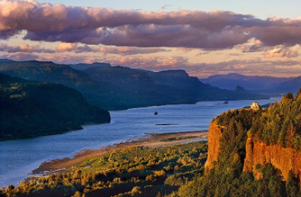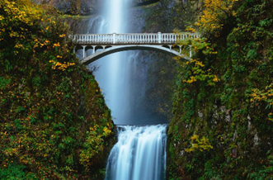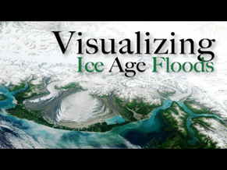

Resources
Recommended references for further study:
- https://volcanoes.usgs.gov/observatories/cvo/Historical/LewisClark/Info/summary_columbia_plateau.shtml

Class Evaluation
- Class evaluations are sent by email.
- If you don’t see it right away, check your junk/spam folder.
- Evaluations are anonymous and come directly from Clark College.
- If you don’t receive one, contact:
  - Email: continuingeducation@clark.edu
  - Phone: 360-992-2939

Inclement Weather
- If the college closes due to weather, updates will appear at www.clark.edu
- Community Education may also cancel classes independently if travel is unsafe.
- If canceled, you will be notified by both phone and email.
- Please check that your contact information is correct on the class roster.

More Classes
Looking for more Community Education courses? Visit: www.clark.edu/cce/

