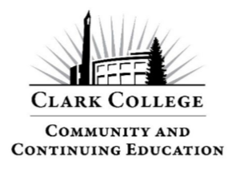
Community Education – Winter Quarter
Course Title: Barre Fusion
Instructor: Erika Levy
Email: erikalevy1977@gmail.com

Course Details

Dates: 1/10/26 - 3/7/26 (No Class 1/17 & 1/24)
Time: Saturday 10:00am

Course Description
Barre Fusion blends ballet-inspired movement with the strength and mobility of yoga, Pilates, and functional training for a dynamic, full-body workout. Set to energizing music, this low-impact, high-joy class builds balance, posture, flexibility, and muscular endurance. Using props like light weights, bands, gliders, and balls, you’ll challenge your muscles in new ways and leave feeling strong, aligned, and uplifted.
Yoga mats and props are available if needed. Please bring a water bottle to stay hydrated during class.

Learning Outcomes
By the end of this course, students will:
- Build strength and stability through safe, low-impact functional training.
- Improve mobility, flexibility, and body awareness to support daily movement.
- Increase muscular endurance for greater stamina and resilience.
- Leave class feeling uplifted, connected, and confident.

Class Evaluation
- Class evaluations are sent by email.
- If you don’t see it right away, check your junk/spam folder.
- Evaluations are anonymous and come directly from Clark College.
- If you don’t receive one, contact:
  - Email: continuingeducation@clark.edu
  - Phone: 360-992-2939

Inclement Weather
- If the college closes due to weather, updates will appear at www.clark.edu
- Community Education may also cancel classes independently if travel is unsafe.
- If canceled, you will be notified by both phone and email.
- Please check that your contact information is correct on the class roster.

More Classes
Looking for more Community Education courses? Visit: www.clark.edu/cce/

