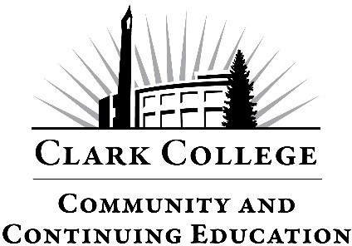

Request for Proctoring Services

**Proctoring fee:** $100 per 2-hour session,

$35 per additional hour; Checks or Credit Cards (VISA, Master Card & Discover) accepted, NO CASH.   
Payment is required prior to testing.

**What to Bring:  
  
Picture ID** will be required (e.g., student ID, driver’s license, passport, military ID).

**Materials permitted** to use on exam (e.g., calculator, notes, etc.)

**Location:** 18700 SE Mill Plain Blvd. Vancouver, WA 98683

Office 360-992-2939

[Continuingeducation@clark.edu](mailto:Continuingeducation@clark.edu)

Requests for proctoring services must be submitted to the CCE Testing Center either by email or in person. Upon receiving the completed form, you will be notified within 1-2 business days whether your request is accepted or denied. Please ensure that this request form is submitted at least 2 weeks prior to the test date.

ALL paper exams must be either emailed to the email listed above or mailed to:

*Clark College, CCE CTC 133*

*18700 SE Mill Plain Blvd. Vancouver, WA 98663*

# Please complete the following:

|  |
| --- |
| Name: |
| Phone: |
| Email: |

# Test Information:

|  |  |  |  |  |  |  |
| --- | --- | --- | --- | --- | --- | --- |
| Exam  Title |  | Time  Allotted |  | Exam  Type: | Paper | Online |

Requested Test Date/Times (list by preference specific days and times ):

|  |  |  |
| --- | --- | --- |
| Date: |  | Time: |
| Date: |  | Time: |
| Date: |  | Time: |

|  |
| --- |
|  |
|  |
|  |

List Materials Permitted (be specific):

Please list any additional testing information or instructions below:

**Note:** Clark College reserves the right to refuse any proctoring services. A proctor will contact you to make any necessary changes or arrangements according to your situation.