How to add an .srt file to a YouTube video:

Step One
Sign into your YouTube account, navigate to the top-right menu and select YouTube Studio.

Step Two
From the left-hand menu select Videos. Click the video to which you are adding captions. This will lead you to the Details page.
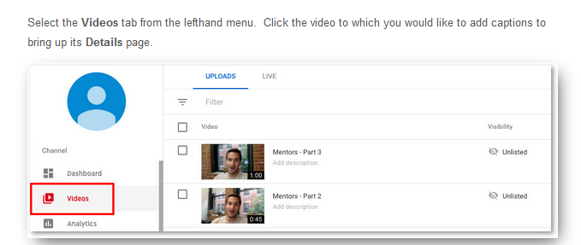

Step three
From the Details page, navigate to the center tab titled Advanced. Midway down the page, set the Original video language, subtitles, and CC to English (United States.)
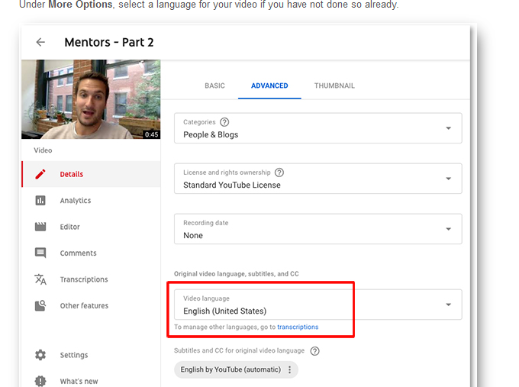

Step Four
Navigate to the bottom of this page and select “upload subtitles/cc”. Then select With timing and select Continue. Navigate to the .srt file you need when prompted. Select Save.
