Congratulations Biggest Loser Participants!

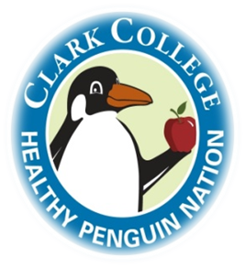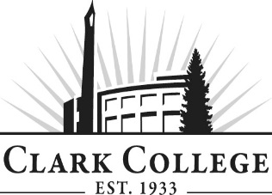

This year, Biggest Loser participants lost a combined total of 104.5 pounds of fat (see yellow gunk) and gained 48 pounds of healthy muscle (see healthy red stuff)!

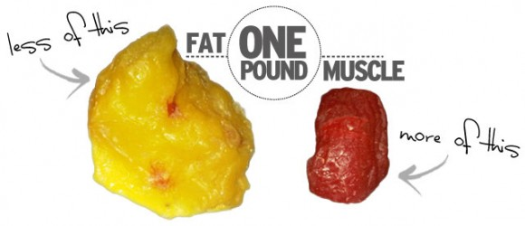

Congratulations to all who participated this year. We hope that you learned a lot about living a healthy lifestyle and are taking steps toward living it out. Don’t forget to utilize your trainers as resources going forward. You can set up training appointments with them through the Thompson Fitness Center to help you reach your next fitness goals.