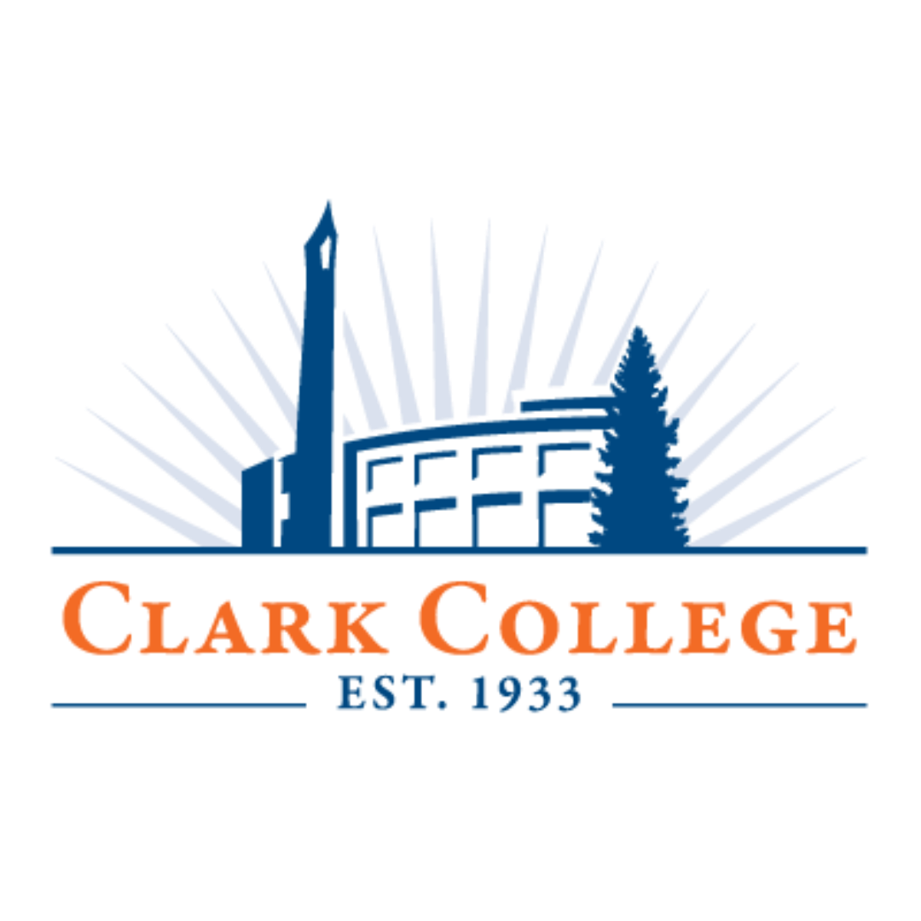

Clark College Club Social Media Guidelines
Last Updated July 2026

Table of Contents
How to Set Up a Club Social Media Account at Clark 3
Security Tips 4
Accessibility on Social Media 5
Key Accessibility Practices 5
Need Help? 5
Threats on Social Media 6
Revocation of Social Media 7
Questions? 7

How to Set Up a Club Social Media Account at Clark
Social media platforms change frequently, and we ask that you work closely with us to ensure the account is set up with best practices for security purposes.
Step 1: Any new social networking presence must be approved by the club’s advisor. This approval should be forwarded to Student Life.
Step 2: After receiving approval, the club representative can create the account. Please adhere to these requirements:
- The email used to create the account needs to be an email the club advisor has access to—this means you should use a general club email (ex: clubgoodclub@gmail.com)
- Ensure your advisor has a copy of the login information (username and password).
- Put this disclaimer in the account bio: "This account is student-run and not affiliated with, endorsed, or managed by Clark College or ASCC."
Step 3: Submit the ASCC Club Social Media Information Form. This will officially register your club account.
- This form must be submitted by each new club representative to keep your club account active.

Security Tips
The purpose of these tips is to prevent hackers from accessing your account, to prevent your organization from accidentally being locked out of the account, and to allow Student Life to act as a backup administrator if needed.
- The account should be created with an email address that multiple people have access to, such as your club’s centralized email address.
- Choose the above email as your method for multi-factor authentication.
- Create a complex password with at least 14 characters and a mix of numbers, letters, and special characters.
- Keep the credentials on file with Student Life.
- Give the credentials to your club advisor.
- When someone with the credentials leaves your club, change the password and update Student Life with the new credentials.

Accessibility on Social Media
It’s a high priority to ensure all members of the Clark community can access social media content.

Key Accessibility Practices
The most important long-standing practices include:
- Always include image descriptions using the alt text feature.
- Always include captions on videos with speech.
- Don’t use orange for text—only as an accent color.

Need Help?
Sprout Social maintains a great guide.
The Accessible Social Checklist is a great reference to add to your workflow.
You can always reach out to Carly Rae Zent (czent@clark.edu) for any questions or additional training.

Threats on Social Media
Take every threat posted on social media seriously, even if you suspect it may be a joke. The procedure for handling threats made on social media are as follows:
Step 1: If you feel that a message on social media poses an immediate threat to someone’s safety, please call 911 before moving on to Step 2.
Step 2: If you feel that a message on social media requires immediate action on the part of the college, please report the threat via email to the following people:
- Christopher Layfield, Director of Security & Safety, CLayfield@clark.edu
- Damon Grady, Campus Security Lieutenant, dgrady@clark.edu
Include as much information as you can in the report.
- Time and date of the threat
- Any context surrounding it
- A direct web link to the threat
- Any personal knowledge you have of the student’s identity (if they are posting under a pseudonym).
Note: Take a screenshot of the post for future reference should the user delete the post.
Step 3: If you feel that a message doesn’t pose immediate danger but includes threatening language or suggests a potential threat, please skip steps 1 and 2 and fill out the online referral form: https://clark-advocate.symplicity.com/public_report/index.php/pid523661.

Revocation of Social Media
Any violation of the above guidelines and procedures may result in the college’s revoking a social media administrator’s access to their account and/or deleting the account entirely.

Questions?
Carly Rae Zent, Digital Media Specialist
360.992-2526 | czent@clark.edu
Sarah Gruhler, M.Ed., Director of Student Life
360.992.2406| sgruhler@clark.edu

