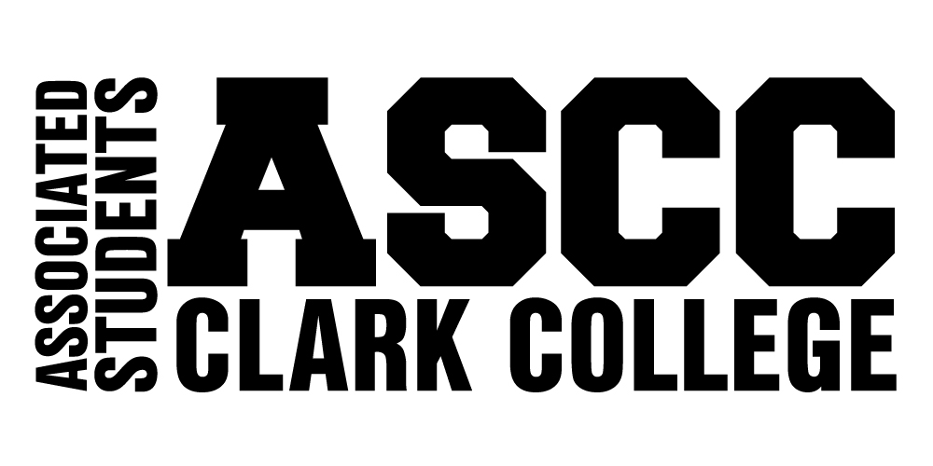

CONSTITUTION

Ratified June 7, 2007

PREAMBLE
We, the students of Clark College, as a self-governing body, affirm and establish this Constitution. In order to promote our educational, cultural, athletic, and social well being, we ensure an equal opportunity for participation and representation. We hereby agree to uphold the ASCC Constitution and Bylaws in their entirety.

Article I – Name
The name of this organization shall be the Associated Students of Clark College (ASCC).

Article II – ASCC Student Government Mission Statement
Section 1 - Statement of Purpose
The ASCC Student Government exists to represent student voice and advocate for student interests.

Section 2 - Mission Statement
The ASCC Student Government will advocate for and represent the students at Clark College by serving as the liaison between students and faculty, staff, administration and the community. By involving students on campus, we will enhance a sense of community, create a sense of belonging and provide opportunities that will benefit the students and the college community through leadership, respect for differences, engagement, and service.

Section 3 - Vision Statement
The ASCC Student Government will be the universally recognized voice of students representing the entire student body as a result of innovative programming, cutting edge leadership training, and dynamic representation. All ASCC students will feel ownership and pride as members of ASCC. They recognize their inclusion in our community and feel empowered to support student success for all.

Section 4 - Guiding Principles
Education, respect for differences, communication, community, leadership, fun, collaboration and integrity.

Article III – Membership
Section 1 - Voting Membership
The voting membership of the ASCC shall consist of all currently enrolled Clark College students.

Section 2 - Honorary Membership
The ASCC Executive Council may bestow the status of honorary membership in the ASCC upon those persons who have made an outstanding contribution to the ASCC and/or the College in general. The alumni of Clark College are honorary members for life. Honorary members do not have voting privileges.

Article IV - Authority and Powers
Section 1 - Power
The ASCC Executive Council is the sole representative governing body for the students of Clark College, operating under the authority of the Board of Trustees, Community College District 14.

Section 2 - Authority
The ASCC Executive Council has the sole authority to administer and enforce the ASCC Constitution and Bylaws.

Section 3 - Responsibility
The ASCC will adhere to the Clark College Policies and Procedures manual, and laws and regulations of the State of Washington, including, but not limited to, the Student Code of Conduct.

Section 4 - Notice of Nondiscrimination and Equal Opportunity
Clark College affirms a commitment to freedom from discrimination for all members of the College community. Clark College expressly prohibits discrimination against any person on the basis of race, color, national origin, sex, age, creed, religion, sexual orientation, gender identity, gender expression, marital status, presence of physical, sensory or mental disability, disabled veteran status, or Vietnam-era veteran status.

The responsibility for, and the protection of, this commitment extends to students, faculty, administration, staff, contractors, and those who develop or participate in College programs. The commitment also encompasses every aspect of employment and every student and community activity.

Article V- ASCC Executive Council
Section 1 - Membership
The Executive Council of the ASCC shall consist of a President, Vice President, Club Coordinator, Finance Director, Activities Director, Public Relations Director, and a non-voting Executive Assistant.

Section 2 – Selection
ASCC Executive Council members shall be selected in accordance with the procedures set forth in the Bylaws.

Section 3 - Authority
The ASCC Executive Council shall have the authority and be responsible for implementing and enacting all matters of legislation.

Section 4 - Responsibilities & Duties
The responsibilities and duties of the ASCC Executive Council shall be specified in the Bylaws.

Section 5 - Terms of Office
A student can hold an ASCC Executive Council position for up to, but no longer than two years. A student cannot hold office if he/she has previously resigned from office, was asked to resign, or has been previously dismissed from the office.

Article VI - Standing Committees
The membership and responsibilities of ASCC standing committees shall be determined in accordance with conditions set forth in the Bylaws.

Section 1 - Services & Activities Fee Committee
The Services & Activities Fee Committee shall be the committee responsible for making budgetary recommendations to the Board of Trustees.

Section 2 - Club Committee
The Club Committee shall be a forum for clubs to maintain a working relationship amongst themselves, the campus, and the community.

Section 3 - Appointments Committee
The Appointments Committee shall assist the Vice President with ASCC officer selection.

Section 4 - Technology Fee Committee
The Technology Fee Committee shall establish and administer the quarterly Technology Fee Budget.

Article VII- Adhoc Committees
The membership and responsibilities of ASCC adhoc committees shall be determined in accordance with conditions set forth in the Bylaws.

Section 1 - Constitution and Bylaws Review Committee
The Constitution and Bylaws Review Committee shall be the sole advisory committee responsible for reviewing and proposing possible changes of the ASCC Constitution and Bylaws to the ASCC Executive Council.

Section 2 - Dispute Resolution Committee
The Dispute Resolution Committee shall be responsible for resolving disputes between the College administration and the ASCC Executive Council with regards to the Services and Activities (S&A) Fee Budget.

Section 3 - Judicial Review Committee
The Judicial Review Committee shall be responsible for settling disputes over interpretation of the ASCC Constitution & Bylaws, and reviewing disciplinary action related to the probation, suspension, or removal of an ASCC Executive Council Officer.

Article VIII – Clubs
A Club is defined as an organized group of students with an advisor and statement of purpose that supports the purpose of the ASCC as outlined in Article II and has met all qualifications for establishing and maintaining a charter. Advisors may consist of faculty, staff, or administrators. All Club Charters must be confirmed according to the procedures as outlined in the ASCC Bylaws and Club Handbook.

Article IX – Programs
Programs shall be defined as the following:
- Student Programs: Extracurricular programs and activities of the student activities/government function offering students opportunities in social, cultural, entertainment, recreational, multicultural, and leadership experiences;
- Sports/Recreation Programs: Programs and activities of the student activities function offering students opportunities in organized intercollegiate athletic, and in intramural/extramural sports;
- Co-curricular Programs: Programs offering students opportunities to be involved in out of classroom work pertaining to curriculum.
- Student Services/Development Programs: Programs of the student services function that promote student development such as assisting students in overcoming personal or physical problems, overcoming educational problems or skill deficiencies, or in promoting cultural awareness;
- Campus Services: Services, other than student services, which support student success.

Section 1-New Programs
New programs may be established according to the procedures as outlined in the Bylaws.

Section 2-Program Review
Existing programs may be reviewed according to the procedures as outlined in the Bylaws.

Article X - Role of the Advisor
The advisor to the ASCC, ASCC Executive Council, and its associated programs and student organization is the Director of Student Life. The responsibilities of the advisor are outlined in the position description of the Director of Student Life, published in the Clark College Policies and Procedures Manual.

Article XI – Appointments
Appointments shall be conducted according to the procedures set forth in the Bylaws.

Article XII - Removal from Office
Probation, suspension, and dismissal procedures shall be conducted in accordance with conditions set forth in the Bylaws.

Article XIII – Resignation
Resignation procedures shall be conducted in accordance with conditions set forth in the Bylaws.

Article XIV – Vacancies
Vacancies shall be filled in accordance with the conditions set forth in the Bylaws.

Article XV – Finances
All monies collected and/or expended by the ASCC, its agents, agencies, and subsidiaries, as defined in the Constitution and Bylaws, shall be subject to and comply with the procedures and regulations as outlined in the ASCC Financial Code, including the funding of programs and activities supported by Services and Activities (S&A) fees.

Article XVI – Meetings
All meetings of the ASCC Executive Council and ASCC committees shall be open and public, and all persons shall be permitted to attend any meetings except as otherwise provided in Revised Code of Washington Chapter 42.30.

Article XVII - Rules of Order (Parliamentary Authority)
The rules of Parliamentary Procedure as contained in Robert’s Rules of Order, Newly Revised, shall be a guideline for the ASCC Executive Council and ASCC committees in all cases to which they are applicable and not inconsistent with the ASCC Constitution and Bylaws, or any special rules of order as determined by the ASCC Executive Council or Clark College.

Article XVIII- Initiatives and Referenda
Initiative and referendum procedures shall be held in accordance with conditions set forth in the Bylaws.

Article XIX - ASCC Bylaws
The Bylaws shall be the lawful means by which the provisions of the Constitution shall be implemented.

Article XX – Amendment
Amendments to any article or section of the ASCC Constitution shall render each and every previously recognized corresponding article or section null and void.

Amendments to the Constitution shall be initiated by the Constitution and Bylaws Review Committee, approved by two-thirds (2/3) vote of the ASCC Executive Council and ratified by a simple majority vote of the students voting in a special election.

Article XXI – Interpretation
The interpretation of the ASCC Constitution and Bylaws shall be the responsibility of the ASCC President, with advice from the Director of Student Life. Initial appeals to interpretation will be made to the ASCC Executive Council. Appeals may be made to the Judicial Review Committee and subsequently, the Board of Trustees.

Any interpretation of the Constitution and Bylaws shall be made with the view of its basic principles, which are to increase and foster student responsibility, interest, and participation in the activities and programs of the Associated Students of Clark College.

Article XXII- Adoption & Implementation
The ASCC Constitution shall be implemented upon its adoption by a majority vote of the students voting in a special election and upon the approval of the Clark College Board of Trustees.

Final draft completed: January 11, 2000
Ratified through ASCC Special Election: February 23, 2000
Ratified by the Clark College Board of Trustees: June 27, 2000

