Thank you for your interest in a Clark College Activities Programming Board (APB) Position. 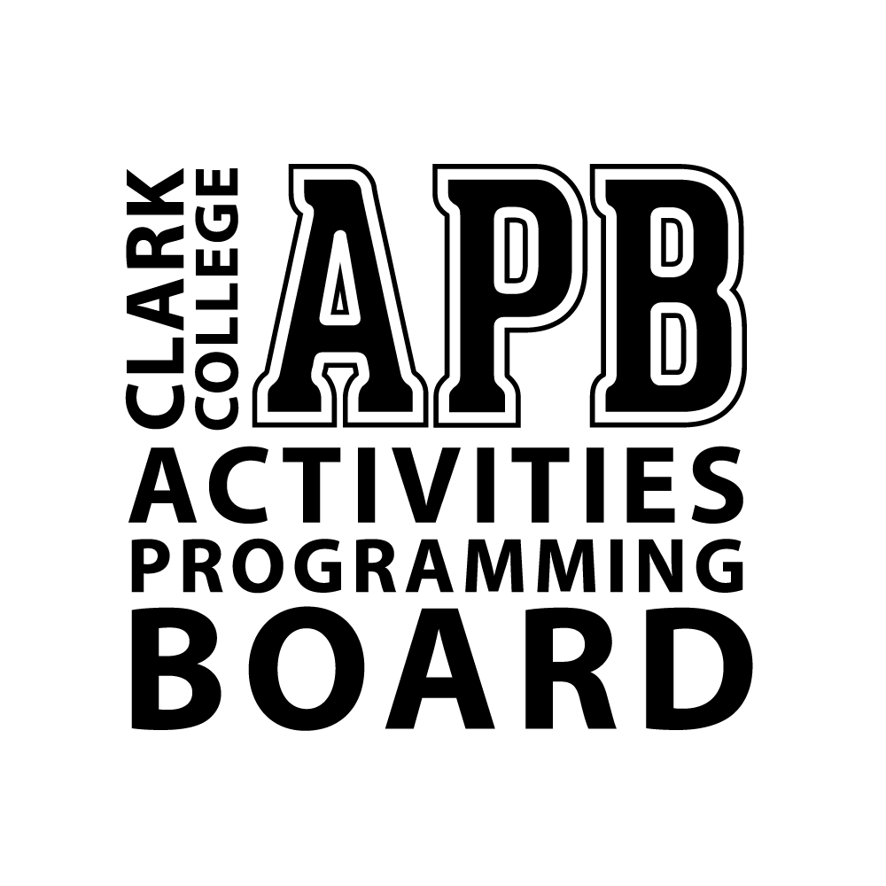

With the group motto, “We run the fun!” this group is charged with the creation of a comprehensive events calendar to include family, social, educational, cultural, and awareness events for Clark students. Hosting 60+ events each year, including the annual Spring Thing event, APB officers gain valuable leadership experience through event research, budgeting, planning, implementation and assessment. We want to help students create memories and experiences while here at Clark. APB members receive ongoing leadership training in order to complete their assigned duties.

It is the responsibility of the Activities Programming Board (APB) to:
- Initiate and coordinate student activities;
- Select, schedule, and implement APB-sponsored events;
- Provide opportunities for individual leadership development and for group participation;
- Plan, organize, budget and facilitate three (3) events each quarter; 2 events on main campus and 1 event on a satellite campus either CTC or CCW;
- Track event attendance and administer event evaluations;
- Schedule and oversee all volunteers at assigned APB events;
- Assist with quarterly ASCC Welcome Week events and activities
- Work as a team to schedule vendors and performers for Spring Thing;
- Attend 15 weekly office hours;
- Attend designated weekly 1:1 meetings with the Student Life Program Support Supervisor;
- Maintain academic eligiblity; submitting quarterly academic mid-quarter evaluations;
- Affirm and support the Clark College Mission, Vision and Values statement.

Minimum qualifications for an Activities Programming Board position include:
- Be currently enrolled in eight (8) college level credits or more at Clark College;
- Possess and maintains a 2.50 cumulative grade point average at Clark College; and
- Have completed a minimum of twelve (12) college level credits at Clark College.
- By Friday, February 1, 2019 you must have attended one (1) APB meeting.

Compensation:
- You will be paid $12.24 hourly.
- You must be able to work up to 15 hours per week during regular business hours.
- Regular business hours are Monday through Thursday 8:00 am-5:00 pm and Friday 8:00 am-1:00 pm.

Application process:
The following materials must be submitted no later than Friday, February 1, 2019 into Sami Lelo’s mailbox by 12:00 pm in PUB 160:
- A typed qualification statement no less than 250 words and no longer than 500 words;
- An APB Job Application Form including 2-3 professional references;
- Verification of attendance at one (1) APB meeting;
- A petition for candidacy with 50 signatures from currently enrolled Clark College students;
- A Career Center-approved resume;
- An unofficial copy of your Clark College transcript. The transcript must include all quarters completed prior to the application deadline.
- Winter quarter class schedule
- Sign-up for an interview at the Office of Student Life front desk (after you turn in your application)

SELECTION PROCESS:
All qualified applicants for the position will be contacted for an interview.

PLEASE NOTE:

- A student may NOT be employed, at the same time, in two student leadership positions. For example: Student Ambassador, Activities Programming Board (APB), Associated Students of Clark College (ASCC), and Peer Mentor.

- When applying for this position, it should be taken into consideration that, barring unforseen circumstances, you will be required to serve for one school year - that is, Winter and Spring quarter of the year you applied for employment in.

- As with all other employed positions at Clark College, all potential employees must submit to a background check before being approved to work. Negative history on a background check does not automatically disqualify you from employment.

- As part of the process, a Career Center-approved resume must be turned in with the application. Please visit Career Services in PUB 002, or call (360) 992-2155. All students must have a Career Services approved resume to qualify for employment. To make sure you can get approved quickly, bring your resume on a thumbdrive to Career Services so that changes can be made right away.

**APPLICATIONS ARE DUE Friday, February 1, 2019 BY 12:00 pm to PUB 160**

If you have any questions, please contact the Student Life Program Support Supervisor, Sami Lelo, at slelo@clark.edu, call (360) 992-2806, or stop by the Office of Student Life in PUB 160.

Tentative Training Schedule:

- Individual Meeting with advisor – February (Exact date and time TBA)

- Student Leader Professional Development Training. This training is required for all positions as it provides ongoing professional development. (Exact dates and times TBA)

- Other trainings as designated by the Director of Student Life and Student Life Program Support Supervisor.

Job Application Form
This form is confidential. All fields must be filled in correctly and legibly. Fields that are not filled in or are illegible may delay or exclude the applicant from approval until rectified.
Name First: __________________________ Last: ____________________________ Middle Name: _________
Date of Birth: _______/_______/_______ Student Identification Number: _______-_______-_________
Address: _______________________________________________________________________________
Telephone: Home_____________________ Cell _________________ Email _____________________________
How long have you attended Clark? __________________ Major or field of study? _______________________
How many credits are you currently taking this quarter? ____________ Next quarter? _____________________
Are you currently or have you ever served on an ASCC or campus committee?
Yes___ No___ Year_______________ If yes, which? ______________________________________________
Are you currently or have you ever been involved in any ASCC or club activities?
Yes___ No___ Year_______________ If yes, explain:______________________________________________

References. Please list at least two professional references.
Name:______________________ Phone: _______________ Email:_____________________________________
Company:_______________________________ Title:_______________________________________________
Name:______________________ Phone: _______________ Email:_____________________________________
Company:_______________________________ Title:_______________________________________________
Name:______________________ Phone: _______________ Email:_____________________________________
Company:_______________________________ Title:_______________________________________________

You may apply to as many postions as you would like. Please check the positions you would like to be considered for:

Available Positions:
APB Family Events Coordinator

The information I have submitted is true to the best of my knowledge. I understand that the contents of this application are subject to verification and, if found untrue, will result in my immediate disqualification. By signing below, I am authorizing the release of my Clark College transcripts for confidential verification purposes.

Signature_________________________________________________________ Date___________________________

All applicants are required to attend one (1) APB meeting. Upon attending these meetings, receive a signature from the APB Chair.

Required Meeting – one (1):
Activities Programming Board:
Committee Chair : _________________________________________________________________________
signature date

Committee Meeting Days/Times for:

Winter Quarter:
Activities Programming Board (APB): Mondays, 10:00 am – 11:00 am in PUB 160D

If you are unable to make the scheduled APB meeting contact Sami Lelo at slelo@clark.edu for a make-up meeting.

PETITION

We, the undersigned students of Clark College, recognize and petition for the said applicant applying for the said office(s) for the winter – spring 2019 academic school year.

Name of Applicant: ____________________________________________________________________

Available Positions: (check all that apply):
APB Family Events Coordinator

**ATTENTION: Please make sure student names and last four of student ID is printed clearly and legibly. All applicants are encouraged to obtain more than the fifty (50) signatures required for candidacy to ensure that enough signatures are validated. This form continues on back.**

NAME OF STUDENT (PRINT) | SIGNATURE | LAST FOUR OF SID
1.
2.
3.
4.
5.
6.
7.
8.
9.
10.
11.
12.
13.
14.
15.
16.
17.
18.
19.
20.
21.
22.
23.
24.
25.
26.
27.
28.
29.
30.
31.
32.
33.
34.
35.
36.
37.
38.
39.
40.
41.
42.
43.
44.
45.
46.
47.
48.
49.
50.
51.
52.
53.
54.
55.
56.
57.
58.
59.
60.
61.
62.
63.
64.
65.
66.
67.
68.
69.
70.

