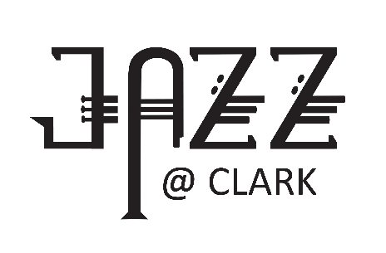

CLARK COLLEGE JAZZ FESTIVAL REGISTRATION

MIDDLE SCHOOL DIVISION
** Use a separate form for each group you are entering **
- Middle School Divisions (AM) . . . . . . . . . . . . . . . . . . . . . .Thursday, January 25, 2024
- Middle School Band Clinic (noon-1pm) – designed for Middle School Band directors and students. Included in registration fee.
Bands will be scheduled when both the form and payment have been received.

PLEASE PRINT CLEARLY
Name of School
Name of Ensemble
Mailing Address of School
City/State/Zip |  |  |  |  | Email
Name of Director |  |  |  |  |  |  | Director Cell Phone
Check all that apply:
 |  | Middle School competition |  |  |  | Middle School Band Clinic (included in fee)
 |  | COMMENTS ONLY (Friday morning only) |  |  |  | My school can participate in the finals on Thursday evening.
REGISTRATION DEADLINE: December 1, 2023. . . . . . . . . . . .REGISTRATION FEE: $250
Any registrations received after December 1 will be charged a late registration fee of $275.
Registration fees are non-refundable and include 3-day festival admission.
Registration includes admission for director and three other chaperones.
Mail check, made payable to
Clark College Foundation,
and registration form to:
Clark College
Music Department Jazz Festival, BMH 116
1933 Fort Vancouver Way, Vancouver, WA 98663
EMAIL form: sjwilliams@clark.edu
If paying by credit card, please call Shelly Williams at: 360-992-2662

