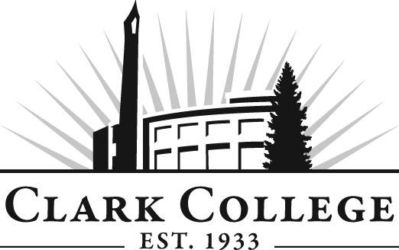
Welding Technology Advisory Committee
Meeting Agenda
Date: Wednesday, May 6, 2015
Time: 5:30—7:30 pm
Meeting Location: Building AA2, room 105

Agenda Item | Expected Outcome | Time
- Call Meeting to Order – Committee Chair | N/A
- Welcome and Introductions – Committee Chair | New members/guests introduced | 5 min.
- Approval of Minutes from Last Meeting – Chair  - November 5, 2014 | Corrections indicated and/or approval of minutes as written. | 5 min.
- Office of Instruction Updates- Advisory Committee Business-Cathy Sherick/Genevieve Howard  - Advisory Breakfast recap  - Fall chair/vice chair training  - Clark College Strategic Plan  - North Campus Update  - Maker Center |  | 15 min.
- Director/division chair Report |  | 15 min.
- Work Plan-Committee Chair and Program Director/Division Chair  - Five year equipment plan  - Looking for new instructor(s)  - What’s new/shop improvements  Brian McVay:  - W.A.B.O. testing  - Testing for City of Portland/P.S.I. | Implement strategies as outlined in work plan. If necessary, identify work groups. | 40 min.
- Old Business-Follow-up- Committee Chair |  | 15 min.
- New Business | New business items are addressed by the committee. | 15 min.
- Summary of follow-up action items – Committee Chair | Summary of follow-up actions communicated to the committee. | 5 min.
- Establish next meeting date and adjournment – Committee Chair | Meeting date established. | 5 min.

