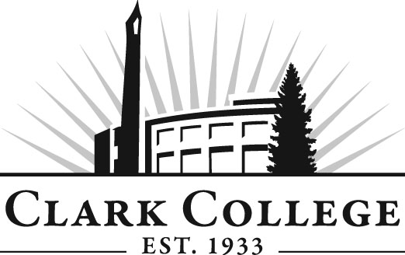

WELDING TECHNOLOGY ADVISORY COMMITTEE

MINUTES
Wednesday, May 23, 2012
5:30 to 7:00 PM
AA2, Room 105

Members Present Representing
Larry Stanks, Vice Chair Bonneville Power Administration
Mark Stanley Columbia Manufacturing Service
Michelle Hall Airgas, Co., Ridgefield

Members Absent
Darlene Chapman
Bob Tafolla
Jim Johnson

Clark College
Patrick Gonzales Welding Tech Department Head, Instructor
Ron Renner Welding Instructor
John Kuhn Welding Instructor
Michael Mesky Welding Instructional Tech
Dedra Daehn Director, Academic Services & Innovation
John Maduta Advising Divisional Manager-Professional
Technical Programs

The meeting was called to order at 5:35 PM by Professor Patrick Gonzales. He introduced Ms. Michelle Hall who was invited to the meeting in an effort to recruit new members to the Welding Advisory Committee.

Review of the Minutes of the Previous Meeting:
Professor Gonzales said that the evening classes could be brought back since the budget cuts were not as severe as first anticipated.

Mr. Stanks reviewed the minutes from the previous meeting. Professor Gonzales said that the oxygen sensor was purchased last quarter at a cost around $3,400 so that item has been taken off the equipment list.

A motion was made to approve the minutes as written. The motion was seconded and unanimously approved.

Advisory Business:
Ms. Dedra Daehn announced that Clark College just received the Worker Retraining Grant so starting July 1. Welding will be able to participate in utilizing the grant funds.

Ms. Daehn explained the Planning and Effectiveness Department’s follow-up of CTE programs based on surveys sent to graduates of the various programs. The surveys’ results have been posted on respective advisory websites.

Work Plan:
Professor Gonzales said the first item on the 2011-2012 Work Plan has been completed and the next three items will be transferred to the 2012-2013 Work Plan. One additional item for the Work Plan will be the Open Entry Plan. He and Ms. Daehn will work together on the language of the Work Plan items and update it for 2012-2013 and send it out to the members for their approval later.

Mr. Tafolla asked to be relieved of his responsibility as Committee Chair because of his heavy work load. Nomination was made for Mr. Mark Stanley as Vice Chair and Mr. Larry Stanks was nominated as committee chair. Mr. Mark Stanley seconded the nominations and they were unanimously approved.

Professor Gonzales distributed a list of certificates currently offered in Welding. He explained that they cleaned up the number of certificates offered in Welding. Sculpture class was the one certificate of completion because of the number of credits. Professor Gonzales announced that the Larch Welding Program was recently developed. He said he went up to Larch four or five times and there is an opportunity to put in a certificate of achievement at Larch. He said the response from the inmates has been positive. There will be ten students at a time to learn wire feed, plasma cutting, auxiliary grinding, etc. Welding benches will be built here for the ten students there. The classes will be from 1:00 to 3:00 five days a week. The projected budget for this project is around $76,000 to $79,000. Professor Gonzales said the power source will take a big bite out of that budget.

Open Entry Program:
Professor Gonzales said there are six welding classes right now, excluding blueprint and metallurgy. There are three first year classes and since they are clusters, it is difficult to have class of students for second year classes. He said students can enroll at any quarter throughout the year. No more clusters and pre-reqs are required for any of the welding classes.

Professor Gonzales said he would like to proceed with this open entry concept for the program. A motion was made to accept the open entry plan. The motion was seconded and unanimously approved.

Professor Gonzales said he is proposing having models developed so that the students who do not know how to use a piece of equipment will be taught to use the equipment plus will need to take a written test after the training. The training will include hydraulic saw, plasma cutting, 5/8 x 10’ shear, abrasives & grinders, 110 ton iron worker. He said he would like to have the committee vote on the models to have these instructional slides made up for all five models. A motion was made to accept the models for safety and instruction as presented by Professor Gonzales. The motion was seconded and unanimously approved.

Next Meeting Date:
Middle of November, 2012.

Meeting adjourned at 6:50.

