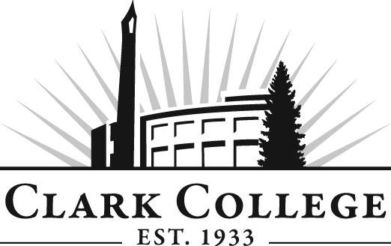

Welding Tech Advisory Committee

Meeting Agenda
Date: Wednesday, May 23, 2012
Time: 5:30-7:0 PM
Meeting Room Location: AA2, Room 105

- Call to order- - - - - - - - - - - - - - - - - - - - - - -Mr. Bob Tafolla, Committee Chair

- Welcome & Introduction

- Approval of minutes from last meeting

- Open issues

- Advisory Committee Business- - - - - - Dedra Daehn, Office of Instruction

- Work Plan- - - - - - - - - - - - - - - - - - - - Dedra Daehn, Office of Instruction

- Election of Officers – Mr. Bob Tafolla, Chair of the Committee, stepping down. Mr. Larry Stanks is current Vice Chair. Need to replace Chair.

- New business

- Revised program certificates

- Larch Welding program

- Open entry into program –update - committee approval on modular projects.

- Next Meeting Schedule

