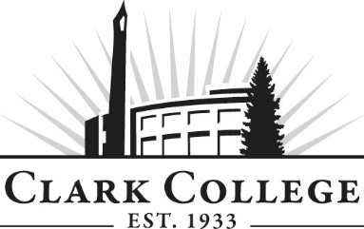
WEB DESIGN & DEVELOPMENT ADVISORY COMMITTEE - Meeting Minutes
Tuesday, November 6, 2018* 6:00—8:00 p.m.
GHL 213

Members Present: Aaron Johnson, Committee Chair, Intel; Troy Uyan, Vice Chair, Clark County; Tracy Caretto, Made By Tracy; Erin Lynch, SHOP; Christine Watson, Formations Design Group

Members Absent: Gus Torres, US Digital

Clark College: Kristl Plinz, Professor/Computer Graphics/Web Department Head; Robert Hughes, Professor/CTEC Department Head; Fellene Gaylord, Instructor; Genevieve Howard, Dean – WPTE; Kathy Chennault, Foundation; Renee Schiffhauer, Associate Director of Advising; Cathy Sherick, Assoc. Dir. Instructional Planning & Innovation; SueAnn McWatters, Program Specialist - Advisory Committees

Committee Chair Aaron Johnson called the meeting to order at 6:04pm and introductions were made.

  - Minutes of the Previous Meeting

The minutes of May 15, 2018 were presented: Aaron made a motion to approve, Christine seconded and was unanimously approved.

  - Next Meeting Date

The committee will next meet on Thursday, May 16th, 6:00pm.

The meeting has been moved to Thursday, May 30th, 2019 at 6:00pm.

  - Elections of New Chair/Vice Chair

Troy volunteered to chair while Aaron volunteered to vice chair.

Aaron motioned for Troy as chair and himself as vice chair; Christine seconded and was unanimously approved.

  - Office of Instruction Announcements

Cathy Sherick made the following announcements:

Welcome back to 2018-19 Academic year, Advisory Committees will continue to see how they fit in to the implementation work of Pathways at Clark. The goal is to improve rates of completion, transfer and attainment of jobs to that end this year we will be working very closely with other colleges to make sure our programs link directly to opportunities for students who are continuing. Our high school partners are also working with us to ensure that their programs are also aligning closely to Clark.

To that end, Clark will be producing the Career and Technical Education Insert again this year. It will go out in February in the Food Day Columbian reaching 56,000 households. We are asking business partners to advertise in the insert again – and we will be working on some very compelling stories of students in CTE programs. Please contact Cathy Sherick in the Office of Instruction if you would like to advertise or for more details.

Clark is always opening the invitation to more Advisory volunteers for the twenty-five committees that support CTE programs. It might mean infusing current committees with new members or building new committees for new programs. Also, we are continuing to work on the Master Advisory Committee as well to assist with visiting current committees to talk to members, planning and hosting an Advisory event and reporting to the Board of Trustees every year on the great work of Advisory Committees.

The energy is heating up around the development of the new Advanced Manufacturing Center planned for the North Campus at Boschma farms. Contact Dean Genevieve Howard for details on this amazing new building and the advanced manufacturing programs that will be located there.

October 9th Clark College, in partnership with Partners in Careers (PIC) and Workforce SW, hosted over 250 local high school students on campus for National Manufacturing day. Special thanks to S.E.H. America, Columbia Machine, Graphic Packaging, Silicon Forest Electronics, General Sheet metal, and BagCraft for providing activity stations.

  - Curriculum Changes

Digital Media Arts AAT Proposal (Appendix A):

Red is going away; Green is new and Black isn’t changing. General Education requirements are staying the same.

Fine Art Foundations
ART &101: 2D Art and Design - Combines ART 115 and ART 116.

Computer Graphics Technology (Renamed Digital Media Arts)
ART&208: Digital Painting and Illustration – Revised ART which adds digital painting skills.
DMA&204: Motion Graphics & Animation II – New advanced course.
DMA&202: Video & Sound Production II – New advanced course.

Web Design:
CTEC&112: Programming Essentials - adding programming class which already exists
Bob will take over all of the web design classes, which’ll be renamed under CTEC headings.

Professional Development:
DMA&214: Professional Practices & Portfolio II
DMA&215: Professional Studio Experience – all client work, more portfolio building opportunity
These courses provide more soft skill and real world experiences.
Art will teach their portfolio class specifically to their art students, and the DMA program customize their own portfolio requirements so that students can focus on online portfolios vs. fine art and print layout portfolios. Students should have a competitive portfolio to be prepared for job searching or get ready for transfer.

Bob mentioned that students will have the opportunity to take web programming foundational classes. This will enhance student’s skillset to be successful in web design.

Christine Watson explained her enjoyment as an alumnus to see color theory in the program.

Kristl discussed the program’s involvement with WSU Vancouver and the Portland Art Institute. The Art Institute was very eager to articulate with us, but the campus closed in December 2018. There aren’t a lot of active articulation agreements between WSUV and Clark College. However, there is an articulation agreement between Cark’s Early Childhood Education and WSUV’s Human Development. We can use that as a template or guide when working with WSUV’s Digital Technology and Culture program to articulate with our new Digital Media Arts program.

Course Descriptions Discussion:

Kristl reviewed the new DMA course titles and descriptions. She stated that certain courses have prerequisites. We want to make sure that students take courses at the right time and in the right sequence. The “consent of instructional unit” is to help with the timelines of courses intended to be taken near graduation. The course descriptions clearly capture what the courses are about so that students, the community, industry and campus committees can easily understand our course goals. The advanced courses are more team-based with client projects. Professional practices courses align with guided pathways to prepare students with personal/educational/career insights and goals after the first year, and upon graduation.

Kathy Chennault asked about what businesses and nonprofits need work done. Kristl explained that there is a constant flow of requests, but that the program tries to focus more on nonprofits. They will work with smaller businesses however.

Program Outcomes:

Kristl mentioned that the program used to have 8 program outcomes and 3 general education outcomes for a total of 11 outcomes. They have been able to narrow down to a total of 4 outcomes:
- Contextual communication
- Strategize and articulate the context, purpose, and meaning of digital media messaging
- Design thinking
- Engage in design thinking through user-centered, iterative design and evaluation process.
- Media technology
- Integrate media technology through synthesis of content, interaction and functionality.
- Professional practice
- Demonstrate professional practices through industry preparation, performance and portfolio.

Kristl provided job market data from our Institutional Effectiveness group, and did research on various job sites. She provided a list of the variety of entry-level or freelance/contract jobs that are available, including some that prefer a bachelor’s degree or equivalent. There is no industry standardization of job titles or descriptions.

Web Development CP & AAT (See Appendix B):

Slide 3: Fall 2018 vs Spring 2018
The program has grown from 109 to 139. There is talk across the campus that enrollment has been low, however our program has actually grown.

Slide 4: First Year of Web Development AAT = Certificate
The program is modified so that the first four quarters will be identified as the Web Development Certificate of Proficiency.
Highlights of this change:
- Request for CTEC 165: Business Web Practices becomes part of the Human Relations Distribution for AAT degree and Certificate of Proficiency.
- Three CGT courses (105, 205, 206) will become CTEC courses with no or very minimal content change.
- New course is developed as CTEC 166: Web Content and Social Media covering much content from ENGL&160: Writing for the Web and CGT&106: Social Media Exploration.

Slide 5: CTEC Web Development Certificate of Proficiency
The Web Development Certificate on the left side focuses on preparation for a career focusing on Front End Design and Development Skills. The Web development AAT expands on that foundation with training in Back end development skills. There are 5 classes which are a part of Kristl’ program, so there will be some opportunity with mobility.

Slide 7: CTEC 165: Human Relations
All of “these’ courses are in the catalog that qualify as human relations. The program is heading in this particular direction.

Slide 8: AAT and CP Human Relations Distribution Requirements
CTEC&165 will be offered in the first quarter. This course is very close to the other that are approved for Human Relations.

CTEC 166 Web Content and Social Media:

Slide 6: CTEC 166: Web Content and Social Media
Kate Scrivener from the English department is working with the program to try and come up with a curriculum that will up the student’s writing skill on a very practical and professional level. The 6 credit course will become a 5 credit course. This will occur in the student’s last quarter and will tie everything together.

The committee discussed students moving through the program as a cohort. Bob stated that they are hopeful that it is moving in that direction. The key is to get engaged. Students need to have PTCS 110 so that when they enter the programming class, they can have an understanding of what they are doing. All programs in the past have been able to start whenever they want. So the discussion has been potentially starting them at a particular time. There are certain classes that will be offered every quarter; HMTL and basic programming. 6 quarters is the ideal time period for completion, but the reality is it can end up being 7 or 8 quarters.

Erin Lynch pointed out that in the 2nd quarter, students get program essentials and then skip a quarter and then head into JavaScipt. He suggested that there is no gap so that the development chain on the skills is continuous. It would be nice to see Programming Essentials, JavaScript, PHP I, PHP II with no break so that each quarter, students are building on that foundation.

Troy mentioned that there are Microsoft Certifications but they are very specific for Microsoft technology. Bob stated that they use MTA Certifications for Microsoft Database and C#.

  - Summarization and Vote

Web and Graphic Design are going away. Graphic Design is going away. The art department can’t keep it going any longer. Web is being handed over to Bob Hughes.

The new focus is Digital Media Arts. Moving forward, the program will keep aligning and modernizing with the current technologies:
- Still has media arts
- More professional arts

Aaron motioned to approve the changes to Digital Media Arts; Troy seconded, and was unanimously approved by the committee (the motion is inclusive of the whole program – courses, outcomes, etc.)

Aaron motioned to approve the changes to the Certificate and Degree; Troy seconded and was unanimously approved by the committee.

Aaron motioned to approve the creation of CTEC&166: Web Content and Social Media; Troy seconded, and was unanimously approved by the committee.

The meeting adjourned at 8:05pm.

Prepared by SueAnn McWatters

Appendix A

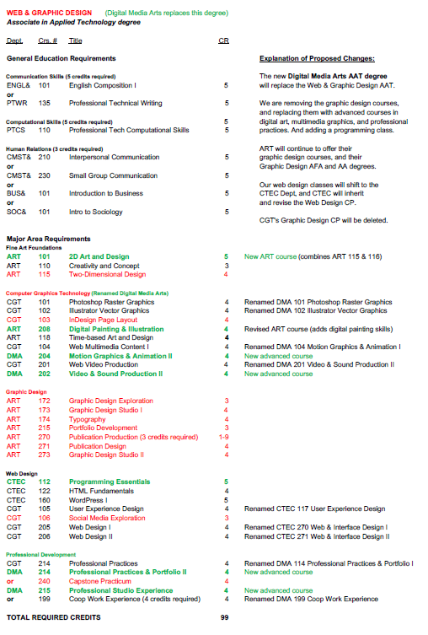

Appendix B

