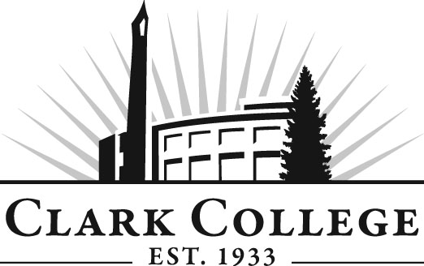

TOYOTA T-TEN TECHNOLOGY
ADVISORY COMMITTEE

MINUTES
Wednesday, May 23, 2012
9:00AM-12:00 PM
McMenamins Edgefield, OR

Members Present Representing
Ken Fritts Toyota Motor Sales
Dave Bora Toyota Motor Sales
Steve Jewell Ron Tonkin Toyota
Grant Lord Broadway Toyota
David Griffith Vancouver Toyota

Members Absent

Clark College
Jason Crone Professor, T-Ten Coordinator
Mike Godson Professor, Auto Tech
Genevieve Howard Dean of Workforce & CTE
Vicki Cheng Administrative Asst. to the Dean
Judy Schilz Secretary Senior, Culinary Arts &
Mechanical Tech

At 10:25 AM, the meeting was turned over to Professors Mike Godson and Jason Crone. Mr. Ken Fritts asked the dealers for their support of the T-Ten program at Clark College.

Professor Crone distributed the T-Ten Program Structure. He said that Clark College needed Toyota’s support on program level outcomes as well as goals level outcomes. The classes are structured on three week blocks of time. Professor Crone said the program begins with Intro to Toyota for the first two weeks of summer. Then four Basic Instructional Blocks on Safety, Personal Vehicle Services, Understanding Basic Service, Basic OBD and Scan Tools.

The next class is T100, Electrical 1, starting in the fall. Electrical 1 Fundamentals, Chassis Electrical, Starting and Charging Systems.

Electrical 2 T101 includes High Level Outline of the Course – Instructional Units 1, 2, and 3 and what are covered under each Instructional Unit.

Internship 1: High level Instructional Unit. Instructional Units 1-4 and what sequals are covered under each.

Winter Quarter, the students will be working at the dealerships but will be paying for credits at Clark and working during that quarer online from the dealerships. Under Unit 4, students will pass Electrical A6, ASE exam and take A5 Brakes exam. The students must pass A6 and hopefully take A5 as well but definitely want them to pass A6.

In Internship 2, the students will take A7 ASE and A4 Brakes exam. Program Electical 1 syllabi – electrical 1, course information, the instructor is Tonia Haney, and the required material is Toyota Flash Drive Courses 623 and 652. The course description is given at the end of the syllabus.

Course Level Outcomes:
FSP’s final scale performance – students will be tested at the end. Program Level Outcomes - the student will be able to achieve at the end of the course. Professor Crone explained the revised program level outcomes on what the students will be able to do at the point they graduate from the program. Professor Godson said the CAR was needed to get college approval but before they can present it to the college, they need the dealers support. The plan is at this time, Clark College will not be enrolling any new students in fall of 2012. There will be no new enrollment until fall of 2013.

Professor Crone talked about the cost of the tools for the students. The tools can cost anywhere from $600 to a few thousand dollars. The program tuition is approximately $13,000. There are several different scholarships for the students to take advantage of, but the students don’t seem to want to take the time to complete the basic simple application forms. Both the Certificate and the AAT degree have same outcomes. On the program level outcomes, Dealers all viewed the outcomes favorably. Consensus support program level outcomes was unanimous. Dean Howard said administrative support was favorable from the onset.

Professor Crone completed his presentation at 11:12 AM. Mr. Fritts thanked the dealers for their participation in the T-Ten program. Clark College has achieved a Recognition Award for 2011- ASE’s NATEF certification and retention of 80%. The curriculum development Release Time. Recognition Award Plaque was presented to the Toyota T-Ten program at Clark College to Professors Godson and Crone for their roles in the program.

