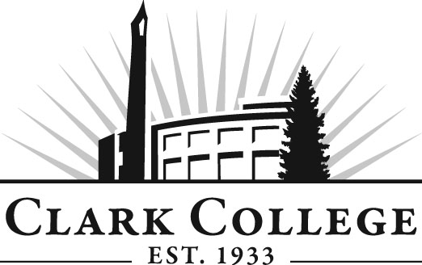

TOYOTA T-TEN TECHNOLOGY
ADVISORY COMMITTEE

MINUTES
Thursday, March 29, 2012
9:00-11:00 AM
Toyota Regional Sales Office, Portland, OR

Members Present Representing

Dave Nelson Toyota
Mike Rynaski Gresham Toyota
Grant Lord Broadway Toyota
Dave Matthiesen Wilsonville Toyota
Steven Schumacher Beaverton Toyota

Members Absent Clark College
Jason Crone Toyota T-Ten

Jason Crone presented his new T-Ten program structure which he said was approved by the Clark College Executive Cabinet as well as Toyota T-Ten Administration in Torrance, CA. Jason distributed a chart that showed how the courses would flow over the two year period. The students would be in classes during one quarter and then at the dealerships for the following quarter doing their internships. The hours shown on the chart are NATEF training hours.

The students will take the Toyota instructor led courses taught over a three weeks long period instead of 2 or 3 days. Each of these class segments will be broken down by day by day worksheet format to show the details. Jason said we are in the process of developing high level outlines based on NATEF training. We will actually have structural outlines that dealers will be able to see in detail what their students are doing at any given time. Jason said the outcomes of this program would be much higher quality technicians.

Next year there will be no first year students. They will do a teach-out of students who are in the program currently. Then, around spring of next year, he will begin recruiting for the 2012-2013 academic year. Jason said that Clark College Toyota T-Ten program will be part of the pilot program of the T-Ten national training. He said that each unit is written the same for all the T-Ten programs across the country. He said beginning with 2012-2013 school year, all the T-Ten programs nationally will work with the same training objectives. The students will be recruited from their own areas so they will stay with the dealers after completing the program.

Jason said that the Clark College T-TEN program received recognition from Toyota. He said representatives from Toyota will be coming to Portland to make the award to Clark College. and Jason said he has scheduled the spring meeting tentatively for May 23, 2012, Wednesday. He said he is thinking about a couple of different venues – Edgefield Golf Course or Al’s Bowling Center. Since it was difficult for the dealer reps who were present to know if they would be available on May 23rd, the general consensus was to that May the 23rd was acceptable but to check with Mr. Fritts and if the date was agreeable with him, then to schedule the meeting and let the dealers know and those who were able to participate would do so. This would be the spring Toyota T-Ten meeting.

Toyota T-Ten portion of the meeting adjourned at 9:30 AM.

