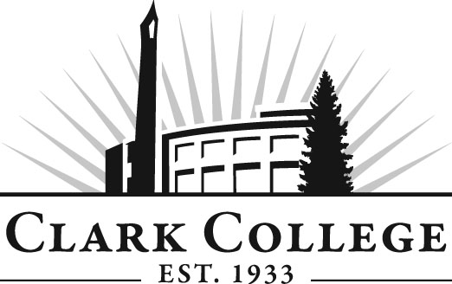

TOYOTA T-TEN TECHNOLOGY
ADVISORY COMMITTEE MINUTES
Tuesday, December 15, 2015
2:30 p.m. – 4:00 p.m.
Clark College - Joan Stout Hall, room 112

Members Present: Dave Griffin, Vancouver Toyota; Brian Hebert, Toyota Portland Region; John Krebsbach, Toyota Motor Sales; Scott Morris, Toyota Motor Sales; David Powell, Gresham Toyota; Dave Ruppert, Toyota of Gladstone; Steven Schumacher, Beaverton Toyota

Clark College: Tonia Haney, Automotive Department Head; Mike Godson, Professor; Jason Crone, Toyota T-TEN Coordinator & Instructor; Michaela Loveridge, Recruitment & Retention Specialist; Genevieve Howard, Dean, WCTE; Andreana DiGiorgio, Secretary Dr., Advisory Committees

In the absence of both the committee chair and vice chair, the meeting was called to order by Jason Crone at 2:35 p.m. and introductions were made. Jason reminded the members how important the committee is to Clark College and the Toyota T-TEN program. Allows ideas to be presented regarding curriculum, what equipment is needed, and student needs. In addition, as students are growing through the program, members have the opportunity to let the college know of industry changes and enhancements.

The April 22, 2015 meeting minutes were approved.

Division Chair/Department Head Report – Tonia Haney & Mike Godson welcomed the attendees. Gave overview of the meeting agenda. Said the program went through the NATEF re-evaluation with flying colors and are certified for next 5 years.

Recruitment Report – Jason Crone gave a report on the recruitment efforts and introduced Michaela Loveridge as the new recruitment & retention specialist. Michaela reported she has reached over 400 high school students. Some with automotive programs and also with stem programs. Trying to break down the idea of what an automotive technician is now versus years ago. Targeted markets are from Astoria, Oregon to Aberdeen, Washington. Scholarships are available to students, however, they don’t apply for them. Not sure if they’re afraid to write the short, required essay. Michaela refers these students to an on-campus scholarship specialist that can help them. She also introduced the Facebook page and emphasized how beneficial this kind of media is both for students and their parents.

Questions and discussion about the screening process, driving records, drug testing.

Challenges or objections? Michaela tries to keep students engaged between the time she meets them until the time they can register for classes.

Someone spoke up about challenges in the Seattle market and some Seattle dealers want to meet in Portland. Jeff Harbaugh said the Seattle market is in need of technicians! Need 20 students going into the pipeline every session. A plan is needed that includes information for students about expected salary during the program. Jason began talking about internships. Student maturity levels vary. He presented a spreadsheet showing student progress. Need to come up with ideas how to create incentives and pathways for students. Discussion of costs to dealerships and investment in the students. Tuition, housing, tool

assistance ideas? Want to come up with a reasonable pay plan that would tie in ASE completions; dealer commitment is needed. The Clark program is focused on the job. The partnership between dealers and Clark is key. How about a night program, possibly a slow track program. Members thought we should overload the program in anticipation of attrition. Need on dealership technician/mentor per two students. Maybe dealer provide tuition assistance if they finish classes and ASEs; need some flexibility with an achievement pathway. Students need mentoring and skill development even in the express maintenance arena. Soft skills needs to be included. Jason- dealer internship needs to be aligned with coursework. Would like a road map of earnings. Need to do a better job at illustrating what the car business is. Need to make appropriate match with mentor to student. Mike and Genevieve talking about college budget and commitment of the program. Discussion of tuition $12,500-16,000 depending on tools, funding, and scholarships.

Mike Godson explained the role of the advisory committees. Struggling with the employer/employee balance; need to incorporate some technicians on the committee, mentors especially. Handed out committee pamphlet with nomination forms.

Old Business

- Discuss Curriculum changes – Vote. Need committee support of the proposed changes to the curriculum. Mike passed around four spreadsheets of all the classes in the T-TEN program. Mike said that they have come to the conclusion that students need less lecture and more lab time. This is one of the changes that went through the curriculum committee at Clark and now need the blessing of the advisory committee. The credits have gone from 95 credits and 1,530 contact hours to 109 credits and 1,980 contact hours. This includes doubling the three internship class time. This will give Jason more time to visit the dealers and students on site, prepare for ASE tests, student portfolios, and working more with mentors. Assessment of each term will allow dealerships to see what the student is working on. A motion was made to approve the changes as presented by Mike. The motion was seconded and unanimously approved by the members.

Next meeting

- Discussion future of Committee
  - State requirements
  - Core Group needed
- Create/ Work Plan
- Election of new officers

Next meeting date is Tuesday, May 17, 2016 at 2:00 p.m.

Jason adjourned the meeting at 3:51 p.m.

Prepared/submitted by Andreana DiGiorgio

