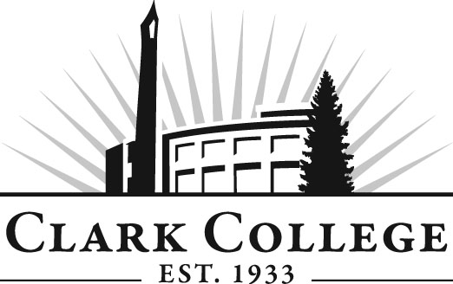

TOYOTA T-TEN TECHNOLOGY
ADVISORY COMMITTEE

MINUTES
Tuesday, February 26, 2013
9:00 AM ~ 10:00 AM
Toyota Portland Regional Office

Members Present Representing
Bill Kush McMinnville Toyota
Smiles Dominici Beaverton Toyota
Bob Barr Tonkin Toyota
Dave Ruppert Gladstone Toyota
Jeff Hay Broadway Toyota
David Griffin Vancouver Toyota
Jeff Parker Wilsonville Toyota
Dave Vandelinde Lexus of Portland
Steven Schumacher Beaverton Toyota
Benjamin Jabusch Dick Hannah Toyota
Kelly Cole Gresham Toyota
Ken Cornelison Gresham Toyota

Members Absent
Dave Nelson Toyota
Mike Rynaski Gresham Toyota
Rick Murray Hillsboro Toyota
Andrew Passage Toyota
Genevieve Howard Dean, WCTE Unit
Ken Fritts Toyota
Dave Bora Toyota

Clark College
Mike Godson Department Head, Automotive Tech
Jason Crone Toyota T-TEN Coordinator

Jason Crone called the meeting to order at 9:00 AM and led the discussion.

Toyota T-TEN:
Jason thanked the members for their participation in the T-TEN program at Clark. He said this new program will need the college and dealers to work together in a partnership to a success.

Review Minutes from Previous Meeting
Meeting minutes were circulated and reviewed. Ken Cornelison motioned to approve the minutes as presented. That motion was seconded by Steve Schumacher. A vote was called and the minutes were unanimously approved.

Agenda
The agenda was circulated and reviewed. Ken Cornelison motioned to approve the agenda as presented. That motion was seconded by Steve Schumacher. A vote was called and the agenda was unanimously approved.

NATEF mid cycle review
Jason talked about how NATEF certifies automotive programs in a similar manner as to how ASE certifies automotive technicians. Jason then discussed the standards and showed the members the binders that Clark College has assembled as documentation of meeting the standards. Jason then gave the floor to Mike Godson who explained the mid cycle review possess in further detail outlining the work that has been completed and asking the members to review and approve the standards. The committee was happy with the work being performed by the college and agreed unanimously to approve the work and five members moved forward to ratify the rated standards.

New program start up
Jason then talked about the new program startup date approaching very quickly and pointed to the T-Ten student enrolment forms that had been passed to each of the dealers. Jason said that the new program would start on 8-19-13 and the students would need to be identified soon so that they could begin the admissions and orientation possess.

Dealership identification of T-Ten students
Jason talked about the past round of recruitment activity’s and told the dealers that the he would be making another round of recruitment visits to local high school. Jason said that he had very much appreciated the support of the dealers in the last round of recruitment and would love to have their support in this round. He also said that any current dealer personnel would be a good choice for the T-Ten program and they should have the selected persons fill out the T-Ten forms that had been passed out.

Discussion on committee meeting dates/times and venues
Jason discussed additional committee meetings. Jason said that the new program would need more involvement of the committee to make the program better. Jason said that he hoped to continue meeting with the members at their MAG group meeting times as a face to face meeting but would like to have additional conference calls/web based meetings in addition to the face to face meetings. The members agreed that this sounded like a good idea. Bob Barr suggested that the next MAG meeting/T-Ten committee meeting be held at Clark College so that the members could view the training assets at the college. Jason said that he thought this possible and would be happy to work with the group and Toyota to make happen, the members all agreed. The MAG group said they had no objection and a tentative date of end of June first part of July was set.

The meeting was then called to a close at 9:30.

