Committee: Surgical Technology
Advisory Committee Meeting
Date: Friday, May 8, 2026
Time: Noon-1:00 pm
Location: Zoom link
The Meeting Agenda integrates the discussion topics with the Academic Plan. Please use the Work Plan boxes on the right-hand side to take notes and record any assigned actions that arise from the meeting.

Work Plan Action Items
Item:
Committee Chair to open meeting and lead vote on previous minutes.

Item:
College updates – Scot Headley, Dean of BHS
Department/Program updates – Jim Reynolds, Surg Tech Department Head

- Cohort #001 Updates

- Accreditation
First ARC/STSA Visit – January 2027

- Advisory member recruitment Anesthesiologist or surgeon needed

- Clinical Placement Needs-Jim/Jeremy
Fall (150 hrs.) & Winter(300 hrs.)

- Cohort - Updates
Lilyan Kogan, Selective Admissions
#002 - Fall 2026 Current/Accepted
#003 – Fall 2027 Projection

Item:
Industry updates
What’s happening in the field?
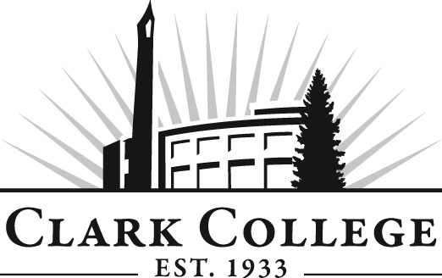

Meeting Guidelines!
- The meeting is run by the committee Chair or Vice Chair
- The meeting will be more effective if the committee is engaged and participates in discussion
- Motions must be proposed, seconded, and voted on: you can vote in favor, oppose, or abstain.
- Please respect the schedules of members and keep to time

