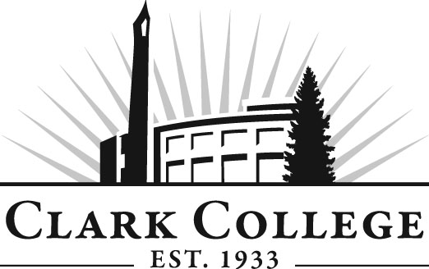

PARALEGAL ADVISORY COMMITTEE
MINUTES
Date: May 8, 2013
Time: Noon-2:00 p.m.
Penguin Union Building, Room 258B

Members Present: Mickey Thompson, Baumgartner, Nelson & Price; Lori Hughes, Miller Nash, LLP;
Diane L. Thompson, CP, RP, Markowitz, Herbold, Glade & Mehlhaf PC; Yolanda Morales, Miles & Miles,
P.S.; Silvia Czafit, Joshua J Bean, PLLC; David Albalos, Graduate of the Program; Pat Janik, MacDonald
Center

Members Absent: Trent Kunz, Committee Chair, Salmon Creek Law Offices; Stefanie Ellis, Vice Chair, Green & Ritchie PLLC; Leslie Hinton, Clark County Skills Center; Rhonda Kates, Landerholm, Memovich, et al; Lincoln Harvey, Attorney; Dean Goff, Charter Communications; Greg Gonzales, Judge, Clark County Superior Court

Clark College: Layne Russell, Director, Paralegal Department; Lynn Hissman, Paralegal Adjunct; Rose White, Student in the Program; DeAndra Macheras, Student in the Program; Debbie Rock, Student in the Program, Brittany Brist, Advisor; Andreana DiGiorgio, Secretary Sr., Advisory Committees
________________________________________________________________________

The meeting was called to order by Paralegal Director Layne Russell with introductions. Layne stated there is no quorum present and so we will defer any necessary votes to an email vote. He thanked the members for attending today’s meeting.

Review of the Minutes of the Previous Meeting:
A motion was made to approve the minutes via an email vote. The motion was seconded. The minutes will be sent via email after today’s meeting for a vote to approve.

Office of Instruction Updates-Advisory Committee Business:
Director of Academic Services, Dedra Daehn, told the committee that they should have received an invitation to the Advisory Committee Recognition Reception being held on Thursday, June 6, 2013. She explained that it’s a “come and go” event between 5:30 and 7:30 p.m. Dedra told the committee members that the reception is a way for Clark College to thank all of the committee members for the time and effort they give to Clark and its students. She said that if they plan to attend the reception to please RSVP with Andreana.

Dedra also passed around the roster for the members to mark their attendance, but also asked them to make sure their “employee/employer” representation is accurate. She added that the State of Washington looks closely at this balance when curricular changes are submitted for approval.

Director/Division Chair Report:
ABA Approval and New Limited Licensed Legal Technician (LLLT). Layne discussed ABA approval. He also updated the Committee on the LLLT. The State of Washington Supreme Court announced that it is putting forth the Limited Licensed Legal Technician (LLLT). The order from the court came out spring 2012 but the court is in the process of development. He said it is looking like the Legal Tech is going to be for those working in family law, as a less expensive legal option for underrepresented folks. Currently, the Court’s plan would permit graduates from ABA approved programs to sit for the LLLT exam.

Admissions Standards Update. Layne reported that the committee voted electronically to support new admission standards and he will finalize the process with the Curriculum Committee. English 111 is the admission prerequisite before moving into the Paralegal program.

Graduate Survey. About 26 graduates of the program have responded so far. For the grads who haven’t responded, Layne and his staff will call and email them.

New Committee Members. Next Layne introduced the two new committee members: Pat Janik and George Middleton. He thanked them both for their time and support to the committee, Clark College and its students.

ABA Defined & Measurable Program Goals (Outcomes). Seventeen courses have been approved so far for course objectives. There are 4 or 5 more to do. This is all part of the accreditation process.

Law Club Update. Rose White gave an update on the silent auction for their trip to Washington DC. They received many donations, including items and cash. It was April 20 at the Red Lion in Vancouver. They raised over $12,000. She said it was a great event with a lot of legal people from the community including judges, lawyers, and legal secretaries and paralegals. There will be more fundraisers. The DC trip has been approved. Mickey Thompson added that the club raised $4,000 in auction items and of the 104 items only one did not sell and it will be donated. She said the law club students work very hard and are tenacious. She said she looks forward to the law club getting more involved with the Clark County Bar Association, the Rotary Club and other law affiliated groups.

There was a discussion about the annual Convention of the Oregon Paralegal Association. There is a scholarship essay available to attend the convention. Last year three scholarships were awarded and two of the people got jobs because of the convention.

Meeting was adjourned at 12:50 p.m.

Next Meeting Date:
Thursday, November 7, 2013 noon – 2:00 p.m.

Submitted/prepared by Andreana DiGiorgio

