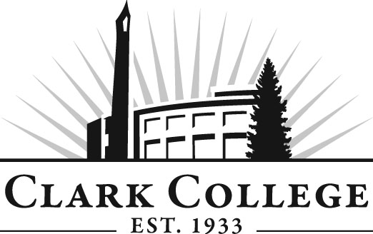

PARALEGAL ADVISORY COMMITTEE

MINUTES
Thursday, May 10, 2012
12:00-2:00 PM
Joan Stout Hall 124

Members Present Representing
Leslie Hinton Clark County Skills Center
Trent Kunz, Committee Chair Salmon Creek Law Offices
Mickey Thompson Baumgartner, Nelson & Price
Lincoln Harvey Attorney
Diane L. Thompson, CP, RP Markowitz, Herbold, Glade & Mehlhaf PC
Greg Gonzales Judge, Clark County Superior Court
Stefanie Ellis Green & Ritchie PLLC
Yolanda Morales Miles & Miles, P.S.
Silvia Czafit Joshua J Bean, PLLC

Members Absent
Rhonda Kates Landerholm, Memovich, et al
Lori Hughes Miller Nash, LLP
Dean Goff Charter Communications

Clark College
Layne Russell Director, Paralegal Department
Dedra Daehn Director, Academic Services & Innovation
Mary Evens Divisional Chair, BTEC
John Maduta Advisor
Rose White Student in the program
Natallie Graham Student in the program
Candace DeGroote Student in the program
Angela Kraft Student in the program

Meeting was called to order by Committee Chair, Mr. Trent Kunz, with introductions. Director Layne Russell thanked everyone for attending today’s meeting. He particularly appreciated the students in the program attending.

Review of the Minutes of the Previous Meeting:
A motion was made to approve the minutes as written. The motion was seconded and unanimously approved.

Advisory Committee Business:
Ms. Dedra Daehn said she is working with all the advisory committees updating their work plans for 2012-2013. She said she would like to discuss the various items on the current work plan and revise the plan as needed.

Director Russell talked about the Law Library at Clark College and the effort that has been put into setting up the library. He said he is looking into applying for a grant to be able to purchase the Washington Reporter index because the volumes without the index would not be very useful. The first item on the work plan is ongoing. Director Russell would like to establish a subcommittee to provide oversight for the development of the law library.

Ms. Mickey Thompson said the students are going to miss Mr. Gonzalez as an instructor but he will continue on with the advisory committee to support Clark College’s Paralegal program. Director Russell wanted to keep the Survey Monkey work plan on the list.

Legal Adm. Asst. Curriculum Update: 0.21m
Professor Mary Evens from BTEC spoke on this item. She said she was reviewing the legal administrative assistant program. There is a certificate of proficiency for Legal Administrative Assistant but there is a requirement for the students to take BTEC 150. Professor Evens said many students take individual Word and Excel courses so BTEC 150 is redundant. Professor Evans asked that the committee agree to remove that class from the requirement and put another class in its place. One member suggested PowerPoint and Professor Evens said that could be added as well as BTEC 169. BTEC 169 is a pre-req for 170, which is advanced Excel. A motion was made to remove BTEC 150 and replace it with PowerPoint 165 and BTEC 169. The motion was seconded and unanimously approved. A new motion was made to make BTEC 169 a pre-req for BTEC 170. The motion was seconded and unanimously approved.

Outcomes Assessment:
Professor Russell said he is working with each of his courses to come up with measurable outcomes. For PRLE 102, Legal Ethics, he said it is very difficult to measure students’ compliance within each of the courses when students are not working with clients. He said he will work with the faculty to make sure the outcomes he has come up with are reasonable.

Electives:
Professor Russell said he has been watching the enrollment each year in the electives. He also said he is making sure required courses run each year and some even twice a year, if necessary.

Professor Russell said Paralegal AAS degree is designed for students with no prior college and law office experience. The Paralegal Certificate of Proficiency is designed for students with prior college and law office experience. Professor Russell asked the members to review the classes for both the Certificate and the Degree and let him know if they feel students coming in with a college degree or prior law office experience should be required to take the classes listed on the Certificate of Proficiency. A motion was made to add PRLE 150 to the Certificate Program as a required course and Business Law as an Elective. The motion was seconded and unanimously approved.

Next Meeting Date:
Thursday, November 1, 2012.

