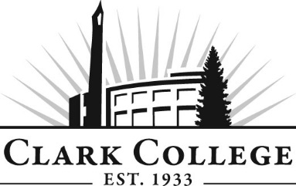

Paralegal Advisory Committee

Meeting Agenda
Date: Thursday, May 10, 2012
Time: 12:00-2:00 PM
Meeting Room Location: Joan Stout Hall 116

- Call to order- - - - - - - - - - - - - - - - - - - - - - -Mr. Trent Kunz, Committee Chair

- Welcome & Introduction

- Approval of minutes from last meeting

- Open issues

- Advisory Committee Business- - - - - - Dedra Daehn, Office of Instruction

- Work Plan- - - - - - - - - - - - - - - - - - - - Dedra Daehn, Office of Instruction

- Library Status (Collections, Library Space, PRLE 103) and Dean’s Ranking for Foundation Grant

- Budget

- Outcomes Assessment

- 2nd year enrollments

- New business

- PRLE 150 Interviewing, Investigation and Evidence for the Certificate Program
- BUS&201 Business Law for Certificate Program

- Mary Evens – Legal Adm. Assistant Curriculum Update/Changes

- 2012/13 PRLE Schedule

- Next Meeting Schedule

