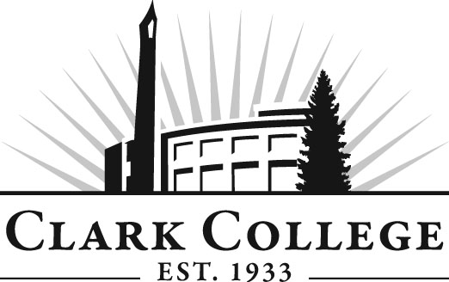

PARALEGAL ADVISORY COMMITTEE
MINUTES
Wednesday 20th April, 2016
11:00 am-1:00 pm
T-Building 101

Members Present: Rhonda Kates, Landerholm, Memovich, et. al.; Pat Janik, Retired, MacDonald Center; Lori Hughes, Miller Nash, LLP

Members Absent: Lori Smith, Committee Vice Chair, Horenstien Law Group; Holly Swofford, Shumsky & Backman Silvia Czafit, Joshua J. Bean, PLLC; Leslie Hinton, Clark County Skills Center George Middleton, CPA, Limoges Investment Management PC;
.
Clark College: Layne Russell, Paralegal Program Director; Genevieve Howard, Dean of Workforce & Career Tech Education; John Maduta, Advising Divisional Manager, Professional Technical Programs; Cathy Sherick, Assoc. Dir. Of Instructional Programming & Innovation; Nichola Farron - Secretary Sr., Advisory Committees

The meeting was called to order by Dean Genevieve Howard at 11.04am

In the absence of a quorum, it was decided that the November 10th 2015 meeting minutes will be presented for approval by email vote. As of 4/22/16, the minutes have been approved according to the quorum requirement

Office of Instruction Updates

Cathy Sherick announced the forthcoming publication of the Academic plan which will soon be available for viewing. In addition, she provided the committee with a demonstration of the Career Coach tool available on the college website.

Director/Division Chair Report

Genevieve Howard presented the committee with an update on the status of the teach-out etc.

The program has been formally deactivated and no new students will be accepted.

In response to a question from Rhonda regarding timeline, Dean Howard explained that Clark has 3 years to remove program from inventory. The College has identified all students that have claimed paralegal as intended program of study over past 7 years – (any credits gained over 7 years ago would not be honored) Students were then asked to declare an intention to return to the program within a teach-out structure. The letter was sent out on March 15th with a month given to complete the Major Declaration Form to ensure that they were included in the teach-out process. Seventy-five responses were received, including six that are for related paralegal programs. Deadline was last Friday and college is currently in the process of reviewing the transcripts of all students who indicated they will be part of the teach-out. Based on what is needed the College will develop a quarter-by-quarter schedule of classes. Teach out needs to be streamlined with students aware that there are time constraints on completion. Genevieve indicated she has experience of 5 teach outs, but this is the first that is not a cohort.

Rhonda inquired whether any adjuncts have been lost as a result of the decision to eliminate the program: the consensus was that it was too early in the teach-out to see. Dean Howard shared that the VP at PCC has reached out with an offer of help. Clark also looking for a professor to take over some of the teaching.

Layne expressed concern that the Law Library collection is now under threat; Dean Howard assured the committee that she will ensure the continued provision of those materials throughout the teach-out.

Advisory Committee Status

Genevieve shared with the committee that it is still a state requirement that they continue to meet throughout the-teach out process. In addition, supporting the students will remain a high priority. In particular, the college will look to ensure opportunities for internships, and the committee will be vital in networking and helping with that part.

Future meetings will likely be shorter with specific agendas.

John reiterated the importance of internship opportunities for students on the teach-out program, as there may be as many as 10 to 15 students requiring a placement at any one time and they are essential to completion.

Next Meeting Date

The committee agreed to meet again on October 12, 2016.

The meeting was adjourned at 11.40am.m.

Prepared & submitted by Nichola Farron

