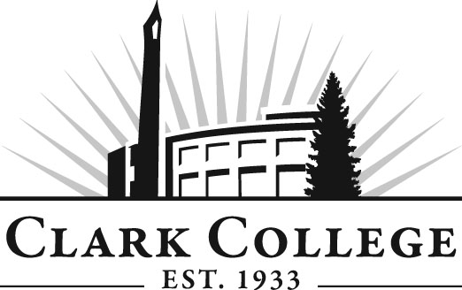

PARALEGAL ADVISORY COMMITTEE

MINUTES
Tuesday, October 18, 2011
12:00-1:00 PM
JSH 124

Members Present Representing
Leslie Hinton Clark County Skills Center
Rhonda Kates Landerholm, Memovich, et al
Mickey Thompson Baumgartner, Nelson & Price
Lori Hughes Miller Nash, LLP
Lincoln Harvey Attorney at Law
Diane Thompson, CP, RP Markowitz, Herbold, Glade & Mehlhaf PC
Stefanie Ellis, Vice Chair

Members Absent
Trent Kunz, Committee Chair
Dean Goff
Clark College
Layne Russell Department Head, Paralegal Professor
Mark Baum Professor, Paralegal
Lynn Hissman Paralegal, Adjunct
Tammy Hutchinson Paralegal, Adjunct
Genevieve Howard Dean, WorkForce & CTE
Dedra Daehn Director of Academic Services & Innovation
John Maduta Advising Divisional Manager-Professional
Technical Programs
Gail Conners-Junker Secretary-Senior, Business

Professor Russell called the meeting to order at 12:07 PM with introductions.

Library Status:
Professor Russell said that this project initially got started when the Law Library at the County Courthouse said it would be closed to Clark students as of Spring, 2011 due to budget cuts and they would not be able to staff the library to accommodate the Paralegal class. Professor Russell said a decision was made to form a law library here at Clark College. He said donations came in, Washington State Law Library donated a lot of law books and volumes of the Washington Reporters. He said that it is going to take time to catalogue all the books for the library. He said that he is going to recommend a standing committee from the advisory committee on the library and resources to oversee the library.

Review of the Minutes of the Previous Meeting:
After reviewing the minutes, a motion was made to approve the minutes. The motion was seconded and unanimously approved.

Advisory Business:
Ms. Dedra Daehn announced that the Advisory Recognition Reception is scheduled for Thursday, November 3, 2011 and reminded the members to come and enjoy the evening.

Ms. Daehn also talked about the updated Advisory Handbook which has been posted on the website. She talked about the revisions and additions that were made to this issue.

Work Plan:
Ms. Daehn said the first goal to create a law library has been completed. Professor Russell said goals 1 and 2 are both part of goal 1 and they are ongoing. Mark Baum said the local bar will send the survey out for Clark or sell the list to Clark but it will cost over a $100 so Mark Baum would like to leave it with the County Bar to send it out. The fourth goal, Legal clinic, Mark said he is trying to make it self-sufficient so that it will not have to rely on Clark for funding. The legal foundation may give him the money to create the legal clinic. He is waiting to hear back from them. So the date has been extended on this item.

Outcomes Assessment:
Professor Russell said after the advisory portion of this meeting, the faculty and staff will discuss what outcomes this program is striving for. Professor Russell passed out a form that will be used by the interns’ supervisors in evaluating the interns’ performance. The college wants each program to be able to measure the goals the students achieve.

Second Year Enrollment:
Professor Russell said enrollment tends to drop in the second year, which is the same in other law schools. Clark College thought about dropping the Paralegal program completely but Professor Russell said that the program is necessary here in Washington because students here need to learn Washington state law. Dean Howard said this is common in many other professional and technical programs such as automotive, diesel and paralegal where enrollment drops in the second year.

Miscellaneous:
Professor Russell said that he was able to recruit two alumni to the advisory committee – Dean Goff and Yolanda Morales, who are graduates from the program. They have both agreed to serve on this committee.

Ms. Mickey Thompson talked about the Law Club’s trip to Washington D.C. and said it was the most memorable trip for the entire group. The law club is planning a trip to D.C. every other year now.

Ms. Diane Thompson said that a Paralegal conference is being planned and they have students from many of the regional colleges, but not one student from Clark College has signed up. She said that’s disappointing because she would like to see the students from Clark College come and take advantage of this wonderful learning opportunity.

Meeting adjourned at 1:25 PM.

