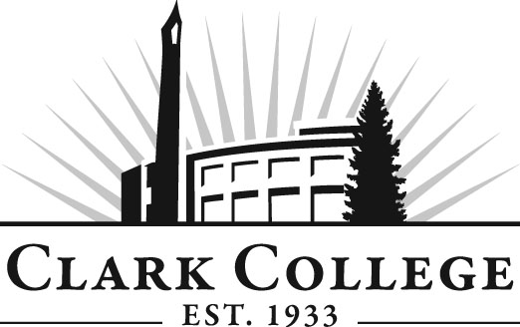

PHLEBOTOMY ADVISORY COMMITTEE

MINUTES
Tuesday, June 5, 2012
5:00-7:00 PM
CCW 124

Members Present Representing
Lisa Gonzalez, Committee Chair Providence Med. Ctr. Milwaukee
Terri Foxx-Wishert PeaceHealth St. John Med. Ctr.
Alicia Quigley Adventist Medical Center
Audrey Lang Adventist Medical
Svetlana Senchuk Providence Med. Ctr. Milwaukee
Lisa Parkman The Vancouver Clinic

Members Absent
Debbie Chenette PeaceHealth South West Med. Ctr.
Nichy Lee Legacy Salmon Creek

Clark College
Debra Ortiz Director, Allied Health
Stephanie Robinson Lead Phlebotomy Instructor
Lori Anderson Clinical Coordinator/Adjunct
Blake Bowers Dean, Business & Health Sciences
Dedra Daehn Director of Academic Services & Innovation
Shelley Ostermiller Advising Divisional Manager
Barb Davenport Credential Evaluations Program Support
Brenda Walstead Outcomes Assessment Liaison for CTEC
Programs

Ms. Lisa Gonzalez, committee chair, called the meeting to order at 5:05 PM with introductions.

Approval of the Minutes of the Previous Meeting:
A motion was made to approve the minutes as written. The motion was seconded and unanimously approved.

Old Business:
- Recommendations to Program Requirements:
- Entry Requirements
Director Ortiz passed out the objectives the committee decided on at an earlier meeting. She said the students will have these outcomes and the written objectives will be used as reinforcements for the students. Outcomes is in everything that is being done right now but we need to pick a few outcomes to use as goals.
- Currently, 2.0 is the cumulative GPA required for incoming students. Pharmacy Tech, Medical Assisting and Phlebotomy all have required minimum GPAs but of these three programs, Pharm Tech has the highest requirement. Director Ortiz explained the changes to the requirements. The committee wanted to increase the GPA requirement to 2.5. Reading and writing was the next area that was reviewed to increase the entry requirement on Compass scores.
- Anatomy and physiology HEOC 1001/101 as well as Lab procedures HEOC 160 are sequence changes.

Summary of the changes:
*Preliminary Requirements
High School diploma or its equivalent required
GPA from 2.0 to 2.5
READ 87 – Critical Reading (or higher) or Compass score to 74
ENGL 98 – Writing Fundamentals (or higher) or Compass score to 78 (from 49)
HEOC 100/101 (or BIOL 165/165) from a co-requisite to prerequisite

Program Requirements
CMST& 210 Interpersonal Communication added as a co-requisite
HEOC 115, 197, & 198 to PHLE 115, 197, & 198
PHLE 197 - Phlebotomy Clinical Experience increasing by one credit (120 to 150 hours)
Cohort – size reduced to 30 (from 40)

Communication:
Director Ortiz said she will be proposing this curriculum to the internal faculty and staff. Ms. Shelley Ostermiller said she said she does not know what kind of impact the changes will have. We may see numbers drop as students will have to have time to become eligible at these new levels.

Mission Statement:
Ms. Gonzalez said she sent out her proposed mission statements to the members but she did not hear back from the members.
Phlebotomy Program Mission Statement:
The Clark College Phlebotomy Program is committed to providing students with a comprehensive professional and practical application of phlebotomy and its relevance to patient care through quality teaching and varied clinical settings.

A motion was made to approve the statement as proposed. Another member suggested that the Mission Statement always be included at the top of the Agenda page. With the Vision Statement, a member suggested having a program that mirrors Clackamas Community College and asked the committee members to start thinking about the Vision Statement.

There will be a tour of the lab tonight after the meeting.

Dean Bowers congratulated Professor Stephanie Robinson for being hired for the tenure track position.

Professor Walstead said the Phlebotomy outcomes were approved by the Outcomes Committee today. The next step is to review the Assessments again and make sure they actually assess the outcomes of the program. It was proposed that the Vision Statement be put on hold and added to the Work Plan for 2012-2013.

The committee will tour the lab now and come back and discuss any open items. The lab tour began at 6:30 PM.

Next Meeting Date:
Tuesday, October 9, 2012 at the main campus.

Meeting adjourned at 6:50 PM.

