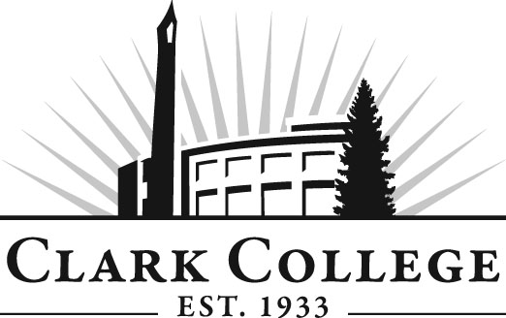

PHLEBOTOMY ADVISORY COMMITTEE

MINUTES
Tuesday, May 8, 2012
5:00-7:00 PM
TBG-101

Members Present Representing
Lisa Gonzalez, Committee Chair Providence Med. Ctr. Milwaukee
Terri Foxx-Wishert PeaceHealth St. John Med. Ctr.
Alicia Quigley Adventist Medical Center
Audrey Lang Adventist Medical
Svetlana Senchuk Providence Med. Ctr. Milwaukee

Members Absent:
Debbie Chenette PeaceHealth South West Med. Ctr.
Frannie Montgomery Providence Health & Services
Nichy Lee Legacy Salmon Creek

Clark College
Debra Ortiz Director, Allied Health
Stephanie Robinson Lead Phlebotomy Instructor
Lori Anderson Clinical Coordinator/Adjunct
Shelley Ostermiller Advising Divisional Manager
Rhianna Derscheid Credential Evaluations Manager
Brenda Walstead Outcomes Assessment Liaison for CTEC
Programs

The meeting was called to order at 5:10 PM by Ms. Lisa Gonzalez, committee chair, with introductions.

Review of the Minutes of the Previous Meeting:
After reviewing the minutes from the previous meeting, a motion was made to approve the minutes as written. The motion was seconded and unanimously approved.

Director Ortiz said she wanted to share information from NAACL. They do accrediting for all types of programs but not for Phlebotomy.

Mission Statement:
Ms. Lori Anderson will send out her statements for the members to see. She also said Clackamas has a one year program and that the student can train to do other simple tests like urine testing.

Program Outcomes:
Ms. Brenda Walstead talked about the Phlebotomy program and said Phlebotomy is a certificate program. She asked what a student can do as a Phlebotomist. Director Ortiz said we need to narrow the outcomes down to 5 top outcomes and the additional items can be objectives. Ms. Walstead asked the members to write as many outcomes as they can come up with.

Ms. Walstead asked the members to come up to the board and put the notes on the board as they read them out loud. The committee spent some time coming up with outcomes statements for the Phlebotomy program. Most of the meeting time was used in coming up with outcomes for the program.

Ms. Walstead asked the committee to bring the outcomes statements back to the next meeting. She also said the committee will look at the Mission Statement at the next meeting.

Next Meeting:
Tuesday, June 5, 2012, CCW 124

