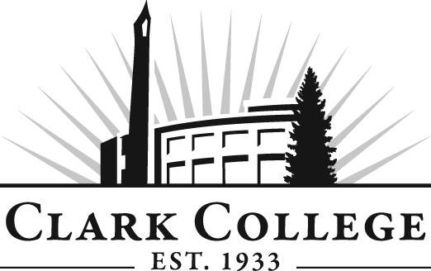

**Phlebotomy Advisory Committee**

**Meeting Agenda**

**Date: Wednesday, May 15th, 2013**

**Time: 5:00-7:00 p.m.**

**Meeting Room Location: CCW 124**

**Phlebotomy Program Mission Statement:**

The Clark College Phlebotomy Program is committed to providing students with a comprehensive professional and practical application of phlebotomy and its relevance to patient care through quality teaching and varied clinical settings.

|  |  |  |
| --- | --- | --- |
| **Agenda Item** | **Expected Outcome** | **Time** |
| 1. Call Meeting to Order – Lisa Gonzalez, Committee Chair | N/A | 5 min. |
| 1. Welcome and Introductions – Lisa Gonzalez, Committee Chair | New members/guests introduced | 5 min. |
| 1. Approval of Minutes from Last Meeting - Chair | Corrections indicated and/or approval of minutes as written. | 5 min. |
| 1. Office of Instruction Updates- Advisory Committee Business-Dean Business & Health Sciences, Blake Bowers or Dedra Daehn  * Review of committee membership * Virtual notebook * Labor market reports |  | 15 min. |
| 1. Director Report – Debbie Ortiz |  | 10 min. |
| 1. Work Plan-Committee Chair and Program Lead  * Student handbook – Stephanie * Clinical evaluation form and midterm progress report – Stephanie * Equipment update – Stephanie * Vision statement – Stephanie Robinson | Implement strategies as outlined in work plan. If necessary, identify work groups. | 35 min. |
| 1. Old Business-Follow-up- Committee Chair  * State requirements - members |  | 15 min. |
| 1. New Business-Committee Chair  * Bar code scanner * NAACLS accreditation | New business items are addressed by the committee. | 20 min. |
| 1. Establish next meeting date (and day) – Committee Chair | Meeting date established. | 5 min. |
| 1. Summary of follow-up action items and adjournment – Committee Chair | Summary of follow-up actions communicated to the committee. | 5 min. |