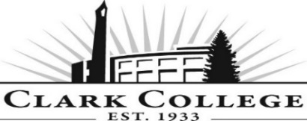
Advisory Committee
Phlebotomy Meeting Agenda
Date: Wednesday, May 11th, 2016
Time: 5—7 pm
Meeting Location: Clark College at WSU (CCW), Room 124

Phlebotomy Program Purpose Statement:
The Clark College Phlebotomy Program is committed to providing students with a comprehensive professional and practical application of phlebotomy and its relevance to patient care through quality teaching and varied clinical settings.
Agenda Item | Expected Outcome | Time
- Call Meeting to Order – Lisa Gonzalez, Committee Chair | N/A | 5:00 – 5:05pm
- Welcome and Introductions – Lisa Gonzalez, Chair | New members/guests introduced | 5:05 – 5:10pm
- Approval of Minutes from Last Meeting – Chair  - November 18th, 2015 | Corrections indicated and/or approval of minutes as written. | 5:10 – 5:15pm
- Office of Instruction Updates- Advisory Committee Business – Cathy Sherick |  | 5:15 – 5:25pm
- Director/Lead Faculty Report – Debra Ortiz & Dr. Amy Castellano |  | 5:25 – 540pm
- Work Plan-Committee Chair and Program Faculty  - Student selection process  - Equipment review  - Program Review with Clinical Preceptors  - Graduate surveys  - Identify new clinical sites  - Vision 2020/Academic Plan Update | Implement strategies as outlined in work plan. If necessary, identify work groups. | 5:40 – 6:30pm
- Old Business-Follow-up- Committee Chair |  | 6:30 – 6:40pm
- New Business-Committee Chair  - CMST& 220 Public Speaking as an potential option for the Communications requirement  - Cohort size | New business items are addressed by the committee. | 6:40 – 6:50pm
- Summary of follow-up action items and adjournment – Committee Chair | Summary of follow-up actions communicated to the committee. | 6:50 – 6:55pm
- Establish next meeting date (and day) –Chair | Meeting date established. | 6:55 – 7:00pm

