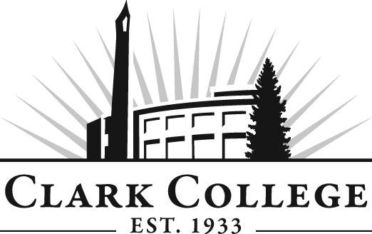
Professional Baking Advisory Committee
Meeting Agenda
Date: Tuesday March 15th 2016
Time: 2:30—4:00 p.m.
Meeting Location: GHL 215 (TBC)

Agenda Item | Expected Outcome | Time
- Call Meeting to Order – Committee Chair | N/A
- Welcome and Introductions – Committee Chair | New members/guests introduced | 5 min.
- Approval of Minutes from Last Meeting – Chair  - October 21st, 2015 | Corrections indicated and/or approval of minutes as written. | 5 min.
- Office of Instruction Updates- Cathy Sherick |  | 10 min.
- Director/division chair Report | -Program completion  -CIA consultant  -move out May 2nd  -Added two Eurodib 20 quart spiral mixers and one more rack oven.  -Small wares list has been ordered  - Review of Advisory Board Employer Engagement Seminar (held Friday 11th March) | 20 min.
- Work Plan-Committee Chair and Program Director/Division Chair | Review work plan. Implement strategies as outlined in work plan. If necessary, identify work groups. | 15 min.
- Old Business-Follow-up- Committee Chair |  | 5 min.
- New Business | -During the hiatus, the new culinary and baking instructors will be recruiting and getting the new name out to the public:  -Review of general follow up activities Advisory Board network opportunities etc.  - Equipment surplus Auction  - Clark Careers information: ‘Clothing Closet’, Careers Days etc. | 10 min.
- Summary of follow-up action items – Committee Chair | Summary of follow-up actions communicated to the committee. | 5 min.
- Establish next meeting date and adjournment – Committee Chair | Meeting date established. | 5 min.

