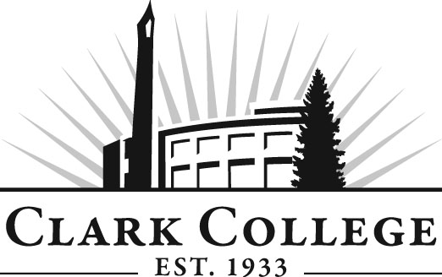

PROFESSIONAL BAKING ADVISORY COMMITTEE

MEETING MINUTES
Tuesday, April 9, 2013
2:30-4:30 PM
Gaiser Chocolate Lab

Members Present Representing
Jesse Dodson, Committee Chair New Seasons Market
Tim Briare, Vice Chair Westco Bakemark
Lisa Dachsel Aquariva Restaurant/Student in the Program
Janelle Kountz Papa Haydn

Members Absent
Daniel Bes Marsee Baking
Ivy Manning Cookbook Author
Sarah Hart Alma Chocolate

Clark College
Ian Titterton Professional Baking Department Head
Alison Dolder Baking Instructional Tech
Genevieve Howard Dean, Workforce & CTE
Dedra Daehn Director, Academic Services & Innovation

Committee Chair Jesse Dodson called the meeting to order at 2:35 p.m.

Review of the Minutes of the Previous Meeting:
After reviewing the minutes of the January 22, 2013 advisory meeting, a motion was made to approve. The motion was seconded and unanimously carried.

Office of Instruction/Advisory Committee Business:
Dedra Daehn, Director of Academic Services, announced that Clark College is planning an advisory committee recognition reception to take place on June 6, 2013 in the Fireside Lounge in the PUB building. It will be a come and go event from 5:30 p.m. - 7:30 p.m. She said an invitation would be sent to members in April.

Perkins Grant. Dedra reported that Perkins grants are underway for academic year 2013-14. This is federal finding that comes through the state and supports Clark’s career and technical programs. Requests are due April 11. 2013.

Worker Retraining Grant. Dedra also reported that the Worker Retraining grants are also underway. She reminded the committee that this funding is used to support and provide education, training, and career services for dislocated and unemployed workers. These moneys can also support some of Clark’s adjunct faculty and equipment needs. The due date for requests is April 25, 2013.

Vision 2020.Dedra reminded the committee that Clark has been gearing up for the next planning cycle and part of this includes the vision 2020 campaign. This campaign will help the college look ahead a few years and figure out where the college will be in the year 2020 by gaining input from students, faculty and staff, advisory committee and community members. She asked the committee members to think about what they would like to see in the Professional Baking program by the year 2020 and to submit their thoughts to Ian Titterton or Genevieve Howard. This is a work plan item and will be discussed at the advisory meetings on an ongoing basis.

Director/Division Chair Report:
Division Chair Ian Titterton reported that the Professional Baking program continues to be recognized as a training center, not only in skill but also in theory. The program is full every quarter. Five students graduated last quarter. He reported that $6,000 in Perkins money was used to purchase large mixers. Six stainless steel bowls were also purchased. Ian reported that the Anderson funding request has been submitted.

Culinary Task Force. The task force is collectively working on revamping the culinary program and is actively writing up a proposal. The proposal will go to the Executive Cabinet for approval. The most logical expansion would be to add a second floor to the culinary area of the building and the expansion will include the Baking program. Ian indicated that this is a great opportunity for the committee to provide input regarding equipment and other program needs.

New Seasons Commissary. Ian reported that this is scheduled for grand opening in August. Jesse Dodson, who is involved in this process, reported that it is a big project and said that this is the largest amount of money New Seasons has ever spent on one project. He reported that he has been busy exploring automation machinery and will take a trip to Italy next month to meet with the makers of the Virtuetti machinery line, which makes bun makers. He mentioned that New Seasons is looking at opening commissaries in 3 more stores between now and next year. Ian stated that this will be a great opportunity for internships for students.

Work Plan:
The committee looked at the 2012-13 work plan.

Equipment Goals. This will stay on the work plan as is and ongoing.

Ian encouraged members to come in and present their experiences to the students. Lisa Daschel volunteered to do this. Jesse suggested one of his baking managers. They decided Tuesday or Thursday would be the best day for presentations.

Program pre-requisites were discussed. Dean Genevieve Howard reported that it is important for students to have basic skill levels in reading, writing, and mathematics. None have been identified as of yet but she suggested that an applied math course be required to be permitted into the program. Genevieve said this is something that will continue to be looked at.

New Business:
Dedra mentioned that the chair and vice chair two-year terms are up. She called for nominations. Lisa Daschel and Tim Braire were nominated for chair and vice chair respectively. Motions were made and seconded, and the vote was unanimous.

Jesse Dodson summarized the meeting and a fall meeting date was discussed. The committee agreed on Tuesday, October 1, 2013, at 2:30.

The meeting was adjourned at 2:30 p.m.

Prepared/submitted by Andreana DiGiorgio

