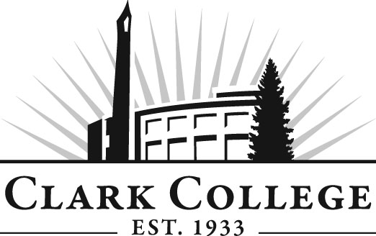

PROFESSIONAL BAKING ADVISORY COMMITTEE
MEETING MINUTES
Tuesday, February 17, 2015 * 2:30-4:30 p.m.
Gaiser Chocolate Lab

Members Present: Lisa Withers, Committee Chair, Mirolo Chocolatier; Tim Briare, Vice Chair, Westco Bakemark; Jesse Dodson, New Seasons Market Janelle Kountz, New Seasons Central Bakery; Bonnie Brasure, Bleu Door Bakery

Members Absent: Janelle Kountz, New Seasons Central Bakery; Bonnie Brasure, Bleu Door Bakery

Clark College: Alison Dolder, Professional Baking Department Head & Instructor; Genevieve Howard, Dean of CTE Programs; John Maduta, Advising Divisional Manager; Andreana DiGiorgio, Secretary Senior

Committee Chair, Lisa Withers, called the meeting to order at 2:36 p.m. and the committee members introduced themselves.

After a review of the November 18, 2014 meeting minutes, a motion was made to approve as written. The motion was seconded and the motion carried.

Office of Instruction
Andreana reminded the committee that the College has planned an advisory member recognition breakfast on March 18, 2015 from 7:30—9:00 a.m. Regional economist Scott Bailey will be guest speaker and will give an economic report on the state of Washington and also our region. She asked the members to please RSVP if they planned to attend.

Director/Division Chair Report:
Interim Department Head, Alison Dolder, said that the college has decided on a new name: “Clark College Culinary Academy.” Underneath this title will be the Culinary Arts and Bakery programs.

Curriculum update. Alison told the committee she would like to see three different areas in the Baking program: Breads, cakes, and French bakery. These will be the main classes in the program. Other classes will be store products, early morning products and barista. This is still a work in progress. They will also offer shorter classes so that students can meet their credit requirements. Currently thinking about how the remodel will work around the new curriculum. The second year of the program will cover management or specialized area such as pastry, bread, etc.

Tim Briare asked if the committee will be involved with the curriculum changes. Genevieve explained that all Career and Technical Education program curriculum must be approved by the various committees and so these curriculum changes will need to be approved by this advisory committee. They will be able to give their feedback and suggestions as curriculum is written for this new program.

Work Plan
The committee reviewed the work plan and updates were recorded including:

- Techs will be talking with each student and giving feedback from the technician. This will be timelier for the students. Students like this as they now know where their strengths and weaknesses are.
- Two freezers died recently. The triple door freezer is going to be replaced and purchased out of the remodel budget. The other freezer has been repaired.
- Met with the architectural firm, Yost Grove Hall out of Portland. They have experience in kitchens and like facilities. This firm was the only one that had educational facility experience.
- Alison invited Tim Healy, owner of Little t America Bakery and he showed interest in becoming a member of this committee.
- The Business Management class has been given an assignment for promoting the bakery. They created a Twitter feed and students also created a flyer that will be posted around campus and outside as well.

Old Business
Remodel update. The college is looking at fall 2016 for the start of the remodel. In spring we should have a more definite timeline. The hope is to phase the progress so disruption stays at a minimum.

New Business
Committee membership. Genevieve thanked the members for their time and feedback. She said since this program is in a transition phase, she would like to increase the size of the committee. She wants to make sure all areas are represented through committee membership. The goal is to make sure the program continues to provide this community with students who are job ready. She asked the members to look around and if they know of someone who would be a good fit on the committee to invite them to the next or future meetings.

Genevieve told the committee that Alison will need a sounding board to bounce all the different aspects of the remodel. Jesse said that someone in the Bay Area uses special wall panels where you can change walls easily. He thought this may be something that could be utilized.

Currently the Clark College Foundation has made fund raising for the Culinary/Baking remodel their number one priority on their list of raising funds.

Community members can come and teach on an adjunct basis. Tim said he loved coming in to talk to students.

Lisa summarized the meeting and they agreed on the next meeting date: Tuesday, May 19, 2015 at 2:30 p.m.

The meeting was adjourned at 3:30 p.m.

Prepared/submitted by Andreana DiGiorgio

