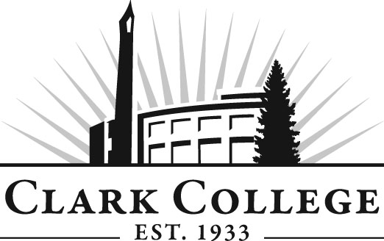

PROFESSIONAL BAKING ADVISORY COMMITTEE

MINUTES
Tuesday, October 11, 2011
2:00 PM to 3:30 PM
JSH 115

Members Present Representing
Tim Briare, Vice Chair Westco Bakemark
Sarah Hart Alma Chocolate
Ivy Manning Cookbook Author
Jesse Dodson, Committee Chair New Seasons Market
Lisa Dachsel Simply Sweets/Student in the Program

Members Absent
Daniel Bes Marsee Baking

Clark College
Ian Titterton Professional Baking Department Head
Genevieve Howard Dean, WCTE
Dedra Daehn Director, Academic Services & Innovation
John Maduta Advising Divisional Manager-Professional
Technical Programs

Mr. Jesse Dodson, committee chair, called the meeting to order at 2:05 PM with introductions. Professor Ian Titterton introduced Ms. Lisa Dachsel from Simply Sweets store. Professor Titterton said that Ms. Dachsel is also a student in the program.

Approval of Minutes from the Previous Meeting:
The members reviewed the minutes of the previous meeting and a motion was made to approve the minutes as written. The motion was unanimously approved.

Advisory Committee Business:
Dedra Daehn reminded the members of the upcoming Advisory Recognition Reception on November 3rd.

Ms. Daehn also talked about the Advisory Handbook and that a recently revised issue was now posted on the advisory homepage and she encouraged the members to go through the booklet. She said that there have been updated information on page 6 of the handbook regarding the work plan and some ideas that the advisory committees could include in their work plans. Pages 6 and 7 also include information on how advisory members can become more engaged in committee activities. Also, questions such as do students on the committee and adjuncts have voting privileges. Ms. Daehn said hard copies of the textbook will not be printed but will be available on the website. She is also planning to have Orientation sessions with each new committee member so that they are familiar with advisory committee meeting proceedings before they sit in on their first meeting.

Work Plan:
Ms. Daehn said the Work Plan needs to be updated for 2011-2012. She said the Work Plan can include goals such as input on Curriculum, Facilities Improvement, and she also encouraged the committee to develop a 3 to 5 year equipment plan. Dean Genevieve Howard said she would like the committee to identify the equipment needs and as budgets become tighter and tighter, consider what is going to happen on the state level while trying to keep CTE programs in a good position. When money should become available, the programs will have an equipment plan that they can go to right away to see what the priorities are.

Mr. Dodson asked how the committee can help in putting together an equipment plan. He asked if the committee should do an audit of the kitchen to see what needs there are in the equipment right now. Professor Titterton said Clark College Foundation has been very generous with the program and that they are working hard to revamp the old department right now. Dean Howard explained there is a potential donor for the Culinary Program but nothing is definite yet, and that she hoped she would know something more definite soon. The members said they would be happy to do anything to help the foundation in ensuring that the donor decides in favor of the culinary program. Dean Howard said that she will let the foundation know that the advisory members are enthusiastic about helping the foundation in any way possible.

Dean Howard said she attended a conference at University of Washington in Skagit Valley. She said the program was well organized, staffed by University of Washington staff. She said the discussions by the millers and farmers were good and also included distribution center operators who move the products more efficiently for the farmers, millers and packers.

Professor Titterton said when he started years ago, he was encouraged as a student to look at the power of the manufacturing system but now the public is looking at hand made, locally produced items and he felt the public needs have come full circle from the days when products were locally made by hand. Mr. Dodson said right now, small private businesses were thriving. He said that for the management students, discussions should include the different tiers of business sizes and how in this economy a business has to grow.

Mr. Dodson said that growth in the local artisan bread market has taken off. He said that New Seasons will open a Vancouver store on November 9th this year, and will have about 105 bakery employees. Professor Titterton said that he would like to bring in medium to large bakery reps to allow the students to learn more about the different size businesses.

Internships:
Professor Titterton said he was feeling more positive lately with internship sites becoming more available. He reported that one student just got hired by Whole Foods and another by Marsee Baking in Portland.

Bean to Bar Chocolate:
Professor Titterton said he revisited a cacao farm in Belize. He said he went to a local bakery which was turned into a chocolate shop. He said he researched some smaller bean roasters, and chocolate machines that are specifically designed for research and development for students. He was able to find reasonable equipment for the classroom for under $1,500. Ms. Sarah Hart added that bean to bar chocolate is becoming very popular and thought it would be worthwhile for the college to invest in this equipment.

Industry Updates:
The members each gave industry updates. Ms. Hart said her chocolate business is still busy and Ms. Ivy Manning said cookbooks outsell all other types of how-to book. Mr. Briare said Bakemart will be moving from Beaverton to Gresham soon and will be expanding their operating space.

Next Meeting:
January 24, 2012 from 2 PM.

Meeting adjourned at 3:10 PM.

