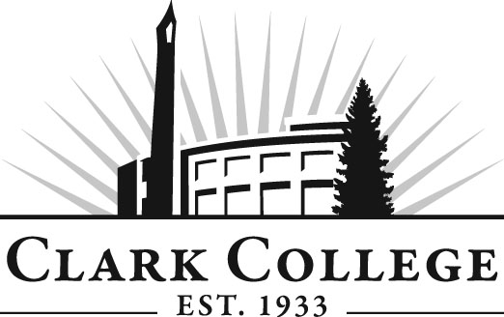

Professional Baking Advisory Committee

Meeting Agenda
Tuesday, October 11, 2011
2:00-3:30 PM
Joan Stout Hall, Room 115

- Call to order- - - - - - - - - - - - - - - - - - - - - - Mr. Jesse Dodson, Committee Chair

- Welcome & Introduction

- Approval of minutes from last meeting

- Open issues

- Advisory Committee Business- - - - - - Dedra Daehn, Office of Instruction

- Work Plan- - - - - - - - - - - - - - - - - - - - Dedra Daehn, Office of Instruction

- Follow up report from Kneading Conference West, Sept 15 - 17, 2011.

- New business

- Growth in local Artisan Bread market will create new baking positions.

- Follow-up Report from Kneading Conference West, Sept. 15-17,2011

- Growth in local Artisan Bread market will create new baking positions

- Student Successes, Placements and Internships

- Bean to Bar Chocolate

- Foundation Funding

- Next Meeting Schedule

