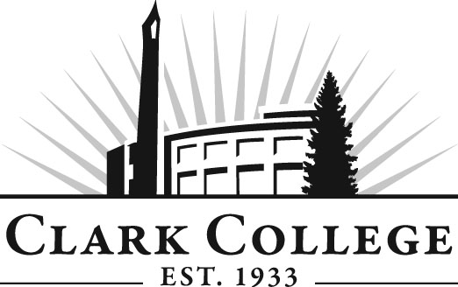

NETWORK TECHNOLOGY
ADVISORY COMMITTEE

MINUTES
Tuesday, June 7, 2011
5:00-6:15 PM
JSH 244

Members Present Representing
Gary Liberman, Vice Chair New Edge Networks
Jeff Groff, Committee Chair Clark PUD

Members Absent
Randy Rooney Integra Telecom
Jamie Daubenspeck ECOS Consulting
Joe Edelen Daimler Trucks North America LLC
Dave Scheuch Clark County OBIS

Clark College
Dwight Hughes NTEC Department Head/Professor
Robert Hughes CTEC Department Head/Professor
Diane Alderman CTEC/DNET Instructor
Adam Coleman CTEC Instructor
Jason Herz CTEC Instructor
Dedra Daehn Director of Instructional Planning

Mr. Jeff Groff, committee chair, called the meeting to order at 5:15 PM with introductions. Professor Dwight Hughes introduced Adam Coleman as the new fulltime tenure track professor for CTEC. Professor Dwight Hughes also added that everyone was happy with the new degree options in Network Technologies. He said staffing was the real issue right now. He said it is difficult to find teachers to teach courses like Security, CC&P, etc. The one faculty they have right now teaching CC&P is commuting between here and San Francisco, and may not continue much longer.

Professor Dwight said we are trying to hire a fulltime DNET faculty, and ended up with four viable applicants for this position. Professor Dwight said employment outlook for the students graduating from the program is looking good. Integra will have seven openings coming up later this week for lower level customer support positions.

Professor Dwight said that donations have been received and appreciated. The donations came from UL worth about $25,000, from Cisco of switches, HP Servers, hard drives and whole racks, with more coming such as Cisco switches, an additional 30,000 to 50,000 in donations. Professor Dwight said he will be receiving more donations of servers from Concordia, also. Did not get any funding for the data center, in fact, did not get any funding for that.

Professor Dwight said he will be on sabbatical for winter and spring quarters working on the security program. Dedra suggested to Dwight that there are some Perkins funding that might be available for Dwight’s research during sabbatical.

Computer Support Specialist Update – Professor Robert Hughes:
Professor Bob said there is no longer a program called Micro Computer Support Specialist but will be called Computer Support Specialist. Professor Bob Hughes said Adam Coleman has come in as a fulltime tenure faculty and will be acting as a lead for the certificate program. He also said there will be many Cisco upgrades coming up in the next eighteen months, with lots of Labs and resources added into that certificate. A+ is 6 credits for 8 hours. Certificate computer support specialist degree, with CCNA class and UNIX included, and a higher level of math were set up. He is working on pathways documents and that has allowed them to see a stronger link between support programs and the networking programs. Dedra said they are excited about building a link between O*Net and current CTE program pathways.

Professor Bob also said they have had real problems in the last few years to maintain networking co-ops. Professor Dwight created a capstone to fill in for lack of co-op sites.

In the fall, AA4, 110 will be setup as a free help desk. Professor Bob will have an update.
He would like to see capstone projects replace co-ops. In the future DNET will have co-ops and capstones.

Progress on Goals:
Professor Dwight said Dedra helped with the framework of goal setting on articulation with four year schools. Professor Dwight has been working on articulations with four year schools and there was only one completed, which was Eastern Washington. Since we have new degrees, Professor Dwight said he got together with Eastern Washington administration to discuss the new degrees and they agreed that the new degrees qualify for the same articulation agreement.

Washington Governors University – Backed by the governors of 19 states. Dr. Ray Korpi helped Professor Dwight on specific articulation for DNET. The articulation agreement now can be used for any 2 year degrees here at Clark. Professor Dwight is looking at DeVry next for an articulation agreement. He wants to be able to offer different options to the students for continuing on to various four year degrees. Mr. Liberman agreed that flexible options were good for the students so they can continue on as best fits their needs.

Discussions on Online Courses:
Professor Dwight thinks we should be doing online courses. Andrew Grimes will be teaching 50% of the classes online this summer. It gives access to larger group of students. Mr. Groff suggested hybrid classes to start. Mr. Liberman also said he agreed that depending on the class, some could be face to face and some could easily be online.

Professor Dwight said he will spend time in the summer to review the 50/50 and discuss it at the fall meeting.

Work Plan:
Dedra said she and Dwight will work on putting the work plan items together and will review it in the fall with the advisory committee to vote on the plan. First item will be the three articulation agreements and the second will be online courses.

Advisory Committee Business:
Dedra announced that the advisory committee meetings beginning in the fall will all be scheduled in SMART classrooms to have access to the computers for reporting. Professor Dwight wanted to know if members could attend meetings remotely so there will be better attendance. Dedra will check with the state board.

Dedra also explained in the future the advisory website will be revised so that log-ins will not be necessary for viewing minutes and agenda but member lists will continue to be protected with log-ins.

Next Meeting:
Mid-October. Send out minutes of the previous meeting for electronic votes.

Meeting adjourned at 6:35 PM.

