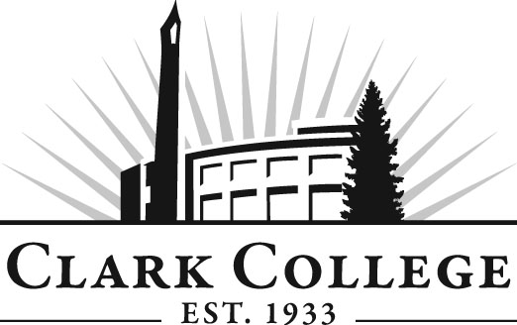

NETWORK TECHNOLOGY ADVISORY COMMITTEE

MINUTES
February 27, 2013
6—8 p.m.
Joan Stout Hall room 127

Members Present Representing
Jeff Groff, Committee Chair Clark PUD
Gary Liberman, Vice Chair Earthlink
Jamie Daubenspeck ECOS Consulting
Nathan Kostrba The Columbian
Michael Mason Wacom Technology Services Corp.

Members Absent
Joe Edelen Daimler Trucks North America, LLC
Wade Stewart eocfwa.org
Nick Lockyear eocfwa.org
Bob Berry TeamLogicIT
Brian Mackay The Columbian Publishing Co.

Clark College
Dwight Hughes NTEC Professor/Department Head
Robert Hughes CTEC Department Head
Adam Coleman CTEC Instructor
Ambra Peters NTEC Instructor
Genevieve Howard Dean, Workforce & Career Tech Ed
Dedra Daehn Director, Academic Services & Innovation
John Maduta Advising Divisional Manager-Professional
Technical Programs
Sarah Weinberger Job Developer, Career Services
Andreana DiGiorgio Secretary Sr., Advisory Committees

The meeting was called to order at 6:05 by Mr. Jeff Groff, Committee Chair and introductions were made.

Review of the Minutes of the Previous Meeting:
A motion was made to approve the minutes as written. The motion was seconded and unanimously approved.

Election of New Officers:
After some discussion, Gary Liberman was nominated for the position of Chair and Jeff Groff was nominated for Vice Chair. A motion was made for the two positions, was seconded, and unanimously approved by the committee.

NTEC Department Head/Chair Report:
Network Technologies Department Head Dwight Hughes reported on the Clark College Foundation Grant request for new Cisco equipment. Dwight is requesting grant dollars for an equipment refresh for his department. He passed out a price quote from SIGMAnet for equipment needs totaling approximately $0K. If this money is approved, the NTEC will be brought up-to-date for Cisco CCNA equipment. A motion was made to support the Foundation Grant request. The motion was seconded and passed unanimously by the committee.

Update on Hybrid Online Approach. This quarter all DNET classes are 25 percent online. One hour of every class is online. It is working out great and students love it.

NTEC 242 Data Center Technology Class. State legislature funded $285K for the purchase of equipment for the datacenter class. This class is going to be revamped to make it more challenging. The data center can also be used for the Microsoft classes. Eventually Dwight would like to see a data center degree program at Clark.

CTEC Department Head Report:
CTEC Department Head Robert (Bob) Hughes reported on the CTEC Department. He said there are three different missions that they’re working on. One is the computer support specialist program, another is the web development degree, which has been approved, and lastly, is the foundational courses that other departments use. CTEC 100 has seen a huge increase in enrollment and currently serves a number of different student populations. The business transfer degrees, this class is required. A lot of students feed into this course. The course is now online, and Adam Coleman will be teaching this class first. There will be three or more CTEC 100 courses offered most every quarter.

Bob updated on the Computer Support Specialist degree. He said that there are two classes that are essential to this curriculum. The classes are the NTEC 221 Cisco CCNA 1 class and the NTEC 232 CompTIA A+ class. Once the student takes these two classes, they can be part of the computer help desk and also have opportunities to explore other NTEC network studies options.

CTEC 200 prerequisite changes. Bob reported that students have to have a “C” or better in both CTEC 104 and NTEC 232 or the consent of the instructional unit in order to be successful in CTEC 120 PC Help Desk Work Experience. Michael Mason asked if a “C” is sufficient. Bob explained that students are carefully chosen to work in the help desk. It was noted that the community loves the help desk, helping the community get their computers fixed. A motion was made to vote on changes in prereqs for CTEC 200 to include both CTEC 104 and NTEC 232 as prerequisites.

The last item under Bob’s report, “Addition of CTEC 230 as a CSS elective” will be tabled until next meeting in spring.

New Microsoft degree. Instructor Ambra Peters reported on this. She reminded the members that Microsoft has changed their certifications recently from Server 2008 to Server 2012. They are also changing the name of the certification from MCITP. After July 31, 2013 the new name for the certificate will be MCSA. The three core classes in the Microsoft program, DNET 234, 235, and 236, will need to have their course titles and descriptions changed to reflect this. She presented two different plans for the future of the Microsoft degree. The committee agreed that Plan B looked best as it aligned with many of the new Microsoft certifications.

New Business
Dean of Career & Workforce Technical Education Genevieve Howard spoke to the committee about Vision 2020. This is an activity the college is taking on to visualize where Clark College will look like in the year 2020. She asked the committee what the CTEC and NTEC departments will look like in terms of curriculum, possibly new programs, technologies, and community outlook. Dwight offered to email questions regarding the future vision of his department and the committee members agreed to make comments and give answers by the spring meeting.

Work Plan
The work plan was tabled until the spring meeting.

Committee Chair Jeff Groff summarized the meeting and adjourned at 7:50 p.m.

Next Meeting:
Wednesday, May 22, 2013, 6—8 p.m.

Prepared/Submitted by: Andreana DiGiorgio

