Clark College

1933 Fort Vancouver Way
Vancouver, Washington 98663
Occupation Report

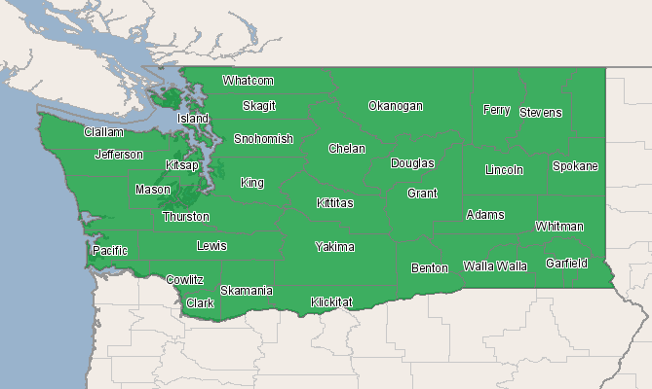
Economic Modeling Specialists, Inc. www.economicmodeling.com


Region Info

Region: WA State
Description: All counties in state of WA
State Area: Washington
Selected Occupations

Occupation | Education Level
Licensed practical and licensed vocational nurses (SOC 29-2061) | Postsecondary vocational award

Executive Summary

Basic Information
2007 Occupational Jobs | 9,667
2012 Occupational Jobs | 10,414
Total Change | 747
Total % Change | 7.73%
Openings | 2,409
Pct 10 Hourly Earnings | $16.78

Occupational Change Summary

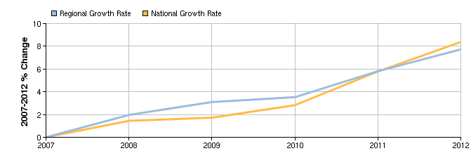
Region | 2007 Jobs | 2012 Jobs | Change | % Change | Openings | Pct 10 Hourly Earnings
Regional Total | 9,667 | 10,414 | 747 | 8% | 2,409 | $16.78
National Total | 728,499 | 789,543 | 61,044 | 8% | 191,844 | $13.76
Source: EMSI Complete Employment - 2nd Quarter 2010

Occupation Distribution

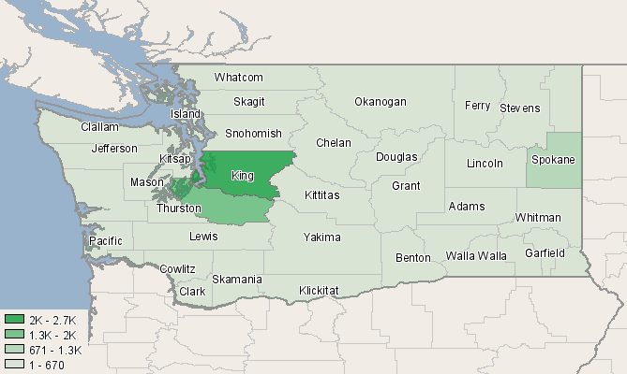
County | 2007 Jobs
King, WA (53033) | 2,670
Pierce, WA (53053) | 1,768
Spokane, WA (53063) | 1,255
Snohomish, WA (53061) | 597
Whatcom, WA (53073) | 398
Kitsap, WA (53035) | 345
Thurston, WA (53067) | 308
Yakima, WA (53077) | 305
Skagit, WA (53057) | 235
Clark, WA (53011) | 206
Benton, WA (53005) | 201
Clallam, WA (53009) | 142
Lewis, WA (53041) | 126
Cowlitz, WA (53015) | 116
Chelan, WA (53007) | 106
Grays Harbor, WA (53027) | 104
Grant, WA (53025) | 96
Walla Walla, WA (53071) | 89
Island, WA (53029) | 86
Kittitas, WA (53037) | 63
Okanogan, WA (53047) | 57
Mason, WA (53045) | 57
Whitman, WA (53075) | 56
Franklin, WA (53021) | 56
Stevens, WA (53065) | 44
Jefferson, WA (53031) | 36
Pacific, WA (53049) | 25
Asotin, WA (53003) | 25
Adams, WA (53001) | 23
Douglas, WA (53017) | 18
San Juan, WA (53055) | 17
Klickitat, WA (53039) | 13
Wahkiakum, WA (53069) | <10
Lincoln, WA (53043) | <10
Pend Oreille, WA (53051) | <10
Ferry, WA (53019) | <10
Columbia, WA (53013) | <10
Skamania, WA (53059) | <10
Garfield, WA (53023) | <10
Source: EMSI Complete Employment - 2nd Quarter 2010

Data Sources and Calculations

Occupation Data

Organizing regional employment information by occupation provides a workforce-oriented view of the regional economy. EMSI's occupation data are based on EMSI's industry data and regional staffing patterns taken from the Occupational Employment Statistics program (U.S. Bureau of Labor Statistics). Wage information is partially derived from the American Community Survey. The occupation-to-program (SOC-to-CIP) crosswalk is based on one from the U.S. Department of Education, with customizations by EMSI.
State Data Sources

This report uses state data from the following agencies: Washington State Employment Security Department, Labor Market and Economic Analysis Branch.

